UNITED STATES
SECURITIES AND EXCHANGE COMMISSION
Washington, D.C. 20549
FORM 8-K
CURRENT REPORT
Pursuant to Section 13 or 15(d)
of The Securities Exchange Act of 1934
Date of Report (Date of earliest event reported): August 6, 2026
Consolidated Edison, Inc.
(Exact name of registrant as specified in its charter)
New York |  |  |  |  |  | 1-14514 |  |  |  |  |  | 13-3965100
(State or Other Jurisdiction  of Incorporation) |  |  |  |  |  | (Commission  File Number) |  |  |  |  |  | (IRS Employer  Identification No.)
4 Irving Place, |  |  | New York, |  |  | New York |  |  |  |  |  | 10003
(Address of principal executive offices) |  |  |  |  |  |  |  |  |  |  |  | (Zip Code)
Registrant’s telephone number, including area code: (212) 460-4600
Consolidated Edison Company of New York, Inc.
(Exact name of registrant as specified in its charter)
New York |  |  |  |  |  | 1-01217 |  |  |  |  |  | 13-5009340
(State or Other Jurisdiction  of Incorporation) |  |  |  |  |  | (Commission  File Number) |  |  |  |  |  | (IRS Employer  Identification No.)
4 Irving Place, |  |  | New York, |  |  | New York |  |  |  |  |  | 10003
(Address of principal executive offices) |  |  |  |  |  |  |  |  |  |  |  | (Zip Code)
Registrant’s telephone number, including area code: (212) 460-4600

Check the appropriate box below if the Form 8-K filing is intended to simultaneously satisfy the filing obligation of the registrant under any of the following provisions:
☐ |  |  | Written communications pursuant to Rule 425 under the Securities Act (17 CFR 230.425)
☐ |  |  | Soliciting material pursuant to Rule 14a-12 under the Exchange Act (17 CFR 240.14a-12)
☐ |  |  | Pre-commencement communications pursuant to Rule 14d-2(b) under the Exchange Act (17 CFR 240.14d-2(b))
☐ |  |  | Pre-commencement communications pursuant to Rule 13e-4(c) under the Exchange Act (17 CFR 240.13e-4(c))

Securities Registered Pursuant to Section 12(b) of the Act:

Title of each class |  |  |  |  |  | Trading Symbol |  |  |  |  |  | Name of each exchange on which registered
Consolidated Edison, Inc., |  |  |  |  |  | ED |  |  |  |  |  | New York Stock Exchange
Common Shares ($.10 par value)

Indicate by check mark whether the registrant is an emerging growth company as defined in Rule 405 of the Securities Act of 1933 (§230.405 of this chapter) or Rule 12b-2 of the Securities Exchange Act of 1934 (§240.12b-2 of this chapter).

Emerging growth company ☐

If an emerging growth company, indicate by check mark if the registrant has elected not to use the extended transition period for complying with any new or revised financial accounting standards provided pursuant to Section 13(a) of the Exchange Act. ☐

-2-

Item 2.02 |  |  | Results of Operations and Financial Condition.
On August 6, 2026, Consolidated Edison, Inc. is issuing a press release and an earnings release presentation regarding, among other things, its results of operations for the three and six months ended June 30, 2026. The press release and the earnings release presentation are “furnished” as exhibits to this report pursuant to Item 2.02 of Form 8-K.

Item 9.01 |  |  | Financial Statements and Exhibits.
(d) Exhibits
Exhibit 99.1 |  |  |  |  |  | Press release, dated August 6, 2026, furnished pursuant to Item 2.02 of Form 8-K.
Exhibit 99.2 |  |  |  |  |  | Earnings release presentation, dated August 6, 2026, furnished pursuant to Item 2.02 of Form 8-K.
Exhibit 104 |  |  |  |  |  | Cover Page Interactive Data File - The cover page iXBRL tags are embedded within the inline XBRL document.
-3-

SIGNATURES
Pursuant to the requirements of the Securities Exchange Act of 1934, each registrant has duly caused this report to be signed on its behalf by the undersigned hereunto duly authorized.
CONSOLIDATED EDISON, INC.
CONSOLIDATED EDISON COMPANY OF NEW YORK, INC.
By |  |  |  |  |  | /s/ Joseph Miller
 |  |  |  |  |  | Joseph Miller
 |  |  |  |  |  | Vice President, Controller and Chief Accounting Officer
Date: August 6, 2026

Exhibit 99.1
-4-

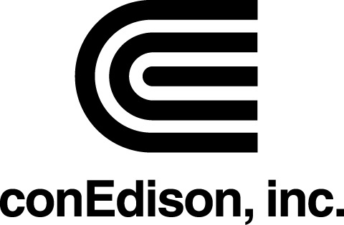 |  |  | Media Relations |  |  | Consolidated Edison, Inc.
 |  |  | 212 460 4111 (24 hours) |  |  | 4 Irving Place
 |  |  |  |  |  | New York, NY 10003
 |  |  |  |  |  | www.conEdison.com

FOR IMMEDIATE RELEASE |  |  |  |  |  |  |  |  |  |  |  | Contact: Allan Drury
August 6, 2026 |  |  |  |  |  |  |  |  |  |  |  | 212-460-4111

CON EDISON REPORTS 2026 SECOND QUARTER EARNINGS

NEW YORK - Consolidated Edison, Inc. (Con Edison) (NYSE: ED) today reported 2026 second quarter net income for common stock of $308 million or $0.83 a share compared with $246 million or $0.68 a share in the 2025 second quarter. Adjusted earnings (non-GAAP) were $308 million or $0.83 a share in the 2026 period compared with $240 million or $0.67 a share in the 2025 period. Adjusted earnings and adjusted earnings per share in the 2026 period exclude transaction costs associated with the strategic alternatives review of Con Edison's equity interests in Mountain Valley Pipeline, LLC (MVP) and Honeoye Storage Corporation (Honeoye). Adjusted earnings and adjusted earnings per share in the 2026 and 2025 periods exclude the effects of hypothetical liquidation at book value (HLBV) accounting for tax equity investments. Adjusted earnings and adjusted earnings per share in the 2025 period exclude accretion of the basis difference of Con Edison's equity interest in MVP, adjustments to the gain and other impacts related to the sale of all of the stock of its former subsidiary, Con Edison Clean Energy Businesses, Inc. (the Clean Energy Businesses) in 2023.

For the first six months of 2026, net income for common stock was $1,232 million or $3.37 a share compared with $1,038 million or $2.93 a share in the first six months of 2025. Adjusted earnings were $1,098 million or $3.00 a share in the 2026 period compared with $1,032 million or $2.91 a share in the 2025 period. Adjusted earnings and adjusted earnings per share in the 2026 period exclude transaction costs associated with the strategic alternatives review of Con Edison's equity interests in MVP and Honeoye, the gain on the sale of Con Edison's equity interest in MVP and the effects of HLBV accounting for tax equity investments. Adjusted earnings and adjusted earnings per share in the 2026 and 2025 periods exclude accretion of the basis difference of Con Edison's equity interest in MVP. Adjusted earnings and adjusted earnings per share in the 2025 period exclude adjustments to the gain and other impacts related to the sale of all of the stock of the Clean Energy Businesses in 2023.

“Con Edison continues to deliver nation-leading electric service reliability, reflecting the strength of our business model, disciplined infrastructure investments, and the dedication and expertise of our workforce," said Tim Cawley, Chairman and CEO of Con Edison. "We are investing to further strengthen reliability and system resilience, including preparing our network for periods of extreme heat, and redoubling our efforts to keep our service affordable for all customers while continuing to support New York's clean energy transition. Our targeted investments benefit our customers, support economic growth, and provide a foundation for stable, long-term returns for investors."

“Our second-quarter results reflect the strength and resilience of our business and reinforce confidence in our long-term strategy,” said Kirk Andrews, Senior Vice President and CFO of Con Edison. “Year-to-date results continue to be in line with expectations. Our vibrant market and the growing momentum for the electrification of buildings and transportation support our confidence that we will provide solid shareholder value for years to come. We expect to have 28 new substations in service by 2035, along with tens of billions of dollars in other capital investments we plan to make to meet our customers’ need for energy.”

-more-

CON EDISON REPORTS 2026 SECOND QUARTER EARNINGS |  |  |  |  |  |  |  |  |  |  |  | page 2
For the year of 2026, Con Edison reaffirmed its adjusted earnings per share (non-GAAP) to be in the range of $6.00 to $6.20 per share. Adjusted earnings per share excludes the gain on the sale of Con Edison's equity interest in MVP ($(0.37) a share after-tax), accretion of the basis difference of Con Edison's equity interest in MVP ($(0.01) a share after-tax), transaction costs associated with the strategic alternatives review of Con Edison's equity interests in MVP and Honeoye and the effects of HLBV accounting for tax equity investments, the amounts of which will not be determinable until year-end. Accordingly, the company is unable to provide equivalent measures determined in accordance with generally accepted accounting principles in the United States of America (GAAP).

See Attachment A to this press release for a reconciliation of Con Edison’s reported earnings per share to adjusted earnings per share and reported net income for common stock to adjusted earnings for the three and six months ended June 30, 2026 and 2025. See Attachments B and C for the estimated effect of major factors resulting in variations in earnings per share and net income for common stock for the three and six months ended June 30, 2026 compared to the respective 2025 periods.

The company's 2026 Second Quarter Form 10-Q is being filed with the Securities and Exchange Commission. A second quarter 2026 earnings release presentation will be available at www.conedison.com. (Select "For Investors" and then select "Press Releases.")

-more-

CON EDISON REPORTS 2026 SECOND QUARTER EARNINGS |  |  |  |  |  |  |  |  |  |  |  | page 3
This press release contains forward-looking statements that are intended to qualify for the safe-harbor provisions of Section 27A of the Securities Act of 1933, as amended, and Section 21E of the Securities Exchange Act of 1934, as amended. Forward-looking statements are statements of future expectations and not facts. Words such as “forecasts,” “expects,” “estimates,” “anticipates,” “intends,” “believes,” “plans,” “will,” “target,” “guidance,” “potential,” “goal,” “consider” and similar expressions identify forward-looking statements. The forward-looking statements reflect information available and assumptions at the time the statements are made, and accordingly speak only as of that time.

Actual results or developments might differ materially from those included in the forward-looking statements because of various factors such as those identified in reports Con Edison has filed with the Securities and Exchange Commission, including that Con Edison's subsidiaries are extensively regulated and may be subject to substantial penalties; its utility subsidiaries' rate plans may not provide a reasonable return; it may be adversely affected by changes to the utility subsidiaries' rate plans; the failure of, or damage to, its subsidiaries' facilities could adversely affect it; a cyber attack could adversely affect it; artificial intelligence is an emerging area of technology that has the potential to impact various aspects of its and its subsidiaries’ business operations and customer interactions; the failure of processes and systems, the failure to retain and attract employees and contractors, and their negative performance could adversely affect it; it is exposed to risks from the environmental consequences of its subsidiaries' operations, including increased costs related to climate change; its ability to pay dividends or interest depends on dividends from its subsidiaries; changes to tax laws could adversely affect it; it requires access to capital markets to satisfy funding requirements; a disruption in the wholesale energy markets, increased commodity costs or failure by an energy supplier or customer could adversely affect it; it faces risks related to health epidemics and other outbreaks; its strategies may not be effective to address changes in the external business environment; it faces risks related to supply chain disruptions, inflation and the imposition of tariffs (or subsequent changes to tariffs once announced or implemented); and it also faces other risks that are beyond its control. This list of factors is not all-inclusive because it is not possible to predict all factors that could cause actual results or developments to differ from the forward-looking statements. Con Edison assumes no obligation to update or revise any forward-looking statements, whether as a result of new information, future events or otherwise, except as required by law.

This press release also contains financial measures, adjusted earnings and adjusted earnings per share, that are not determined in accordance with GAAP. These non-GAAP financial measures should not be considered as an alternative to net income for common stock or net income per share, respectively, each of which is an indicator of financial performance determined in accordance with GAAP. Adjusted earnings and adjusted earnings per share exclude from net income for common stock and net income per share, respectively, certain items that Con Edison does not consider indicative of its ongoing financial performance such as the gain on the sale of Con Edison's equity interest in MVP, accretion of the basis difference of Con Edison's equity interest in MVP, transaction costs associated with the strategic alternatives review of Con Edison's equity interests in MVP and Honeoye and the effects of HLBV accounting for tax equity investments. Management uses these non-GAAP financial measures to facilitate the analysis of Con Edison's financial performance as compared to its internal budgets and previous financial results and to communicate to investors and others Con Edison's expectations regarding its future earnings and dividends on its common stock. Management believes that these non-GAAP financial measures are also useful and meaningful to investors to facilitate their analysis of Con Edison's financial performance.
-more-

CON EDISON REPORTS 2026 SECOND QUARTER EARNINGS |  |  |  |  |  |  |  |  |  |  |  | page 4
Consolidated Edison, Inc. is a holding company that provides a wide range of energy-related products and services to its customers through the following subsidiaries: Consolidated Edison Company of New York, Inc. (CECONY), a regulated utility providing electric service in New York City and New York’s Westchester County, gas service in Manhattan, the Bronx, parts of Queens and parts of Westchester, and steam service in Manhattan; Orange and Rockland Utilities, Inc. (O&R), a regulated utility serving customers in a 1,300-square-mile area in southeastern New York State and northern New Jersey; and Con Edison Transmission, Inc., a regulated company primarily under the oversight of the Federal Energy Regulatory Commission, that develops and invests in electric transmission projects and owns interests in electric assets.

# # #

Attachment A
 |  |  | For the Three Months Ended |  |  |  |  |  |  |  |  |  |  |  |  |  |  | For the Six Months Ended
 |  |  | June 30, |  |  |  |  |  |  |  |  |  |  |  |  |  |  | June 30,
 |  |  | Earnings  per Share |  |  |  |  |  | Net Income for Common Stock  (Millions of Dollars) |  |  |  |  |  |  |  |  | Earnings  per Share |  |  |  |  |  | Net Income for Common Stock  (Millions of Dollars)
 |  |  | 2026 |  |  | 2025 |  |  | 2026 |  |  | 2025 |  |  |  |  |  | 2026 |  |  | 2025 |  |  | 2026 |  |  | 2025
Reported earnings per share (basic) and net income for common stock (GAAP basis) |  |  | $0.83 |  |  | $0.68 |  |  | $308 |  |  | $246 |  |  |  |  |  | $3.37 |  |  | $2.93 |  |  | $1,232 |  |  | $1,038
Loss and other impacts related to the sale of the Clean Energy Businesses in 2025 (pre-tax) |  |  | — |  |  | — |  |  | — |  |  | — |  |  |  |  |  | — |  |  | — |  |  | — |  |  | —
Income taxes |  |  | — |  |  | — |  |  | — |  |  | (1) |  |  |  |  |  | — |  |  | — |  |  | — |  |  | (1)
Loss and other impacts related to the sale of the Clean Energy Businesses in 2025 (net of tax) |  |  | — |  |  | — |  |  | — |  |  | (1) |  |  |  |  |  | — |  |  | — |  |  | — |  |  | (1)
Accretion of the basis difference of Con Edison's equity interest in MVP (pre-tax) |  |  | — |  |  | (0.01) |  |  | — |  |  | (3) |  |  |  |  |  | (0.01) |  |  | (0.02) |  |  | (3) |  |  | (6)
Income taxes (a) |  |  | — |  |  | — |  |  | — |  |  | 1 |  |  |  |  |  | — |  |  | — |  |  | 1 |  |  | 1
Accretion of the basis difference of Con Edison's equity interest in MVP (net of tax) |  |  | — |  |  | (0.01) |  |  | — |  |  | (2) |  |  |  |  |  | (0.01) |  |  | (0.02) |  |  | (2) |  |  | (5)
Transaction costs associated with the strategic alternatives review of Con Edison's equity interests in MVP and Honeoye (pre-tax) |  |  | — |  |  | — |  |  | 1 |  |  | — |  |  |  |  |  | 0.01 |  |  | — |  |  | 4 |  |  | —
Income taxes (b) |  |  | — |  |  | — |  |  | — |  |  | — |  |  |  |  |  | — |  |  | — |  |  | (1) |  |  | —
Transaction costs associated with the strategic alternatives review of Con Edison's equity interests in MVP and Honeoye (net of tax) |  |  | — |  |  | — |  |  | 1 |  |  | — |  |  |  |  |  | 0.01 |  |  | — |  |  | 3 |  |  | —
Gain on the sale of Con Edison's equity interest in MVP (pre-tax) |  |  | — |  |  | — |  |  | — |  |  | — |  |  |  |  |  | (0.52) |  |  | — |  |  | (189) |  |  | —
Income taxes (c) |  |  | — |  |  | — |  |  | — |  |  | — |  |  |  |  |  | 0.15 |  |  | — |  |  | 55 |  |  | —
Gain on the sale of Con Edison's equity interest in MVP (net of tax) |  |  | — |  |  | — |  |  | — |  |  | — |  |  |  |  |  | (0.37) |  |  | — |  |  | (134) |  |  | —
HLBV effects (pre-tax) |  |  | — |  |  | — |  |  | (1) |  |  | (4) |  |  |  |  |  | — |  |  | — |  |  | (1) |  |  | —
Income taxes (d) |  |  | — |  |  | — |  |  | — |  |  | 1 |  |  |  |  |  | — |  |  | — |  |  | — |  |  | —
HLBV effects (net of tax) |  |  | — |  |  | — |  |  | (1) |  |  | (3) |  |  |  |  |  | — |  |  | — |  |  | (1) |  |  | —
Adjusted earnings per share and adjusted earnings (non-GAAP basis) |  |  | $0.83 |  |  | $0.67 |  |  | $308 |  |  | $240 |  |  |  |  |  | $3.00 |  |  | $2.91 |  |  | $1,098 |  |  | $1,032

(a)The amount of income taxes was calculated using a combined federal and state income tax rate of 25% for the six months ended June 30, 2026 and 21% for the three and six months ended June 30, 2025.
(b)The amount of income taxes was calculated using a combined federal and state income tax rate of 26% for the three and six months ended June 30, 2026.
(c)The amount of income taxes was calculated using a combined federal and state income tax rate of 29% for the six months ended June 30, 2026.
(d)The amount of income taxes was calculated using a combined federal and state income tax rate of 26% for the three and six months ended June 30, 2026 and 23% for the three months ended June 30, 2025.

Attachment B
Variation for the Three Months Ended June 30, 2026 vs. 2025
 |  |  | Net Income for Common Stock (Net of Tax) (Millions of Dollars) |  |  | Earnings  per Share
CECONY (a)
Higher electric rate base and timing of billing of rate increase |  |  | $25 |  |  | $0.07
Higher gas rate base and timing of billing of rate increase |  |  | 23 |  |  | 0.06
Lower other interest expense |  |  | 9 |  |  | 0.03
Lower electric operations and maintenance expense |  |  | 9 |  |  | 0.02
Higher income from allowance for funds used during construction |  |  | 4 |  |  | 0.01
Dilutive effect of issuance of common shares |  |  | — |  |  | (0.02)
Other |  |  | 4 |  |  | 0.01
Total CECONY |  |  | 74 |  |  | 0.18
O&R (a)
Electric base rate increase |  |  | 3 |  |  | 0.01
Gas base rate increase |  |  | 2 |  |  | —
Higher interest expense on long-term debt |  |  | (3) |  |  | (0.01)
Other |  |  | (2) |  |  | —
Total O&R |  |  | — |  |  | —
Con Edison Transmission
Accretion of the basis difference of Con Edison's equity interest in MVP |  |  | (2) |  |  | (0.01)
Transaction costs associated with the strategic alternatives review of Con Edison's equity interests in MVP and Honeoye |  |  | (1) |  |  | —
Total Con Edison Transmission |  |  | (3) |  |  | (0.01)
Other, including parent company expenses (b)
Higher other interest expense |  |  | (2) |  |  | (0.01)
HLBV effects |  |  | (2) |  |  | —
Loss and other impacts related to the sale of the Clean Energy Businesses in 2025 |  |  | (1) |  |  | —
Higher income tax expense |  |  | (1) |  |  | —
Other |  |  | (3) |  |  | (0.01)
Total Other, including parent company expenses |  |  | (9) |  |  | (0.02)
Total Reported (GAAP basis) |  |  | $62 |  |  | $0.15
Accretion of the basis difference of Con Edison's equity interest in MVP |  |  | 2 |  |  | 0.01
HLBV effects |  |  | 2 |  |  | —
Loss and other impacts related to the sale of the Clean Energy Businesses in 2025 |  |  | 1 |  |  | —
Transaction costs associated with the strategic alternatives review of Con Edison's equity interests in MVP and Honeoye |  |  | 1 |  |  | —
Total Adjusted (Non-GAAP basis) |  |  | $68 |  |  | $0.16
(a)Under the revenue decoupling mechanisms in the Utilities’ New York electric and gas rate plans, revenues are generally not affected by changes in delivery volumes from levels assumed when rates were approved. The Utilities' gas and CECONY’s steam sales are subject to a weather normalization clause, as a result of which, delivery revenues reflect normal weather conditions during the heating season. In general, the Utilities recover on a current basis the fuel, gas purchased for resale and purchased power costs they incur in supplying energy to their full-service customers. Accordingly, such costs do not generally affect Con Edison’s results of operations.

(b)Other includes the parent company, Con Edison's tax equity investments and consolidation adjustments.

Attachment C
Variation for the Six Months Ended June 30, 2026 vs. 2025
 |  |  | Net Income for Common Stock (Net of Tax) (Millions of Dollars) |  |  | Earnings  per Share
CECONY (a)
Higher electric rate base |  |  | 33 |  |  | 0.09
Higher gas rate base |  |  | 26 |  |  | 0.07
Higher income from allowance for funds used during construction |  |  | 6 |  |  | 0.02
Dilutive effect of issuance of common shares |  |  | — |  |  | (0.09)
Other |  |  | (3) |  |  | (0.01)
Total CECONY |  |  | 62 |  |  | 0.08
O&R (a)
Electric base rate increase |  |  | 8 |  |  | 0.02
Gas base rate increase |  |  | 4 |  |  | 0.01
Higher interest expense on long-term debt |  |  | (6) |  |  | (0.02)
Total O&R |  |  | 6 |  |  | 0.01
Con Edison Transmission
Gain on the sale of Con Edison's equity interest in MVP |  |  | 134 |  |  | 0.37
Transaction costs associated with the strategic alternatives review of Con Edison's equity interests in MVP and Honeoye |  |  | (3) |  |  | (0.01)
Accretion of the basis difference of Con Edison's equity interest in MVP |  |  | (3) |  |  | (0.01)
Other |  |  | 2 |  |  | 0.01
Total Con Edison Transmission |  |  | 130 |  |  | 0.36
Other, including parent company expenses (b)
Higher income tax expense |  |  | (3) |  |  | (0.01)
Higher other interest expense |  |  | (2) |  |  | (0.01)
Loss and other impacts related to the sale of the Clean Energy Businesses in 2025 |  |  | (1) |  |  | —
HLBV effects |  |  | 1 |  |  | —
Other |  |  | 1 |  |  | 0.01
Total Other, including parent company expenses |  |  | (4) |  |  | (0.01)
Total Reported (GAAP basis) |  |  | $194 |  |  | $0.44
Gain on the sale of Con Edison's equity interest in MVP |  |  | (134) |  |  | (0.37)
HLBV effects |  |  | (1) |  |  | —
Accretion of the basis difference of Con Edison's equity interest in MVP |  |  | 3 |  |  | 0.01
Transaction costs associated with the strategic alternatives review of Con Edison's equity interests in MVP and Honeoye |  |  | 3 |  |  | 0.01
Loss and other impacts related to the sale of the Clean Energy Businesses in 2025 |  |  | 1 |  |  | —
Total Adjusted (Non-GAAP basis) |  |  | $66 |  |  | $0.09
(a)Under the revenue decoupling mechanisms in the Utilities’ New York electric and gas rate plans, revenues are generally not affected by changes in delivery volumes from levels assumed when rates were approved. The Utilities' gas and CECONY’s steam sales are subject to a weather normalization clause, as a result of which, delivery revenues reflect normal weather conditions during the heating season. In general, the Utilities recover on a current basis the fuel, gas purchased for resale and purchased power costs they incur in supplying energy to their full-service customers. Accordingly, such costs do not generally affect Con Edison’s results of operations.

(b)Other includes the parent company, Con Edison's tax equity investments, consolidation adjustments and Broken Bow II, the deferred project that was classified as held for sale at December 31, 2024, the sale and transfer of which was completed in January 2025.
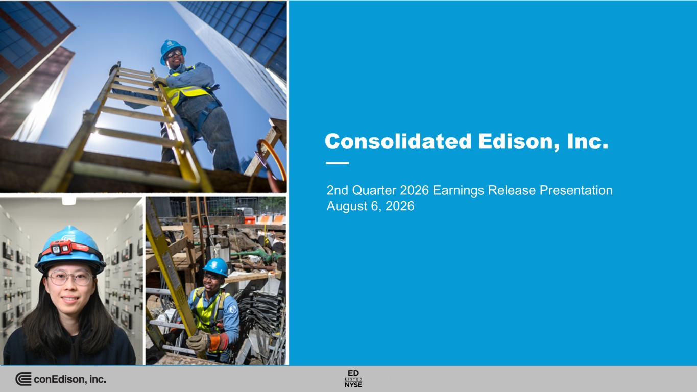

2nd Quarter 2026 Earnings Release Presentation August 6, 2026

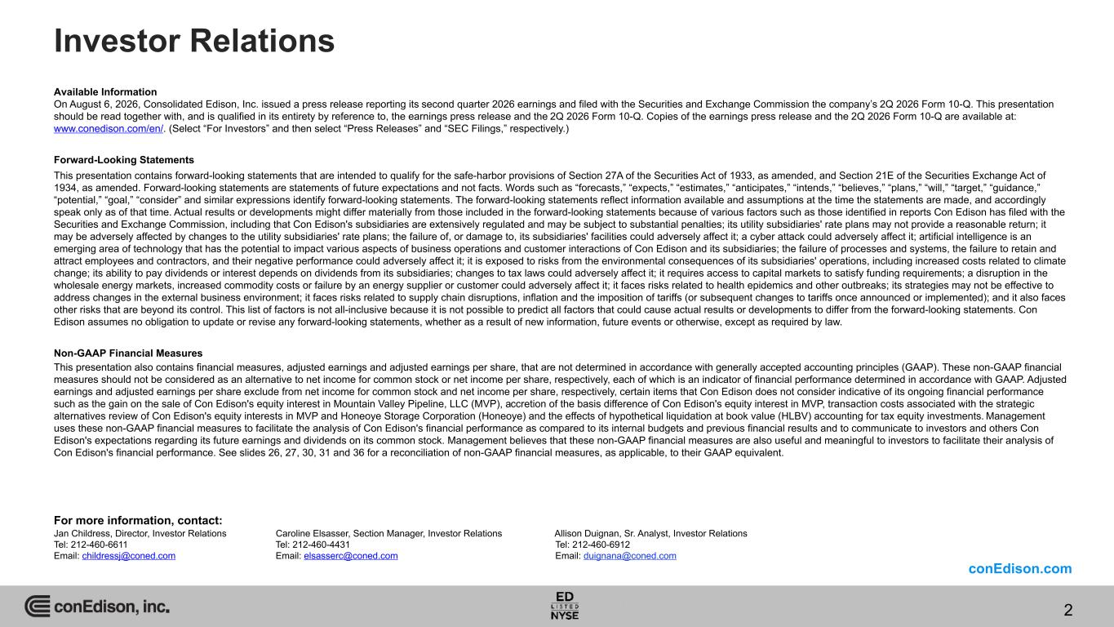
Available Information On August 6, 2026, Consolidated Edison, Inc. issued a press release reporting its second quarter 2026 earnings and filed with the Securities and Exchange Commission the company’s 2Q 2026 Form 10-Q. This presentation should be read together with, and is qualified in its entirety by reference to, the earnings press release and the 2Q 2026 Form 10-Q. Copies of the earnings press release and the 2Q 2026 Form 10-Q are available at: www.conedison.com/en/. (Select “For Investors” and then select “Press Releases” and “SEC Filings,” respectively.) Forward-Looking Statements This presentation contains forward-looking statements that are intended to qualify for the safe-harbor provisions of Section 27A of the Securities Act of 1933, as amended, and Section 21E of the Securities Exchange Act of 1934, as amended. Forward-looking statements are statements of future expectations and not facts. Words such as “forecasts,” “expects,” “estimates,” “anticipates,” “intends,” “believes,” “plans,” “will,” “target,” “guidance,” “potential,” “goal,” “consider” and similar expressions identify forward-looking statements. The forward-looking statements reflect information available and assumptions at the time the statements are made, and accordingly speak only as of that time. Actual results or developments might differ materially from those included in the forward-looking statements because of various factors such as those identified in reports Con Edison has filed with the Securities and Exchange Commission, including that Con Edison's subsidiaries are extensively regulated and may be subject to substantial penalties; its utility subsidiaries' rate plans may not provide a reasonable return; it may be adversely affected by changes to the utility subsidiaries' rate plans; the failure of, or damage to, its subsidiaries' facilities could adversely affect it; a cyber attack could adversely affect it; artificial intelligence is an emerging area of technology that has the potential to impact various aspects of business operations and customer interactions of Con Edison and its subsidiaries; the failure of processes and systems, the failure to retain and attract employees and contractors, and their negative performance could adversely affect it; it is exposed to risks from the environmental consequences of its subsidiaries' operations, including increased costs related to climate change; its ability to pay dividends or interest depends on dividends from its subsidiaries; changes to tax laws could adversely affect it; it requires access to capital markets to satisfy funding requirements; a disruption in the wholesale energy markets, increased commodity costs or failure by an energy supplier or customer could adversely affect it; it faces risks related to health epidemics and other outbreaks; its strategies may not be effective to address changes in the external business environment; it faces risks related to supply chain disruptions, inflation and the imposition of tariffs (or subsequent changes to tariffs once announced or implemented); and it also faces other risks that are beyond its control. This list of factors is not all-inclusive because it is not possible to predict all factors that could cause actual results or developments to differ from the forward-looking statements. Con Edison assumes no obligation to update or revise any forward-looking statements, whether as a result of new information, future events or otherwise, except as required by law. Non-GAAP Financial Measures This presentation also contains financial measures, adjusted earnings and adjusted earnings per share, that are not determined in accordance with generally accepted accounting principles (GAAP). These non-GAAP financial measures should not be considered as an alternative to net income for common stock or net income per share, respectively, each of which is an indicator of financial performance determined in accordance with GAAP. Adjusted earnings and adjusted earnings per share exclude from net income for common stock and net income per share, respectively, certain items that Con Edison does not consider indicative of its ongoing financial performance such as the gain on the sale of Con Edison's equity interest in Mountain Valley Pipeline, LLC (MVP), accretion of the basis difference of Con Edison's equity interest in MVP, transaction costs associated with the strategic alternatives review of Con Edison's equity interests in MVP and Honeoye Storage Corporation (Honeoye) and the effects of hypothetical liquidation at book value (HLBV) accounting for tax equity investments. Management uses these non-GAAP financial measures to facilitate the analysis of Con Edison's financial performance as compared to its internal budgets and previous financial results and to communicate to investors and others Con Edison's expectations regarding its future earnings and dividends on its common stock. Management believes that these non-GAAP financial measures are also useful and meaningful to investors to facilitate their analysis of Con Edison's financial performance. See slides 26, 27, 30, 31 and 36 for a reconciliation of non-GAAP financial measures, as applicable, to their GAAP equivalent. For more information, contact: Jan Childress, Director, Investor Relations Caroline Elsasser, Section Manager, Investor Relations Allison Duignan, Sr. Analyst, Investor Relations Tel: 212-460-6611 Tel: 212-460-4431 Tel: 212-460-6912 Email: childressj@coned.com Email: elsasserc@coned.com Email: duignana@coned.com Investor Relations conEdison.com 2

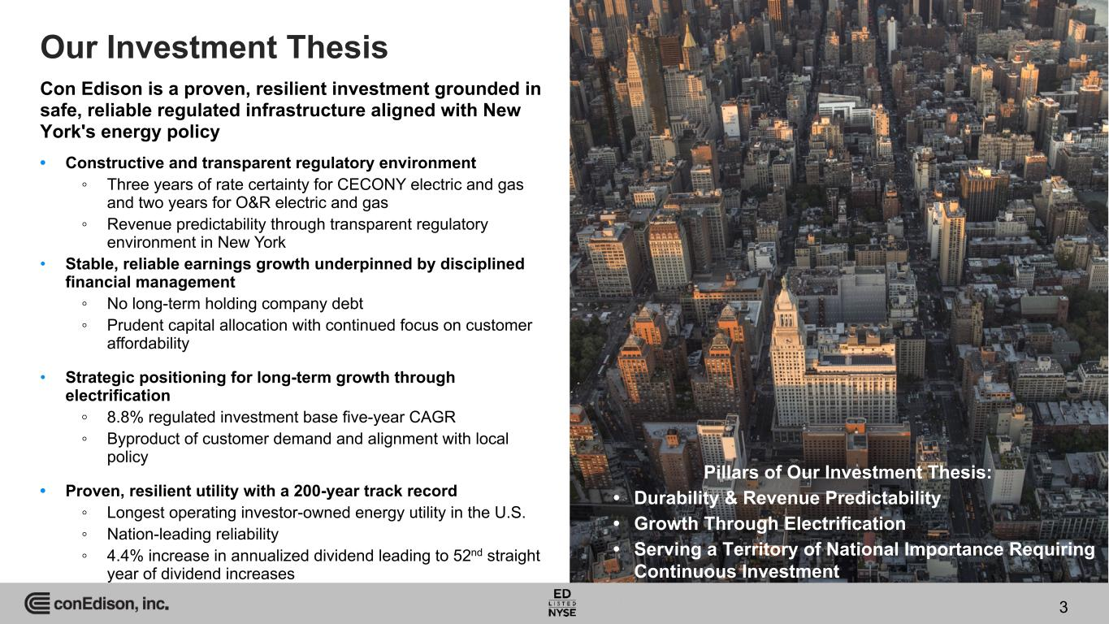
3 Our Investment Thesis Con Edison is a proven, resilient investment grounded in safe, reliable regulated infrastructure aligned with New York's energy policy 3 • Constructive and transparent regulatory environment ◦ Three years of rate certainty for CECONY electric and gas and two years for O&R electric and gas ◦ Revenue predictability through transparent regulatory environment in New York • Stable, reliable earnings growth underpinned by disciplined financial management ◦ No long-term holding company debt ◦ Prudent capital allocation with continued focus on customer affordability • Strategic positioning for long-term growth through electrification ◦ 8.8% regulated investment base five-year CAGR ◦ Byproduct of customer demand and alignment with local policy • Proven, resilient utility with a 200-year track record ◦ Longest operating investor-owned energy utility in the U.S. ◦ Nation-leading reliability ◦ 4.4% increase in annualized dividend leading to 52nd straight year of dividend increases Pillars of Our Investment Thesis: • Durability & Revenue Predictability • Growth Through Electrification • Serving a Territory of National Importance Requiring Continuous Investment

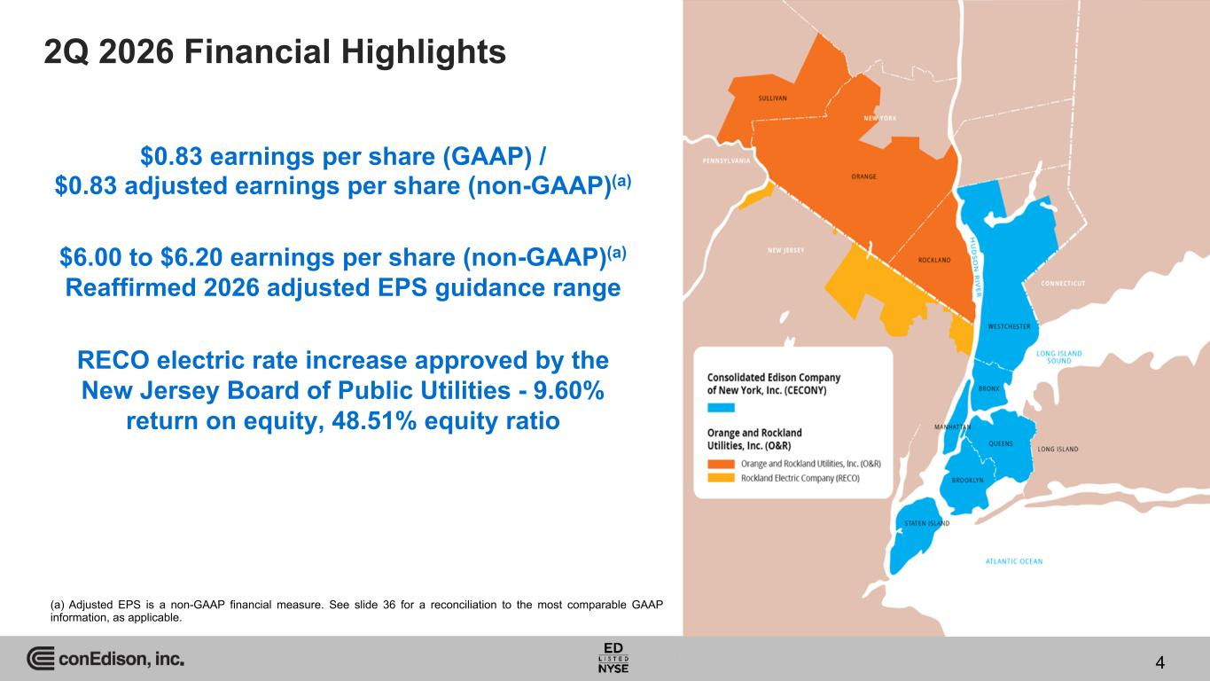
2Q 2026 Financial Highlights $0.83 earnings per share (GAAP) / $0.83 adjusted earnings per share (non-GAAP)(a) $6.00 to $6.20 earnings per share (non-GAAP)(a) Reaffirmed 2026 adjusted EPS guidance range RECO electric rate increase approved by the New Jersey Board of Public Utilities - 9.60% return on equity, 48.51% equity ratio 4 (a) Adjusted EPS is a non-GAAP financial measure. See slide 36 for a reconciliation to the most comparable GAAP information, as applicable.

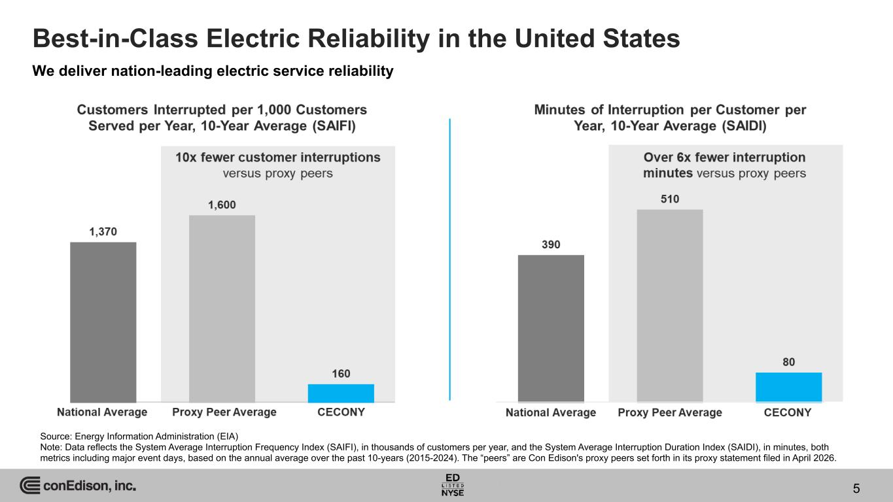
Best-in-Class Electric Reliability in the United States 5 We deliver nation-leading electric service reliability Source: Energy Information Administration (EIA) Note: Data reflects the System Average Interruption Frequency Index (SAIFI), in thousands of customers per year, and the System Average Interruption Duration Index (SAIDI), in minutes, both metrics including major event days, based on the annual average over the past 10-years (2015-2024). The “peers” are Con Edison's proxy peers set forth in its proxy statement filed in April 2026.

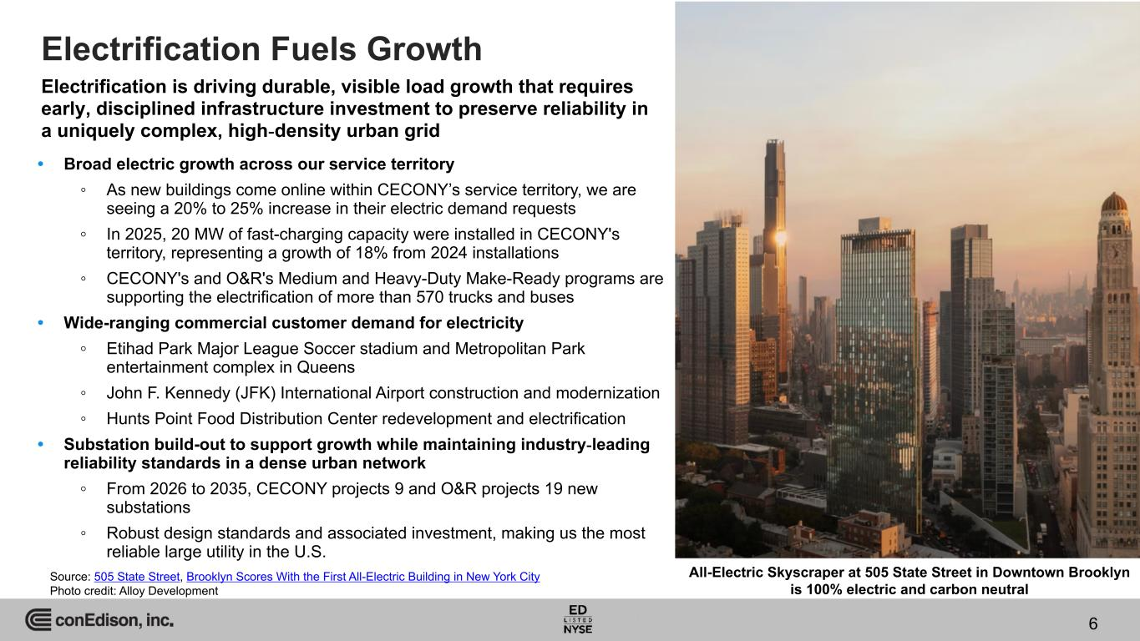
6 Electrification is driving durable, visible load growth that requires early, disciplined infrastructure investment to preserve reliability in a uniquely complex, high-density urban grid 6 • Broad electric growth across our service territory ◦ As new buildings come online within CECONY’s service territory, we are seeing a 20% to 25% increase in their electric demand requests ◦ In 2025, 20 MW of fast-charging capacity were installed in CECONY's territory, representing a growth of 18% from 2024 installations ◦ CECONY's and O&R's Medium and Heavy-Duty Make-Ready programs are supporting the electrification of more than 570 trucks and buses • Wide-ranging commercial customer demand for electricity ◦ Etihad Park Major League Soccer stadium and Metropolitan Park entertainment complex in Queens ◦ John F. Kennedy (JFK) International Airport construction and modernization ◦ Hunts Point Food Distribution Center redevelopment and electrification • Substation build-out to support growth while maintaining industry-leading reliability standards in a dense urban network ◦ From 2026 to 2035, CECONY projects 9 and O&R projects 19 new substations ◦ Robust design standards and associated investment, making us the most reliable large utility in the U.S. All-Electric Skyscraper at 505 State Street in Downtown Brooklyn is 100% electric and carbon neutral Electrification Fuels Growth Source: 505 State Street, Brooklyn Scores With the First All-Electric Building in New York City Photo credit: Alloy Development

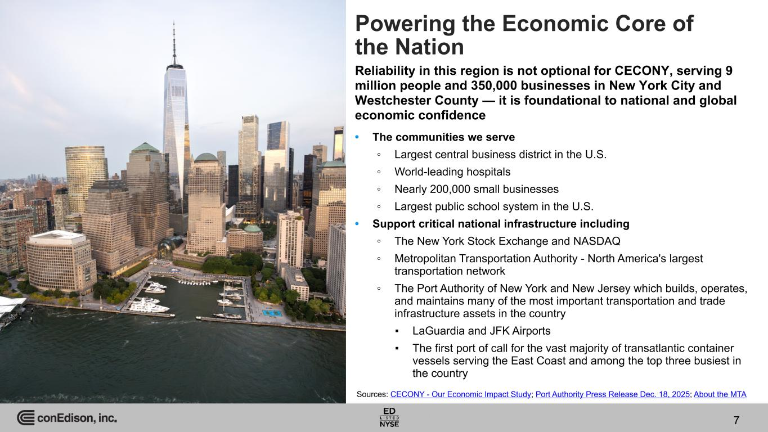
7 Powering the Economic Core of the Nation Reliability in this region is not optional for CECONY, serving 9 million people and 350,000 businesses in New York City and Westchester County — it is foundational to national and global economic confidence 7 • The communities we serve ◦ Largest central business district in the U.S. ◦ World-leading hospitals ◦ Nearly 200,000 small businesses ◦ Largest public school system in the U.S. • Support critical national infrastructure including ◦ The New York Stock Exchange and NASDAQ ◦ Metropolitan Transportation Authority - North America's largest transportation network ◦ The Port Authority of New York and New Jersey which builds, operates, and maintains many of the most important transportation and trade infrastructure assets in the country ▪ LaGuardia and JFK Airports ▪ The first port of call for the vast majority of transatlantic container vessels serving the East Coast and among the top three busiest in the country Sources: CECONY - Our Economic Impact Study; Port Authority Press Release Dec. 18, 2025; About the MTA

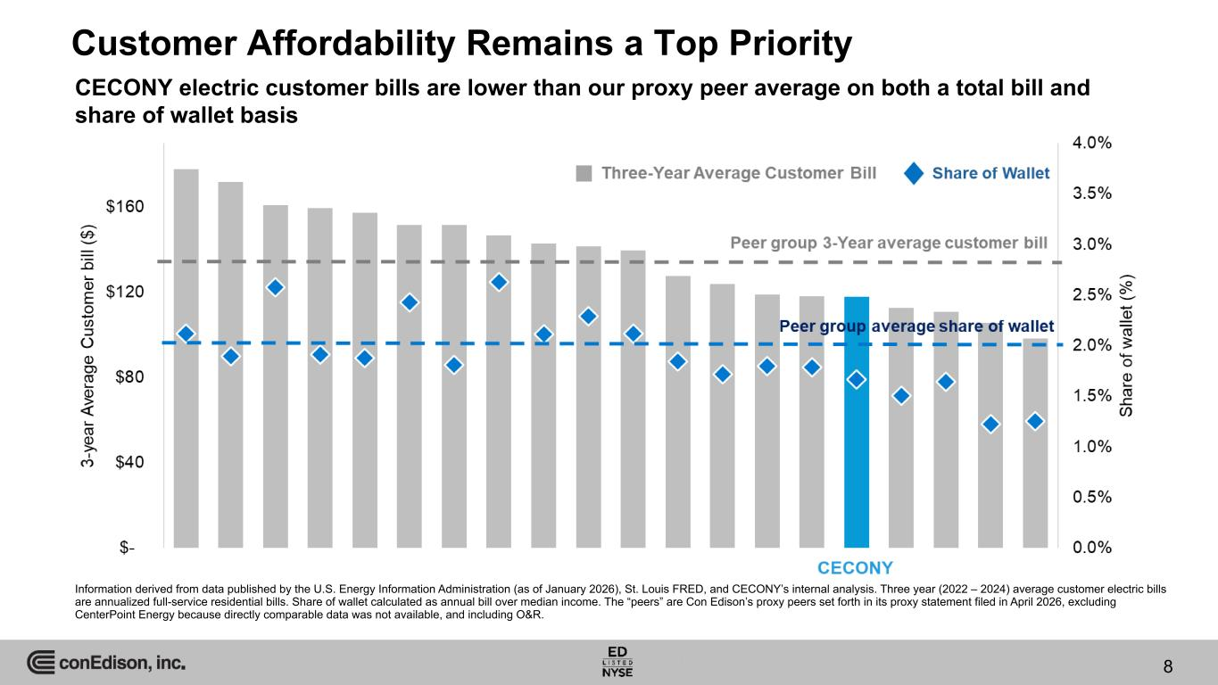
Customer Affordability Remains a Top Priority CECONY electric customer bills are lower than our proxy peer average on both a total bill and share of wallet basis 8 Information derived from data published by the U.S. Energy Information Administration (as of January 2026), St. Louis FRED, and CECONY’s internal analysis. Three year (2022 – 2024) average customer electric bills are annualized full-service residential bills. Share of wallet calculated as annual bill over median income. The “peers” are Con Edison’s proxy peers set forth in its proxy statement filed in April 2026, excluding CenterPoint Energy because directly comparable data was not available, and including O&R.

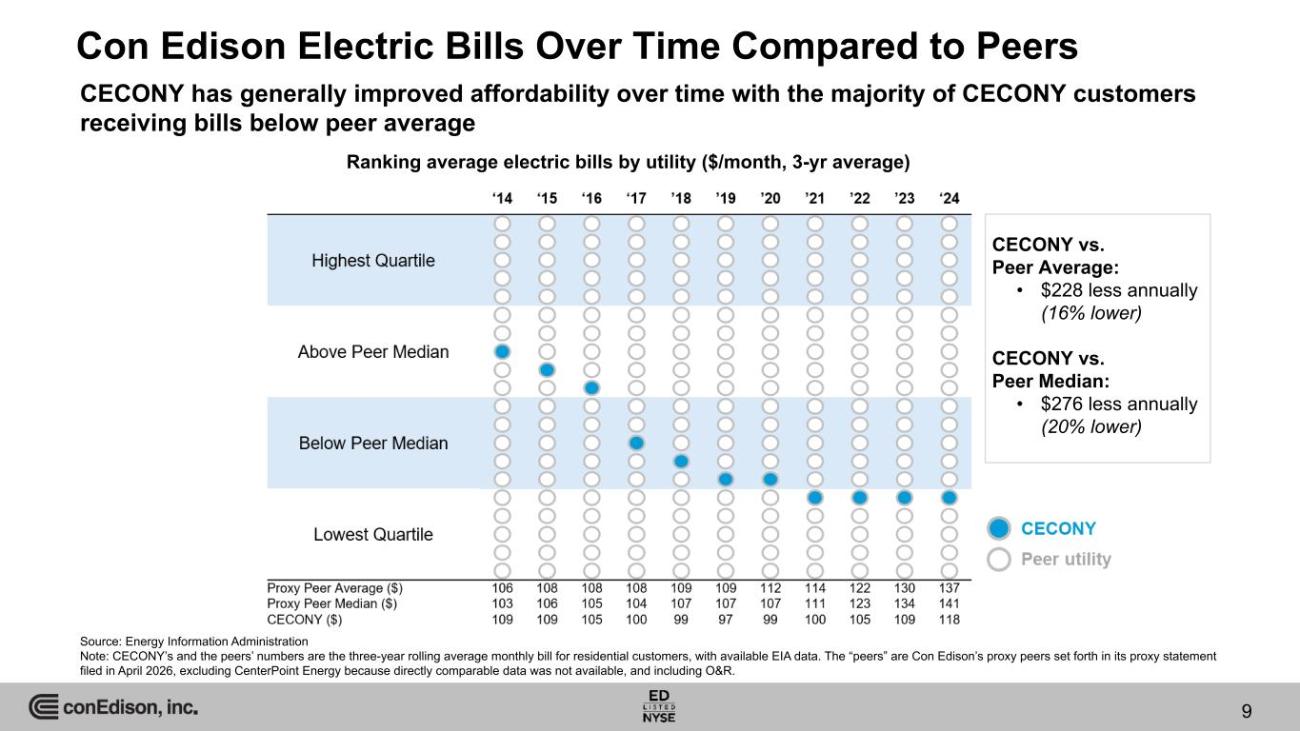
Con Edison Electric Bills Over Time Compared to Peers CECONY has generally improved affordability over time with the majority of CECONY customers receiving bills below peer average Source: Energy Information Administration Note: CECONY’s and the peers’ numbers are the three-year rolling average monthly bill for residential customers, with available EIA data. The “peers” are Con Edison’s proxy peers set forth in its proxy statement filed in April 2026, excluding CenterPoint Energy because directly comparable data was not available, and including O&R. 9 Ranking average electric bills by utility ($/month, 3-yr average) CECONY vs. Peer Average: • $228 less annually (16% lower) CECONY vs. Peer Median: • $276 less annually (20% lower)

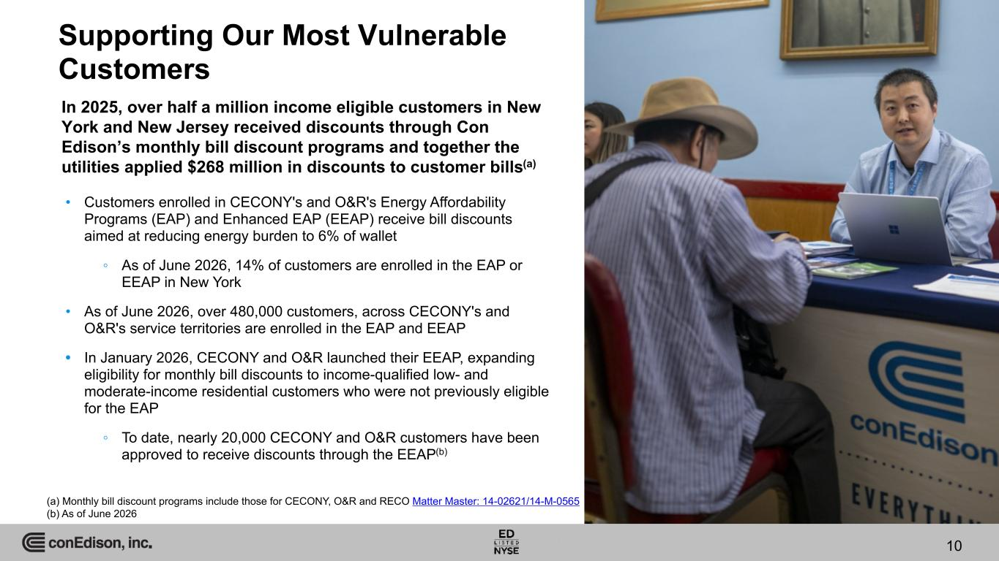
Supporting Our Most Vulnerable Customers In 2025, over half a million income eligible customers in New York and New Jersey received discounts through Con Edison’s monthly bill discount programs and together the utilities applied $268 million in discounts to customer bills(a) 10 • Customers enrolled in CECONY's and O&R's Energy Affordability Programs (EAP) and Enhanced EAP (EEAP) receive bill discounts aimed at reducing energy burden to 6% of wallet ◦ As of June 2026, 14% of customers are enrolled in the EAP or EEAP in New York • As of June 2026, over 480,000 customers, across CECONY's and O&R's service territories are enrolled in the EAP and EEAP • In January 2026, CECONY and O&R launched their EEAP, expanding eligibility for monthly bill discounts to income-qualified low- and moderate-income residential customers who were not previously eligible for the EAP ◦ To date, nearly 20,000 CECONY and O&R customers have been approved to receive discounts through the EEAP(b) (a) Monthly bill discount programs include those for CECONY, O&R and RECO Matter Master: 14-02621/14-M-0565 (b) As of June 2026

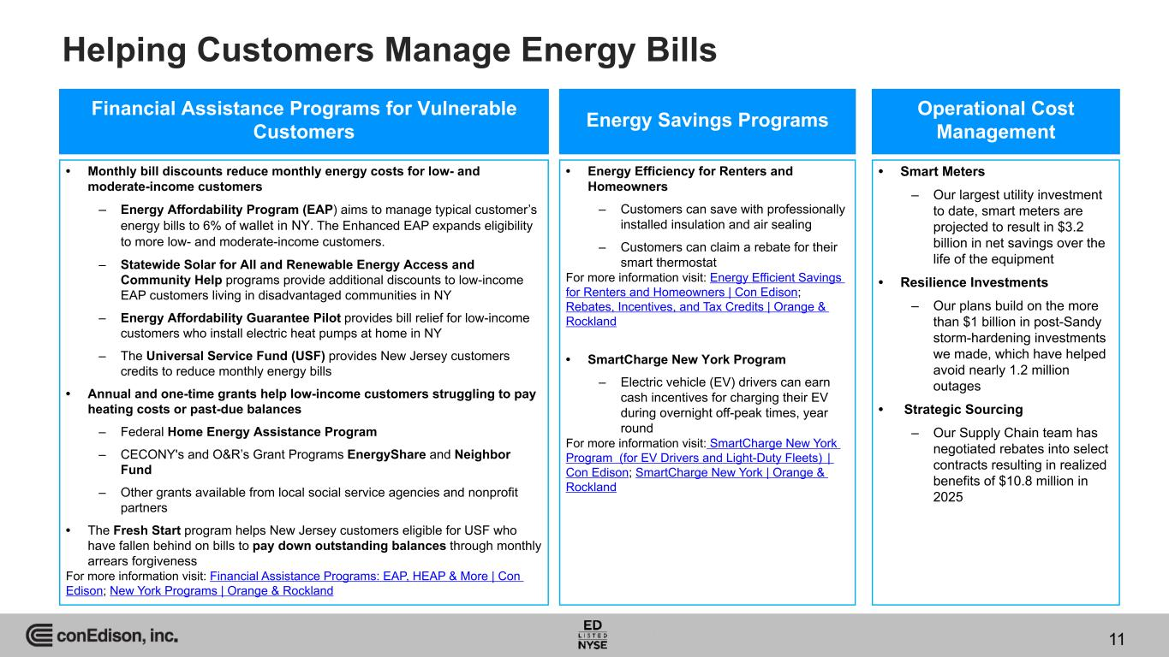
Helping Customers Manage Energy Bills 11 Financial Assistance Programs for Vulnerable Customers • Monthly bill discounts reduce monthly energy costs for low- and moderate-income customers – Energy Affordability Program (EAP) aims to manage typical customer’s energy bills to 6% of wallet in NY. The Enhanced EAP expands eligibility to more low- and moderate-income customers. – Statewide Solar for All and Renewable Energy Access and Community Help programs provide additional discounts to low-income EAP customers living in disadvantaged communities in NY – Energy Affordability Guarantee Pilot provides bill relief for low-income customers who install electric heat pumps at home in NY – The Universal Service Fund (USF) provides New Jersey customers credits to reduce monthly energy bills • Annual and one-time grants help low-income customers struggling to pay heating costs or past-due balances – Federal Home Energy Assistance Program – CECONY's and O&R’s Grant Programs EnergyShare and Neighbor Fund – Other grants available from local social service agencies and nonprofit partners • The Fresh Start program helps New Jersey customers eligible for USF who have fallen behind on bills to pay down outstanding balances through monthly arrears forgiveness For more information visit: Financial Assistance Programs: EAP, HEAP & More | Con Edison; New York Programs | Orange & Rockland Energy Savings Programs • Energy Efficiency for Renters and Homeowners – Customers can save with professionally installed insulation and air sealing – Customers can claim a rebate for their smart thermostat For more information visit: Energy Efficient Savings for Renters and Homeowners | Con Edison; Rebates, Incentives, and Tax Credits | Orange & Rockland • SmartCharge New York Program – Electric vehicle (EV) drivers can earn cash incentives for charging their EV during overnight off-peak times, year round For more information visit: SmartCharge New York Program (for EV Drivers and Light-Duty Fleets) | Con Edison; SmartCharge New York | Orange & Rockland Operational Cost Management • Smart Meters – Our largest utility investment to date, smart meters are projected to result in $3.2 billion in net savings over the life of the equipment • Resilience Investments – Our plans build on the more than $1 billion in post-Sandy storm-hardening investments we made, which have helped avoid nearly 1.2 million outages • Strategic Sourcing – Our Supply Chain team has negotiated rebates into select contracts resulting in realized benefits of $10.8 million in 2025

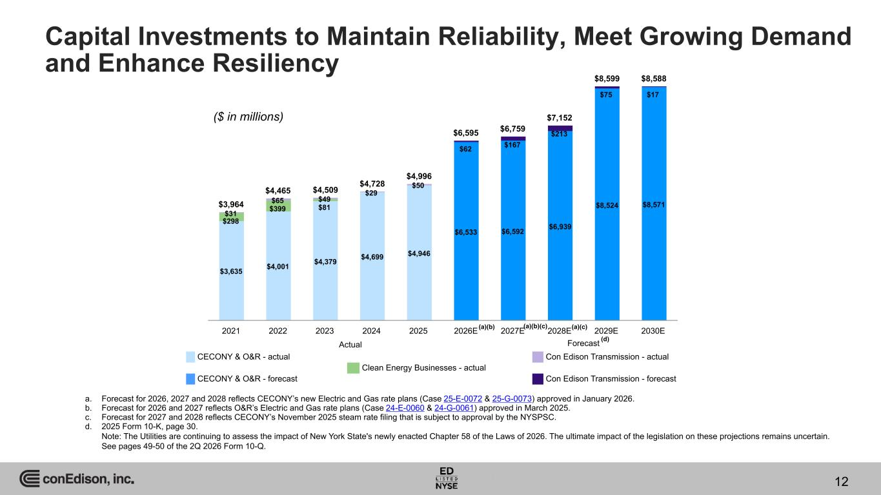
Capital Investments to Maintain Reliability, Meet Growing Demand and Enhance Resiliency $3,964 $4,465 $4,509 $4,728 $4,996 $6,595 $6,759 $7,152 $8,599 $8,588 $3,635 $4,001 $4,379 $4,699 $4,946 $6,533 $6,592 $6,939 $8,524 $8,571 $298 $399 $81 $31 $65 $49 $29 $50 $62 $167 $213 $75 $17 2021 2022 2023 2024 2025 2026E 2027E 2028E 2029E 2030E Actual Forecast (d) CECONY & O&R - actual Con Edison Transmission - actual Clean Energy Businesses - actual CECONY & O&R - forecast Con Edison Transmission - forecast a. Forecast for 2026, 2027 and 2028 reflects CECONY’s new Electric and Gas rate plans (Case 25-E-0072 & 25-G-0073) approved in January 2026. b. Forecast for 2026 and 2027 reflects O&R’s Electric and Gas rate plans (Case 24-E-0060 & 24-G-0061) approved in March 2025. c. Forecast for 2027 and 2028 reflects CECONY’s November 2025 steam rate filing that is subject to approval by the NYSPSC. d. 2025 Form 10-K, page 30. Note: The Utilities are continuing to assess the impact of New York State's newly enacted Chapter 58 of the Laws of 2026. The ultimate impact of the legislation on these projections remains uncertain. See pages 49-50 of the 2Q 2026 Form 10-Q. ($ in millions) 12 (a)(b)(c) (a)(c)(a)(b)

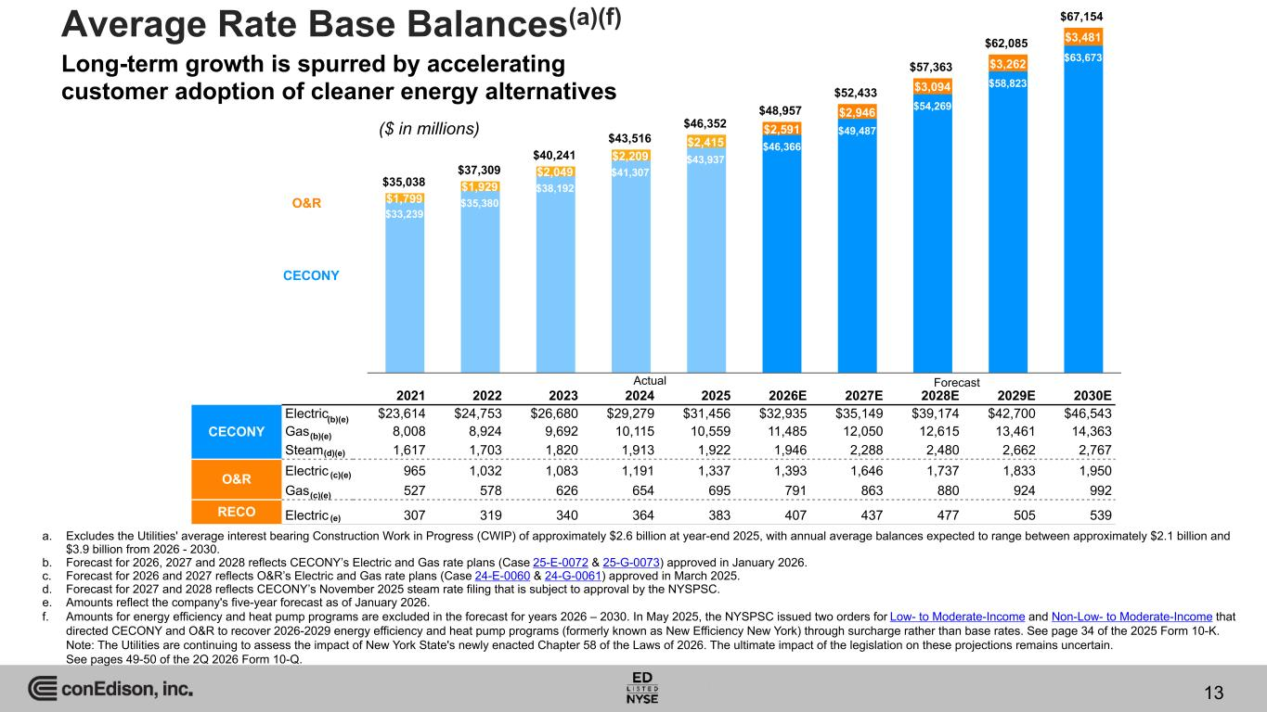
$35,038 $37,309 $40,241 $43,516 $46,352 $48,957 $52,433 $57,363 $62,085 $67,154 $33,239 $35,380 $38,192 $41,307 $43,937 $46,366 $49,487 $54,269 $58,823 $63,673 $1,799 $1,929 $2,049 $2,209 $2,415 $2,591 $2,946 $3,094 $3,262 $3,481Average Rate Base Balances(a)(f) O&R CECONY 2021 2022 2023 2024 2025 2026E 2027E 2028E 2029E 2030E CECONY Electric $23,614 $24,753 $26,680 $29,279 $31,456 $32,935 $35,149 $39,174 $42,700 $46,543 Gas 8,008 8,924 9,692 10,115 10,559 11,485 12,050 12,615 13,461 14,363 Steam 1,617 1,703 1,820 1,913 1,922 1,946 2,288 2,480 2,662 2,767 O&R Electric 965 1,032 1,083 1,191 1,337 1,393 1,646 1,737 1,833 1,950 Gas 527 578 626 654 695 791 863 880 924 992 RECO Electric 307 319 340 364 383 407 437 477 505 539 ForecastActual a. Excludes the Utilities' average interest bearing Construction Work in Progress (CWIP) of approximately $2.6 billion at year-end 2025, with annual average balances expected to range between approximately $2.1 billion and $3.9 billion from 2026 - 2030. b. Forecast for 2026, 2027 and 2028 reflects CECONY’s Electric and Gas rate plans (Case 25-E-0072 & 25-G-0073) approved in January 2026. c. Forecast for 2026 and 2027 reflects O&R’s Electric and Gas rate plans (Case 24-E-0060 & 24-G-0061) approved in March 2025. d. Forecast for 2027 and 2028 reflects CECONY’s November 2025 steam rate filing that is subject to approval by the NYSPSC. e. Amounts reflect the company's five-year forecast as of January 2026. f. Amounts for energy efficiency and heat pump programs are excluded in the forecast for years 2026 – 2030. In May 2025, the NYSPSC issued two orders for Low- to Moderate-Income and Non-Low- to Moderate-Income that directed CECONY and O&R to recover 2026-2029 energy efficiency and heat pump programs (formerly known as New Efficiency New York) through surcharge rather than base rates. See page 34 of the 2025 Form 10-K. Note: The Utilities are continuing to assess the impact of New York State's newly enacted Chapter 58 of the Laws of 2026. The ultimate impact of the legislation on these projections remains uncertain. See pages 49-50 of the 2Q 2026 Form 10-Q. (c)(e) (c)(e) (e) (b)(e) (b)(e) (d)(e) ($ in millions) 13 Long-term growth is spurred by accelerating customer adoption of cleaner energy alternatives

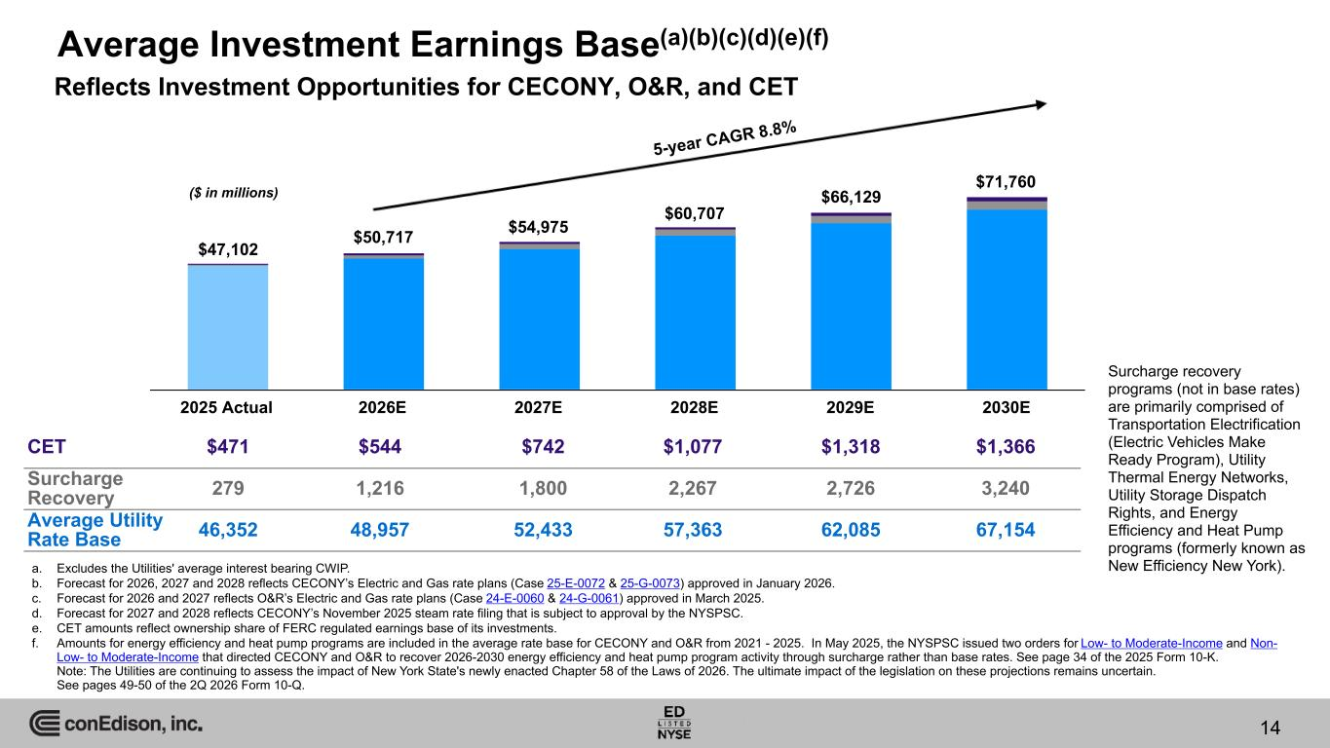
Average Investment Earnings Base(a)(b)(c)(d)(e)(f) 14 Reflects Investment Opportunities for CECONY, O&R, and CET $46,352 $48,957 $52,433 $57,363 $62,085 $67,154 2025 Actual 2026E 2027E 2028E 2029E 2030E ($ in millions) Surcharge recovery programs (not in base rates) are primarily comprised of Transportation Electrification (Electric Vehicles Make Ready Program), Utility Thermal Energy Networks, Utility Storage Dispatch Rights, and Energy Efficiency and Heat Pump programs (formerly known as New Efficiency New York).a. Excludes the Utilities' average interest bearing CWIP. b. Forecast for 2026, 2027 and 2028 reflects CECONY’s Electric and Gas rate plans (Case 25-E-0072 & 25-G-0073) approved in January 2026. c. Forecast for 2026 and 2027 reflects O&R’s Electric and Gas rate plans (Case 24-E-0060 & 24-G-0061) approved in March 2025. d. Forecast for 2027 and 2028 reflects CECONY’s November 2025 steam rate filing that is subject to approval by the NYSPSC. e. CET amounts reflect ownership share of FERC regulated earnings base of its investments. f. Amounts for energy efficiency and heat pump programs are included in the average rate base for CECONY and O&R from 2021 - 2025. In May 2025, the NYSPSC issued two orders for Low- to Moderate-Income and Non- Low- to Moderate-Income that directed CECONY and O&R to recover 2026-2030 energy efficiency and heat pump program activity through surcharge rather than base rates. See page 34 of the 2025 Form 10-K. Note: The Utilities are continuing to assess the impact of New York State's newly enacted Chapter 58 of the Laws of 2026. The ultimate impact of the legislation on these projections remains uncertain. See pages 49-50 of the 2Q 2026 Form 10-Q. 5-year CAGR 8.8% $47,102 $50,717 $54,975 $60,707 $66,129 $71,760 CET $471 $544 $742 $1,077 $1,318 $1,366 Surcharge Recovery 279 1,216 1,800 2,267 2,726 3,240 Average Utility Rate Base 46,352 48,957 52,433 57,363 62,085 67,154

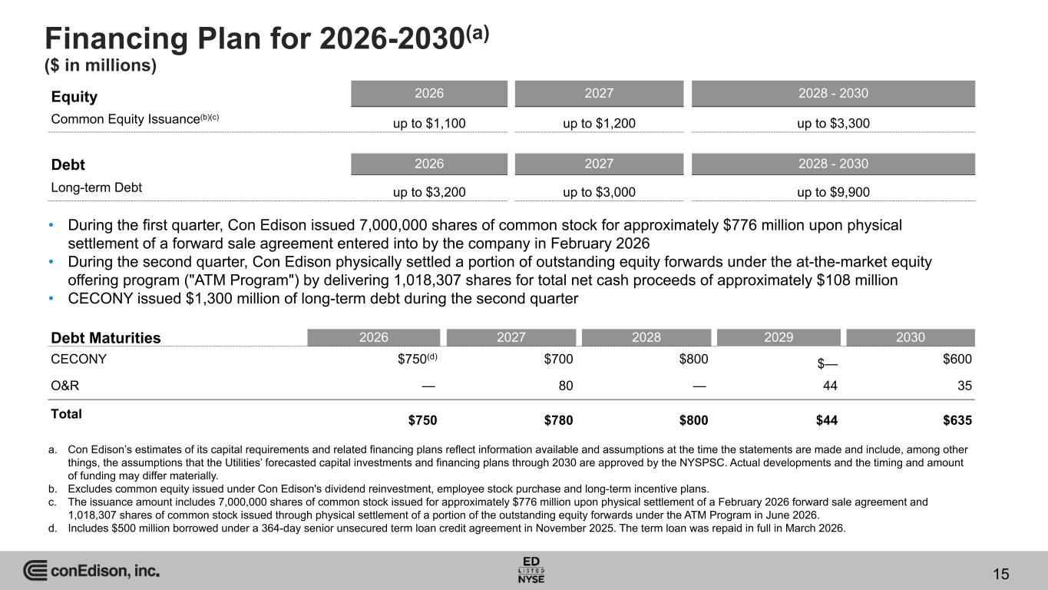
Financing Plan for 2026-2030(a) ($ in millions) Equity 2026 2027 2028 - 2030 Common Equity Issuance(b)(c) up to $1,100 up to $1,200 up to $3,300 Debt 2026 2027 2028 - 2030 Long-term Debt up to $3,200 up to $3,000 up to $9,900 a. Con Edison’s estimates of its capital requirements and related financing plans reflect information available and assumptions at the time the statements are made and include, among other things, the assumptions that the Utilities’ forecasted capital investments and financing plans through 2030 are approved by the NYSPSC. Actual developments and the timing and amount of funding may differ materially. b. Excludes common equity issued under Con Edison's dividend reinvestment, employee stock purchase and long-term incentive plans. c. The issuance amount includes 7,000,000 shares of common stock issued for approximately $776 million upon physical settlement of a February 2026 forward sale agreement and 1,018,307 shares of common stock issued through physical settlement of a portion of the outstanding equity forwards under the ATM Program in June 2026. d. Includes $500 million borrowed under a 364-day senior unsecured term loan credit agreement in November 2025. The term loan was repaid in full in March 2026. Debt Maturities 2026 2027 2028 2029 2030 CECONY $750(d) $700 $800 $— $600 O&R — 80 — 44 35 Total $750 $780 $800 $44 $635 15 • During the first quarter, Con Edison issued 7,000,000 shares of common stock for approximately $776 million upon physical settlement of a forward sale agreement entered into by the company in February 2026 • During the second quarter, Con Edison physically settled a portion of outstanding equity forwards under the at-the-market equity offering program ("ATM Program") by delivering 1,018,307 shares for total net cash proceeds of approximately $108 million • CECONY issued $1,300 million of long-term debt during the second quarter

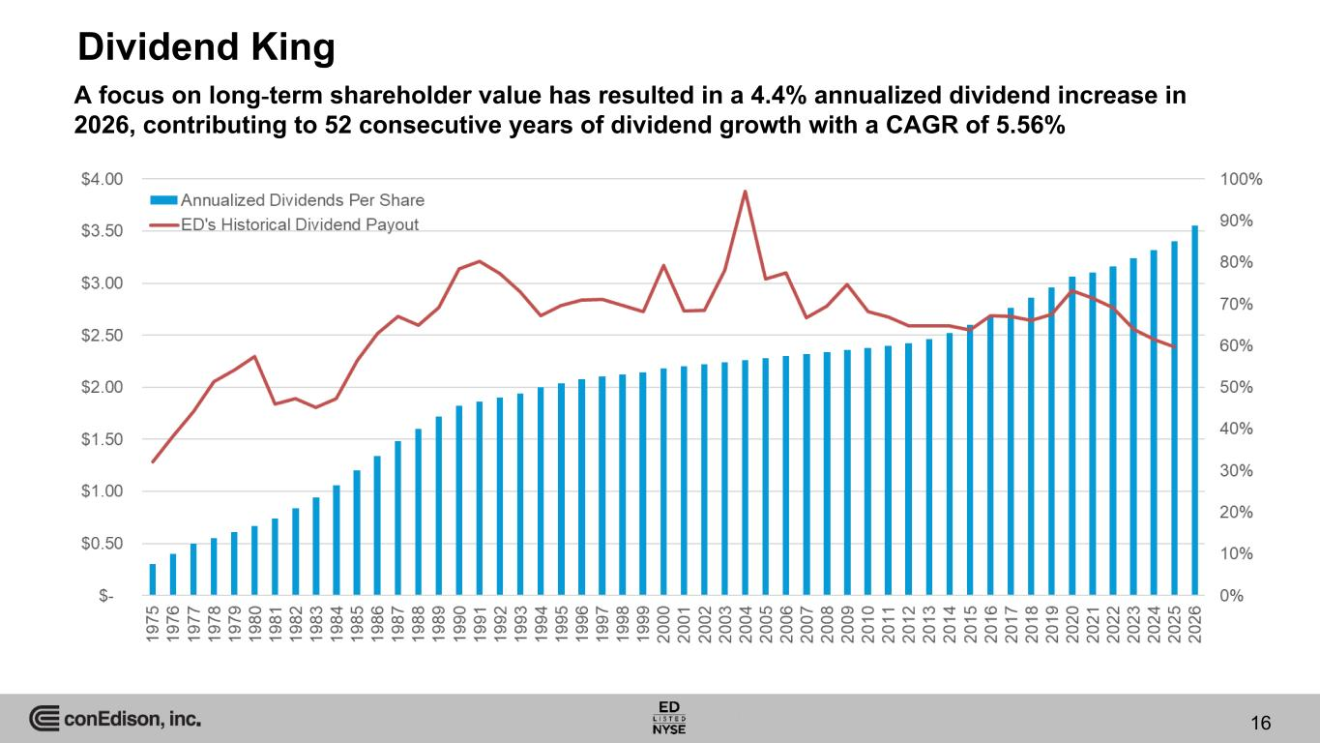
Dividend King A focus on long-term shareholder value has resulted in a 4.4% annualized dividend increase in 2026, contributing to 52 consecutive years of dividend growth with a CAGR of 5.56% 16

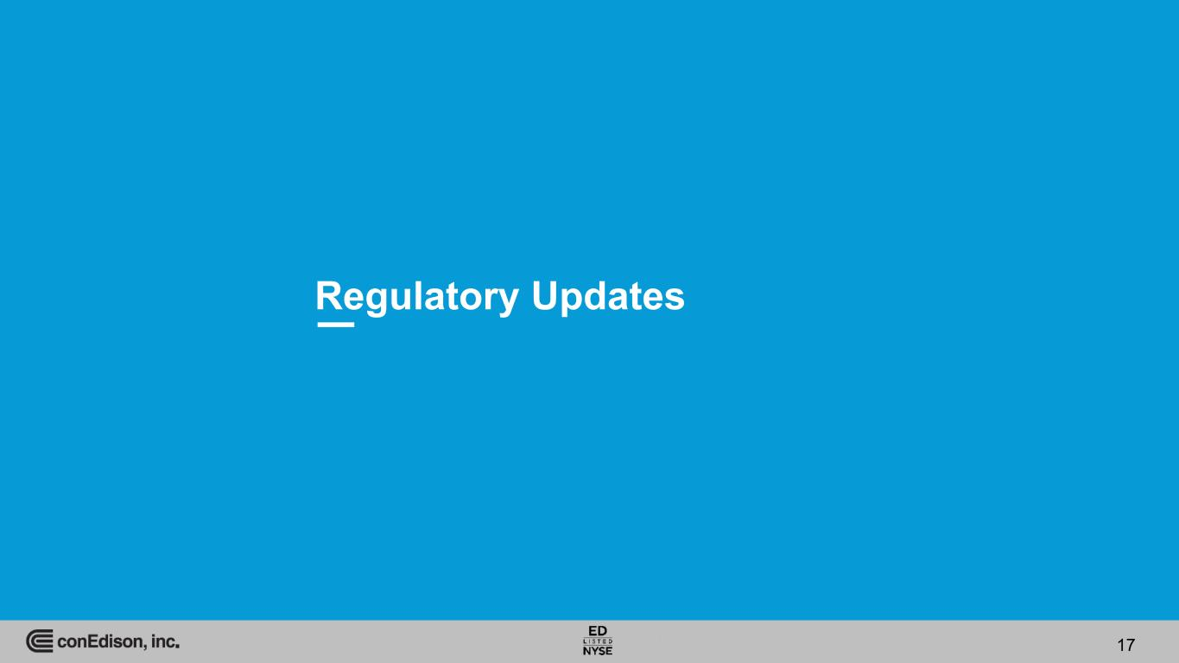
Regulatory Updates 17

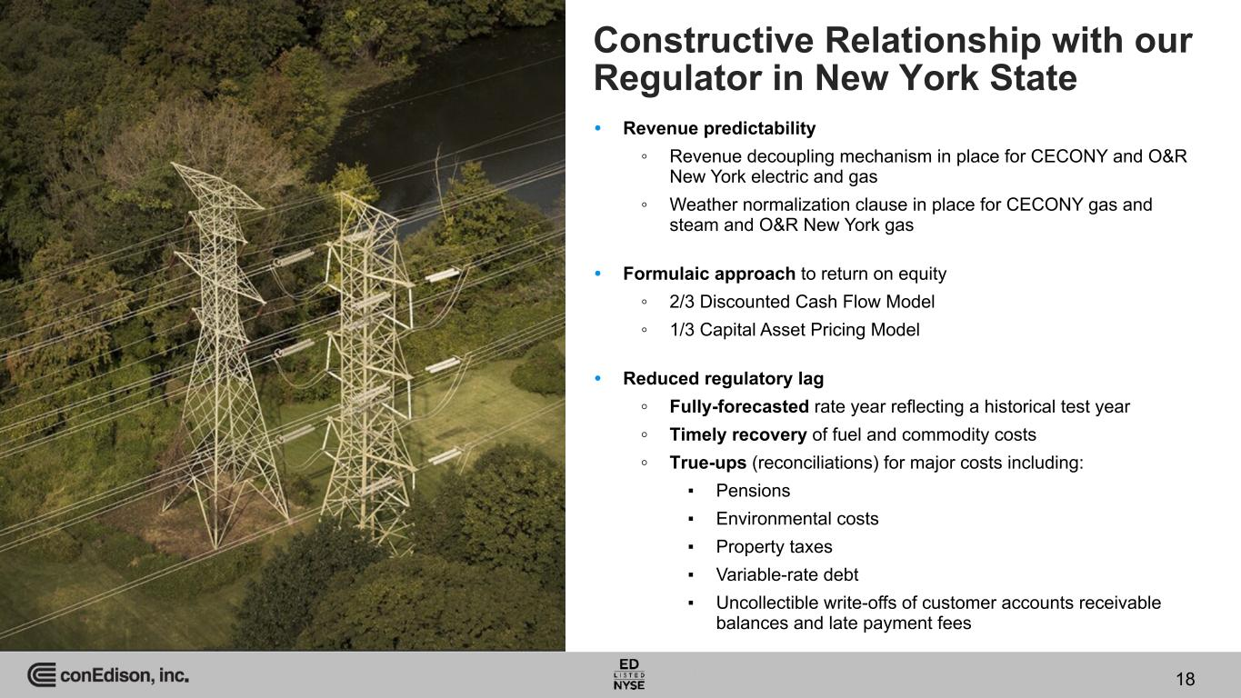
18 Constructive Relationship with our Regulator in New York State 18 • Revenue predictability ◦ Revenue decoupling mechanism in place for CECONY and O&R New York electric and gas ◦ Weather normalization clause in place for CECONY gas and steam and O&R New York gas • Formulaic approach to return on equity ◦ 2/3 Discounted Cash Flow Model ◦ 1/3 Capital Asset Pricing Model • Reduced regulatory lag ◦ Fully-forecasted rate year reflecting a historical test year ◦ Timely recovery of fuel and commodity costs ◦ True-ups (reconciliations) for major costs including: ▪ Pensions ▪ Environmental costs ▪ Property taxes ▪ Variable-rate debt ▪ Uncollectible write-offs of customer accounts receivable balances and late payment fees

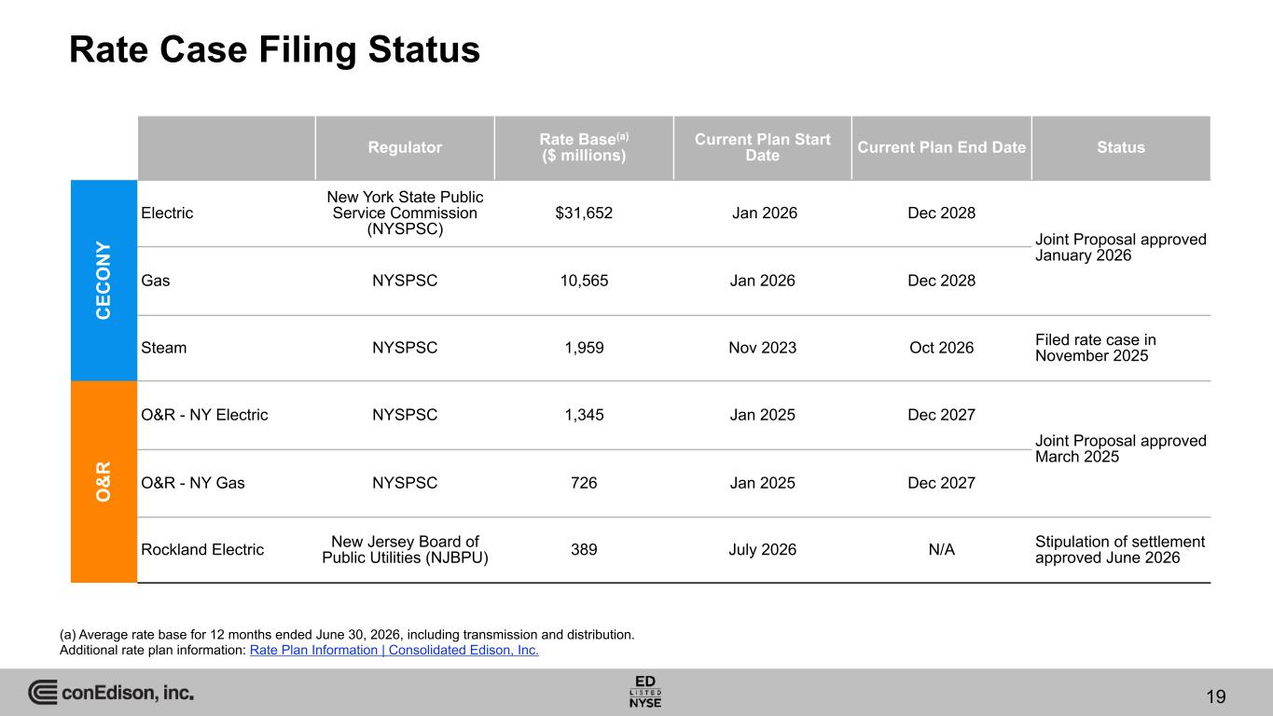
19 19 Rate Case Filing Status (a) Average rate base for 12 months ended June 30, 2026, including transmission and distribution. Additional rate plan information: Rate Plan Information | Consolidated Edison, Inc. Regulator Rate Base(a) ($ millions) Current Plan Start Date Current Plan End Date Status C EC O N Y Electric New York State Public Service Commission (NYSPSC) $31,652 Jan 2026 Dec 2028 Joint Proposal approved January 2026 Gas NYSPSC 10,565 Jan 2026 Dec 2028 Steam NYSPSC 1,959 Nov 2023 Oct 2026 Filed rate case in November 2025 O & R O&R - NY Electric NYSPSC 1,345 Jan 2025 Dec 2027 Joint Proposal approved March 2025 O&R - NY Gas NYSPSC 726 Jan 2025 Dec 2027 Rockland Electric New Jersey Board of Public Utilities (NJBPU) 389 July 2026 N/A Stipulation of settlement approved June 2026

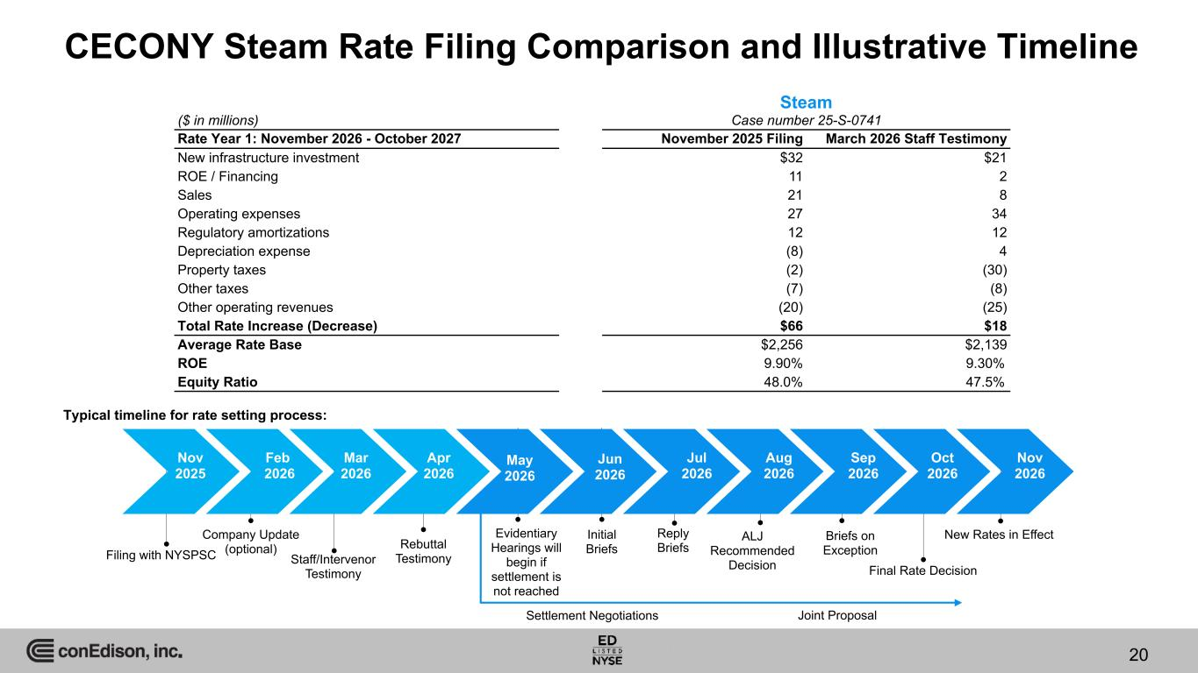
20 20 CECONY Steam Rate Filing Comparison and Illustrative Timeline Typical timeline for rate setting process: Nov 2025 Feb 2026 Mar 2026 Apr 2026 May 2026 Jun 2026 Jul 2026 Aug 2026 Sep 2026 Oct 2026 Nov 2026 Filing with NYSPSC Company Update (optional) Staff/Intervenor Testimony Rebuttal Testimony Settlement Negotiations New Rates in Effect Joint Proposal Evidentiary Hearings will begin if settlement is not reached Initial Briefs Reply Briefs ALJ Recommended Decision Briefs on Exception Final Rate Decision Steam ($ in millions) Case number 25-S-0741 Rate Year 1: November 2026 - October 2027 November 2025 Filing March 2026 Staff Testimony New infrastructure investment $32 $21 ROE / Financing 11 2 Sales 21 8 Operating expenses 27 34 Regulatory amortizations 12 12 Depreciation expense (8) 4 Property taxes (2) (30) Other taxes (7) (8) Other operating revenues (20) (25) Total Rate Increase (Decrease) $66 $18 Average Rate Base $2,256 $2,139 ROE 9.90% 9.30% Equity Ratio 48.0% 47.5%

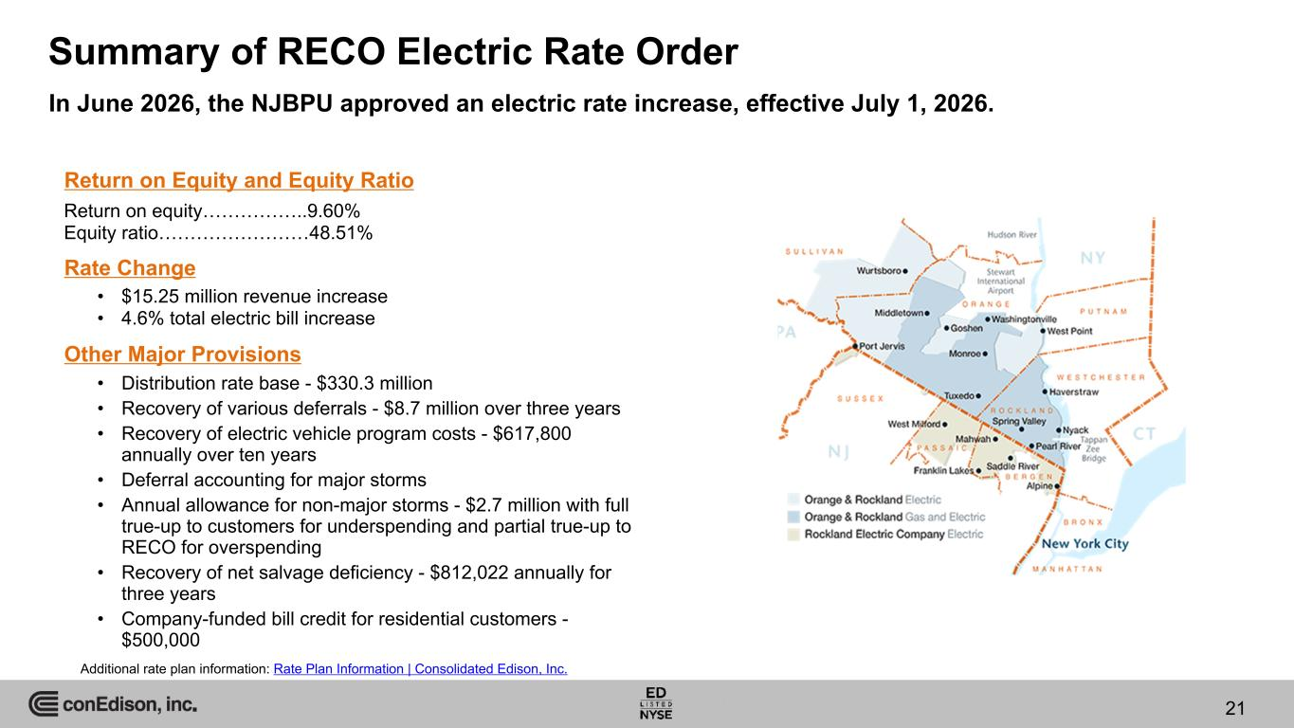
INTERNAL Summary of RECO Electric Rate Order Return on equity……………..9.60% Equity ratio……………………48.51% Rate Change Return on Equity and Equity Ratio Other Major Provisions In June 2026, the NJBPU approved an electric rate increase, effective July 1, 2026. Additional rate plan information: Rate Plan Information | Consolidated Edison, Inc. 21 • $15.25 million revenue increase • 4.6% total electric bill increase • Distribution rate base - $330.3 million • Recovery of various deferrals - $8.7 million over three years • Recovery of electric vehicle program costs - $617,800 annually over ten years • Deferral accounting for major storms • Annual allowance for non-major storms - $2.7 million with full true-up to customers for underspending and partial true-up to RECO for overspending • Recovery of net salvage deficiency - $812,022 annually for three years • Company-funded bill credit for residential customers - $500,000

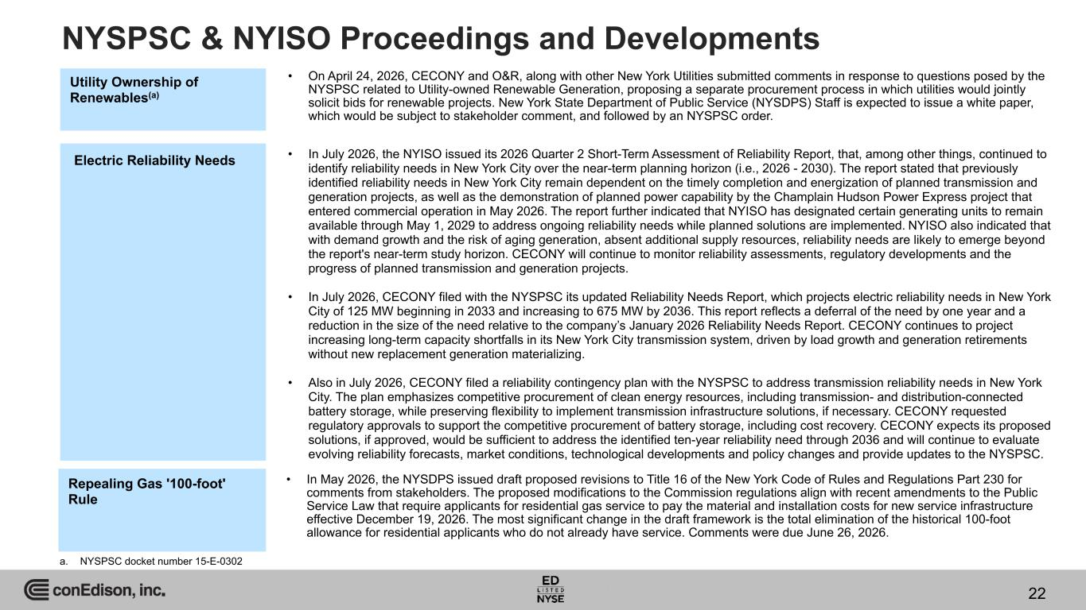
NYSPSC & NYISO Proceedings and Developments 22 a. NYSPSC docket number 15-E-0302 Utility Ownership of Renewables(a) • On April 24, 2026, CECONY and O&R, along with other New York Utilities submitted comments in response to questions posed by the NYSPSC related to Utility-owned Renewable Generation, proposing a separate procurement process in which utilities would jointly solicit bids for renewable projects. New York State Department of Public Service (NYSDPS) Staff is expected to issue a white paper, which would be subject to stakeholder comment, and followed by an NYSPSC order. • In July 2026, the NYISO issued its 2026 Quarter 2 Short-Term Assessment of Reliability Report, that, among other things, continued to identify reliability needs in New York City over the near-term planning horizon (i.e., 2026 - 2030). The report stated that previously identified reliability needs in New York City remain dependent on the timely completion and energization of planned transmission and generation projects, as well as the demonstration of planned power capability by the Champlain Hudson Power Express project that entered commercial operation in May 2026. The report further indicated that NYISO has designated certain generating units to remain available through May 1, 2029 to address ongoing reliability needs while planned solutions are implemented. NYISO also indicated that with demand growth and the risk of aging generation, absent additional supply resources, reliability needs are likely to emerge beyond the report's near-term study horizon. CECONY will continue to monitor reliability assessments, regulatory developments and the progress of planned transmission and generation projects. • In July 2026, CECONY filed with the NYSPSC its updated Reliability Needs Report, which projects electric reliability needs in New York City of 125 MW beginning in 2033 and increasing to 675 MW by 2036. This report reflects a deferral of the need by one year and a reduction in the size of the need relative to the company’s January 2026 Reliability Needs Report. CECONY continues to project increasing long-term capacity shortfalls in its New York City transmission system, driven by load growth and generation retirements without new replacement generation materializing. • Also in July 2026, CECONY filed a reliability contingency plan with the NYSPSC to address transmission reliability needs in New York City. The plan emphasizes competitive procurement of clean energy resources, including transmission- and distribution-connected battery storage, while preserving flexibility to implement transmission infrastructure solutions, if necessary. CECONY requested regulatory approvals to support the competitive procurement of battery storage, including cost recovery. CECONY expects its proposed solutions, if approved, would be sufficient to address the identified ten-year reliability need through 2036 and will continue to evaluate evolving reliability forecasts, market conditions, technological developments and policy changes and provide updates to the NYSPSC. Electric Reliability Needs Repealing Gas '100-foot' Rule • In May 2026, the NYSDPS issued draft proposed revisions to Title 16 of the New York Code of Rules and Regulations Part 230 for comments from stakeholders. The proposed modifications to the Commission regulations align with recent amendments to the Public Service Law that require applicants for residential gas service to pay the material and installation costs for new service infrastructure effective December 19, 2026. The most significant change in the draft framework is the total elimination of the historical 100-foot allowance for residential applicants who do not already have service. Comments were due June 26, 2026.

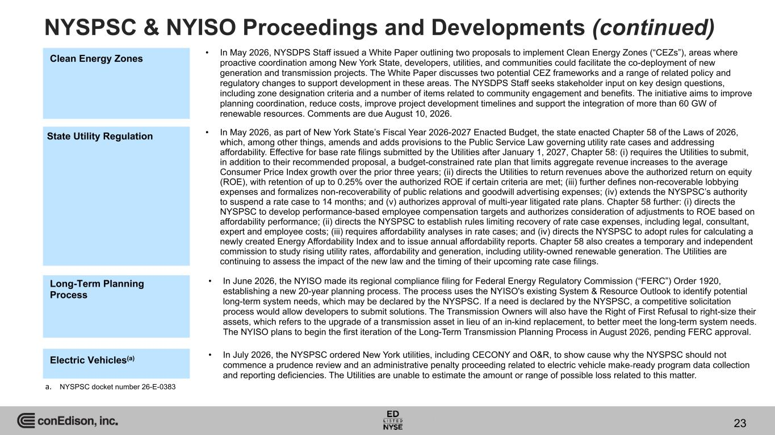
NYSPSC & NYISO Proceedings and Developments (continued) 23 Long-Term Planning Process • In June 2026, the NYISO made its regional compliance filing for Federal Energy Regulatory Commission (“FERC”) Order 1920, establishing a new 20-year planning process. The process uses the NYISO's existing System & Resource Outlook to identify potential long-term system needs, which may be declared by the NYSPSC. If a need is declared by the NYSPSC, a competitive solicitation process would allow developers to submit solutions. The Transmission Owners will also have the Right of First Refusal to right-size their assets, which refers to the upgrade of a transmission asset in lieu of an in-kind replacement, to better meet the long-term system needs. The NYISO plans to begin the first iteration of the Long-Term Transmission Planning Process in August 2026, pending FERC approval. Clean Energy Zones • In May 2026, NYSDPS Staff issued a White Paper outlining two proposals to implement Clean Energy Zones (“CEZs”), areas where proactive coordination among New York State, developers, utilities, and communities could facilitate the co-deployment of new generation and transmission projects. The White Paper discusses two potential CEZ frameworks and a range of related policy and regulatory changes to support development in these areas. The NYSDPS Staff seeks stakeholder input on key design questions, including zone designation criteria and a number of items related to community engagement and benefits. The initiative aims to improve planning coordination, reduce costs, improve project development timelines and support the integration of more than 60 GW of renewable resources. Comments are due August 10, 2026. State Utility Regulation • In May 2026, as part of New York State’s Fiscal Year 2026-2027 Enacted Budget, the state enacted Chapter 58 of the Laws of 2026, which, among other things, amends and adds provisions to the Public Service Law governing utility rate cases and addressing affordability. Effective for base rate filings submitted by the Utilities after January 1, 2027, Chapter 58: (i) requires the Utilities to submit, in addition to their recommended proposal, a budget-constrained rate plan that limits aggregate revenue increases to the average Consumer Price Index growth over the prior three years; (ii) directs the Utilities to return revenues above the authorized return on equity (ROE), with retention of up to 0.25% over the authorized ROE if certain criteria are met; (iii) further defines non-recoverable lobbying expenses and formalizes non-recoverability of public relations and goodwill advertising expenses; (iv) extends the NYSPSC’s authority to suspend a rate case to 14 months; and (v) authorizes approval of multi-year litigated rate plans. Chapter 58 further: (i) directs the NYSPSC to develop performance-based employee compensation targets and authorizes consideration of adjustments to ROE based on affordability performance; (ii) directs the NYSPSC to establish rules limiting recovery of rate case expenses, including legal, consultant, expert and employee costs; (iii) requires affordability analyses in rate cases; and (iv) directs the NYSPSC to adopt rules for calculating a newly created Energy Affordability Index and to issue annual affordability reports. Chapter 58 also creates a temporary and independent commission to study rising utility rates, affordability and generation, including utility-owned renewable generation. The Utilities are continuing to assess the impact of the new law and the timing of their upcoming rate case filings. Electric Vehicles(a) • In July 2026, the NYSPSC ordered New York utilities, including CECONY and O&R, to show cause why the NYSPSC should not commence a prudence review and an administrative penalty proceeding related to electric vehicle make-ready program data collection and reporting deficiencies. The Utilities are unable to estimate the amount or range of possible loss related to this matter. a. NYSPSC docket number 26-E-0383

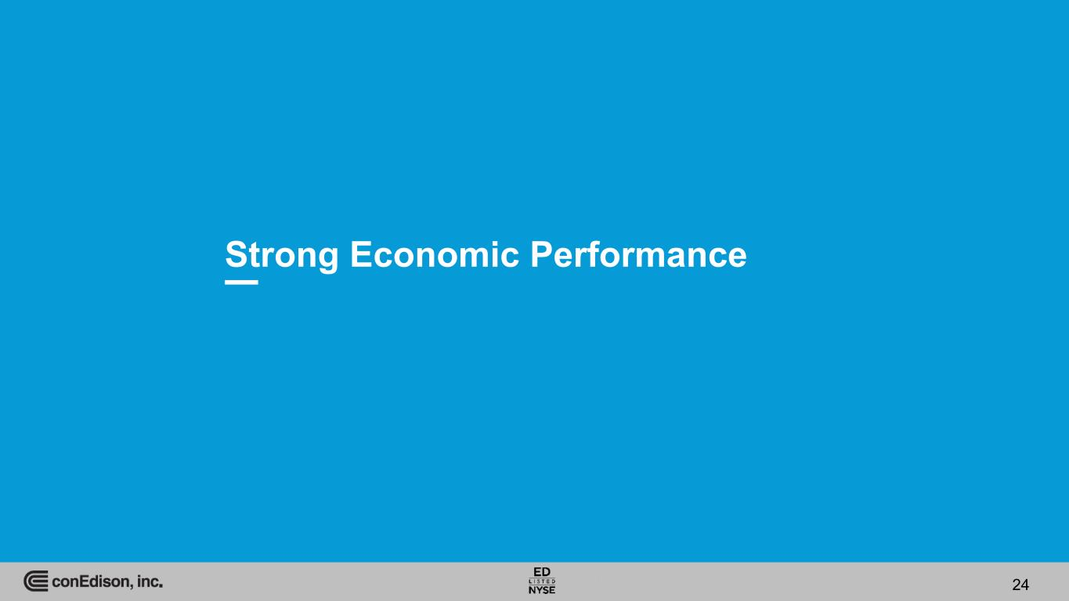
Strong Economic Performance 24

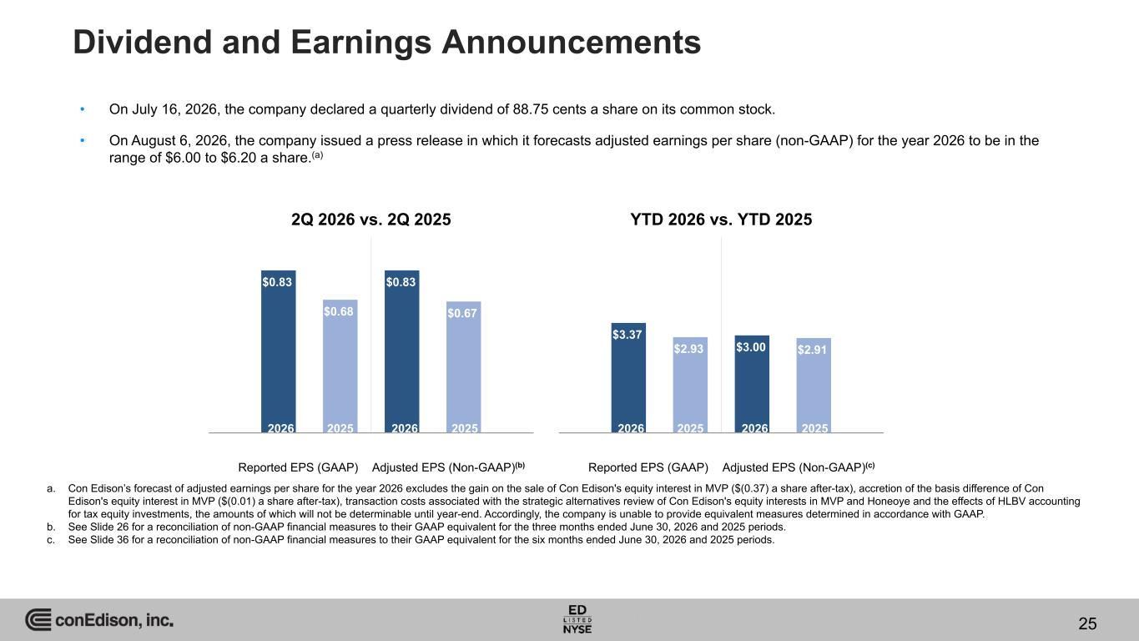
Dividend and Earnings Announcements • On July 16, 2026, the company declared a quarterly dividend of 88.75 cents a share on its common stock. • On August 6, 2026, the company issued a press release in which it forecasts adjusted earnings per share (non-GAAP) for the year 2026 to be in the range of $6.00 to $6.20 a share.(a) Reported EPS (GAAP) Adjusted EPS (Non-GAAP)(b) $0.83 $0.68 $0.83 $0.67 2026 2025 2026 2025 2Q 2026 vs. 2Q 2025 a. Con Edison’s forecast of adjusted earnings per share for the year 2026 excludes the gain on the sale of Con Edison's equity interest in MVP ($(0.37) a share after-tax), accretion of the basis difference of Con Edison's equity interest in MVP ($(0.01) a share after-tax), transaction costs associated with the strategic alternatives review of Con Edison's equity interests in MVP and Honeoye and the effects of HLBV accounting for tax equity investments, the amounts of which will not be determinable until year-end. Accordingly, the company is unable to provide equivalent measures determined in accordance with GAAP. b. See Slide 26 for a reconciliation of non-GAAP financial measures to their GAAP equivalent for the three months ended June 30, 2026 and 2025 periods. c. See Slide 36 for a reconciliation of non-GAAP financial measures to their GAAP equivalent for the six months ended June 30, 2026 and 2025 periods. 25 Reported EPS (GAAP) Adjusted EPS (Non-GAAP)(c) $3.37 $2.93 $3.00 $2.91 2026 2025 2026 2025 YTD 2026 vs. YTD 2025

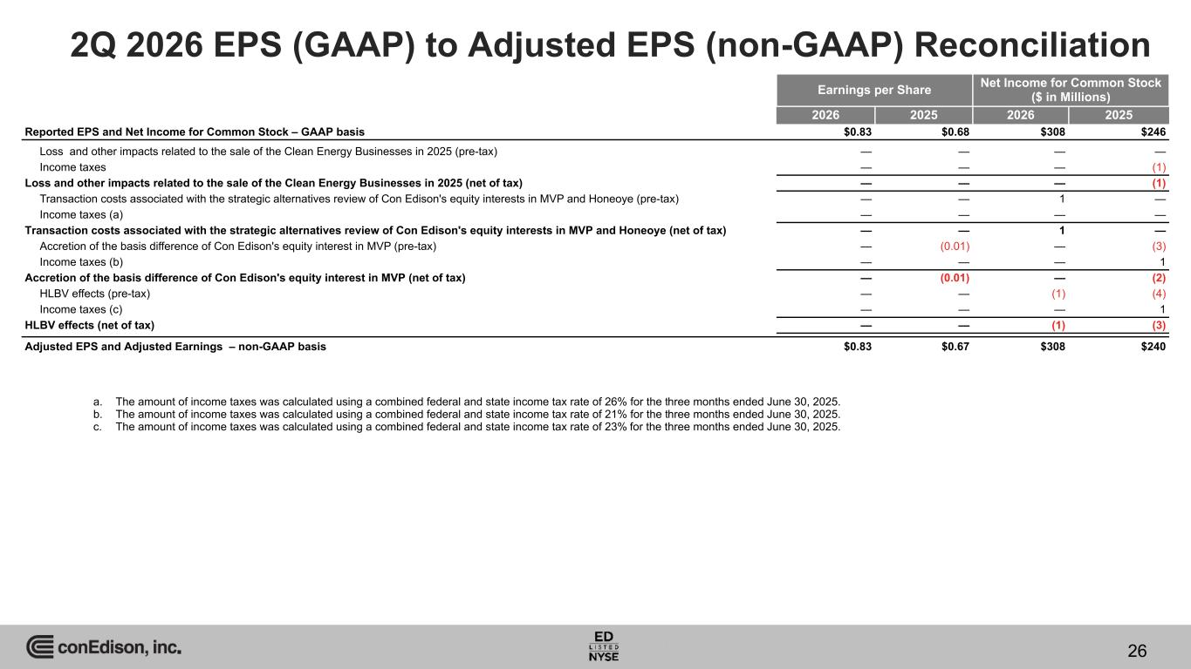
2Q 2026 EPS (GAAP) to Adjusted EPS (non-GAAP) Reconciliation Earnings per Share Net Income for Common Stock ($ in Millions) 2026 2025 2026 2025 Reported EPS and Net Income for Common Stock – GAAP basis $0.83 $0.68 $308 $246 Loss and other impacts related to the sale of the Clean Energy Businesses in 2025 (pre-tax) — — — — Income taxes — — — (1) Loss and other impacts related to the sale of the Clean Energy Businesses in 2025 (net of tax) — — — (1) Transaction costs associated with the strategic alternatives review of Con Edison's equity interests in MVP and Honeoye (pre-tax) — — 1 — Income taxes (a) — — — — Transaction costs associated with the strategic alternatives review of Con Edison's equity interests in MVP and Honeoye (net of tax) — — 1 — Accretion of the basis difference of Con Edison's equity interest in MVP (pre-tax) — (0.01) — (3) Income taxes (b) — — — 1 Accretion of the basis difference of Con Edison's equity interest in MVP (net of tax) — (0.01) — (2) HLBV effects (pre-tax) — — (1) (4) Income taxes (c) — — — 1 HLBV effects (net of tax) — — (1) (3) Adjusted EPS and Adjusted Earnings – non-GAAP basis $0.83 $0.67 $308 $240 a. The amount of income taxes was calculated using a combined federal and state income tax rate of 26% for the three months ended June 30, 2025. b. The amount of income taxes was calculated using a combined federal and state income tax rate of 21% for the three months ended June 30, 2025. c. The amount of income taxes was calculated using a combined federal and state income tax rate of 23% for the three months ended June 30, 2025. 26

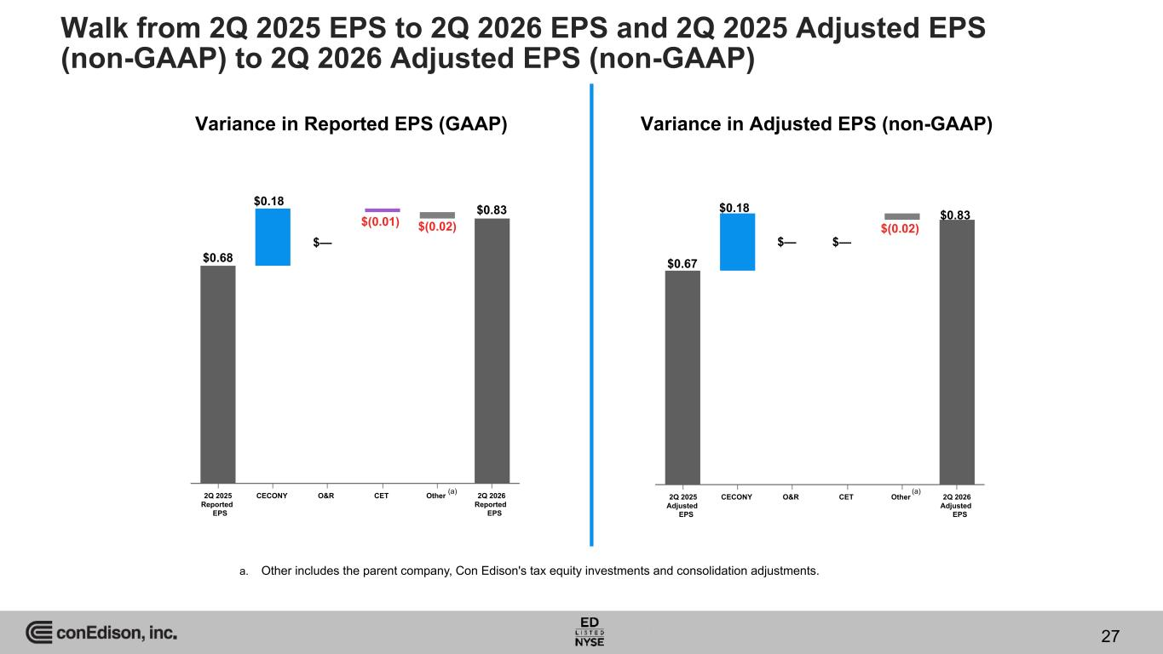
Variance in Reported EPS (GAAP) Variance in Adjusted EPS (non-GAAP) 2Q 2025 Reported EPS CECONY O&R CET Other 2Q 2026 Reported EPS $0.68 $0.18 $— $(0.01) $0.83 2Q 2025 Adjusted EPS CECONY O&R CET Other 2Q 2026 Adjusted EPS $0.67 $0.18 $— $(0.02) $0.83 (a) (a) $— $(0.02) a. Other includes the parent company, Con Edison's tax equity investments and consolidation adjustments. Walk from 2Q 2025 EPS to 2Q 2026 EPS and 2Q 2025 Adjusted EPS (non-GAAP) to 2Q 2026 Adjusted EPS (non-GAAP) 27

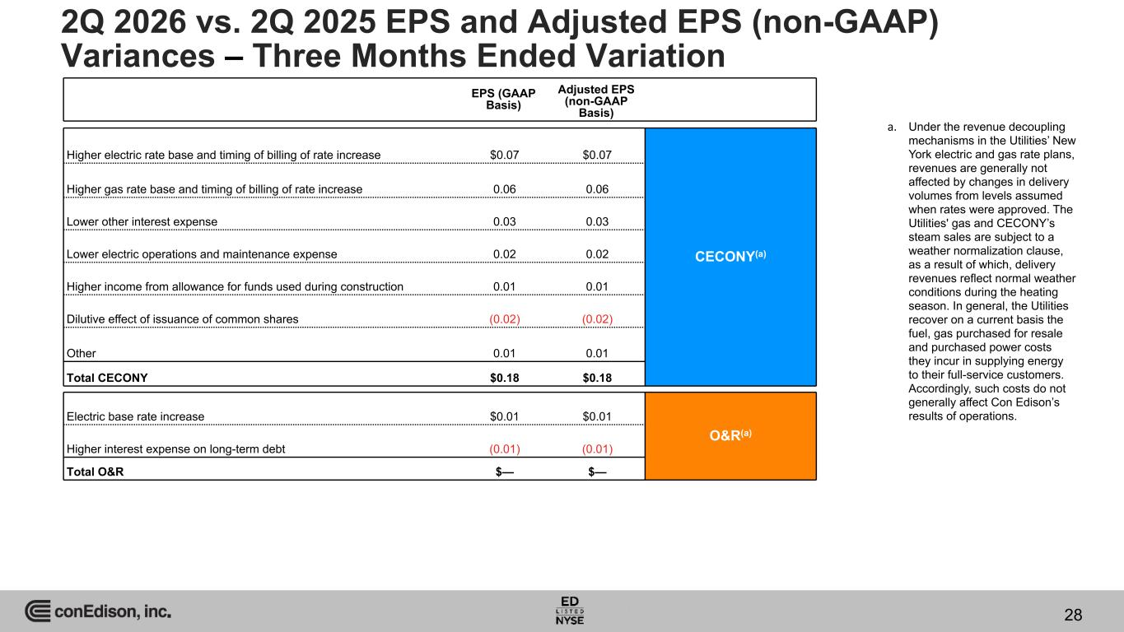
EPS (GAAP Basis) Adjusted EPS (non-GAAP Basis) Higher electric rate base and timing of billing of rate increase $0.07 $0.07 CECONY(a) Higher gas rate base and timing of billing of rate increase 0.06 0.06 Lower other interest expense 0.03 0.03 Lower electric operations and maintenance expense 0.02 0.02 Higher income from allowance for funds used during construction 0.01 0.01 Dilutive effect of issuance of common shares (0.02) (0.02) Other 0.01 0.01 Total CECONY $0.18 $0.18 Electric base rate increase $0.01 $0.01 O&R(a) Higher interest expense on long-term debt (0.01) (0.01) Total O&R $— $— 2Q 2026 vs. 2Q 2025 EPS and Adjusted EPS (non-GAAP) Variances – Three Months Ended Variation a. Under the revenue decoupling mechanisms in the Utilities’ New York electric and gas rate plans, revenues are generally not affected by changes in delivery volumes from levels assumed when rates were approved. The Utilities' gas and CECONY’s steam sales are subject to a weather normalization clause, as a result of which, delivery revenues reflect normal weather conditions during the heating season. In general, the Utilities recover on a current basis the fuel, gas purchased for resale and purchased power costs they incur in supplying energy to their full-service customers. Accordingly, such costs do not generally affect Con Edison’s results of operations. 28

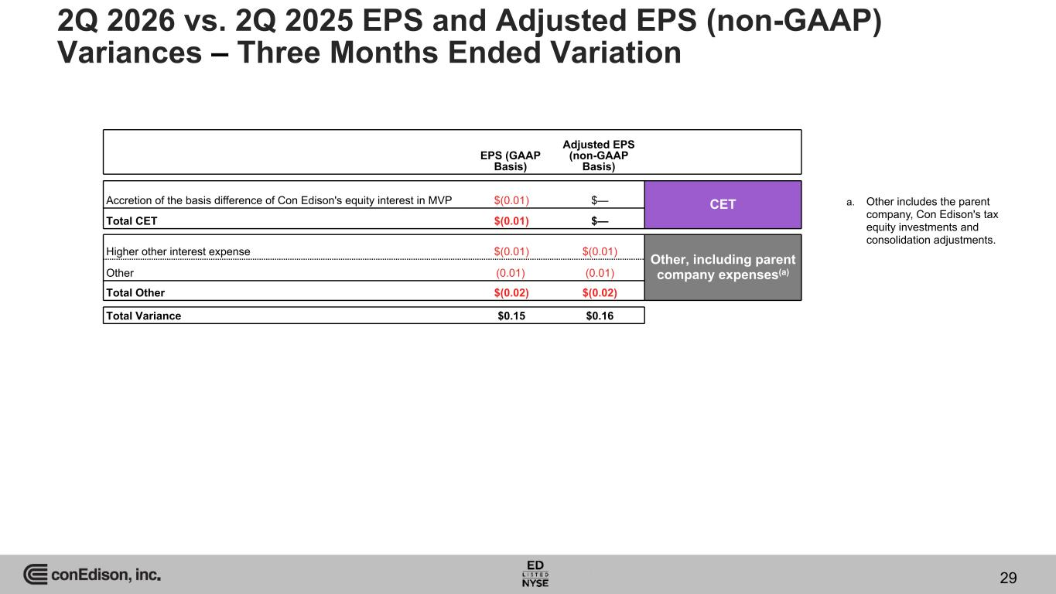
EPS (GAAP Basis) Adjusted EPS (non-GAAP Basis) Accretion of the basis difference of Con Edison's equity interest in MVP $(0.01) $— CET Total CET $(0.01) $— Higher other interest expense $(0.01) $(0.01) Other, including parent company expenses(a)Other (0.01) (0.01) Total Other $(0.02) $(0.02) Total Variance $0.15 $0.16 2Q 2026 vs. 2Q 2025 EPS and Adjusted EPS (non-GAAP) Variances – Three Months Ended Variation 29 a. Other includes the parent company, Con Edison's tax equity investments and consolidation adjustments.

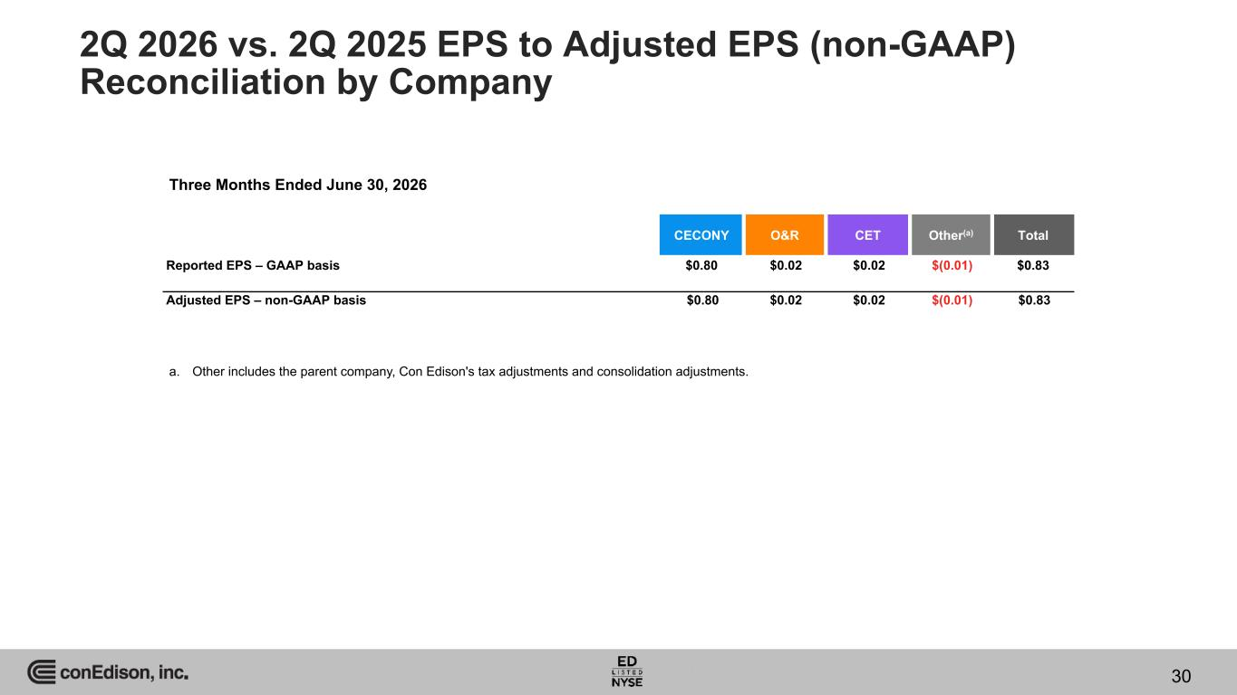
2Q 2026 vs. 2Q 2025 EPS to Adjusted EPS (non-GAAP) Reconciliation by Company CECONY O&R CET Other(a) Total Reported EPS – GAAP basis $0.80 $0.02 $0.02 $(0.01) $0.83 Adjusted EPS – non-GAAP basis $0.80 $0.02 $0.02 $(0.01) $0.83 Three Months Ended June 30, 2026 a. Other includes the parent company, Con Edison's tax adjustments and consolidation adjustments. 30

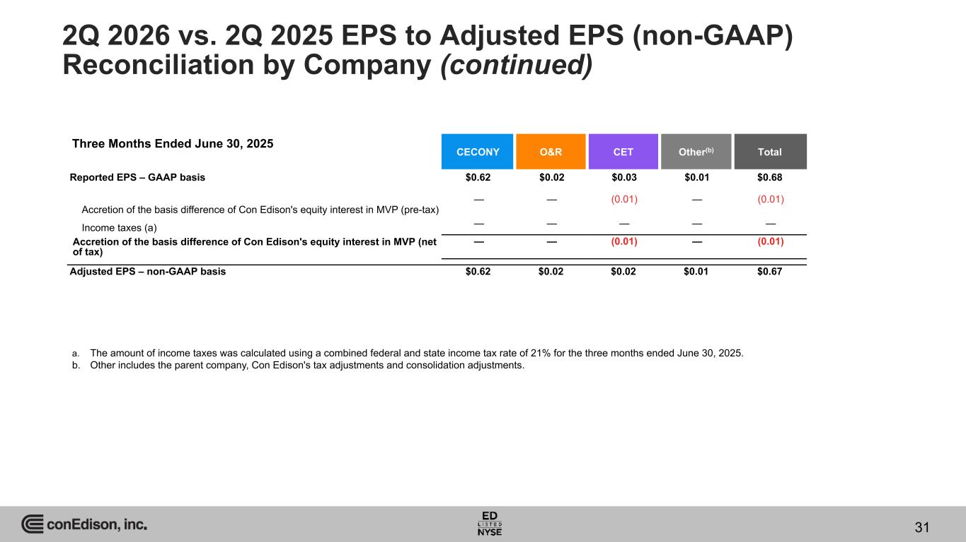
2Q 2026 vs. 2Q 2025 EPS to Adjusted EPS (non-GAAP) Reconciliation by Company (continued) CECONY O&R CET Other(b) Total Reported EPS – GAAP basis $0.62 $0.02 $0.03 $0.01 $0.68 Accretion of the basis difference of Con Edison's equity interest in MVP (pre-tax) — — (0.01) — (0.01) Income taxes (a) — — — — — Accretion of the basis difference of Con Edison's equity interest in MVP (net of tax) — — (0.01) — (0.01) Adjusted EPS – non-GAAP basis $0.62 $0.02 $0.02 $0.01 $0.67 Three Months Ended June 30, 2025 a. The amount of income taxes was calculated using a combined federal and state income tax rate of 21% for the three months ended June 30, 2025. b. Other includes the parent company, Con Edison's tax adjustments and consolidation adjustments. 31

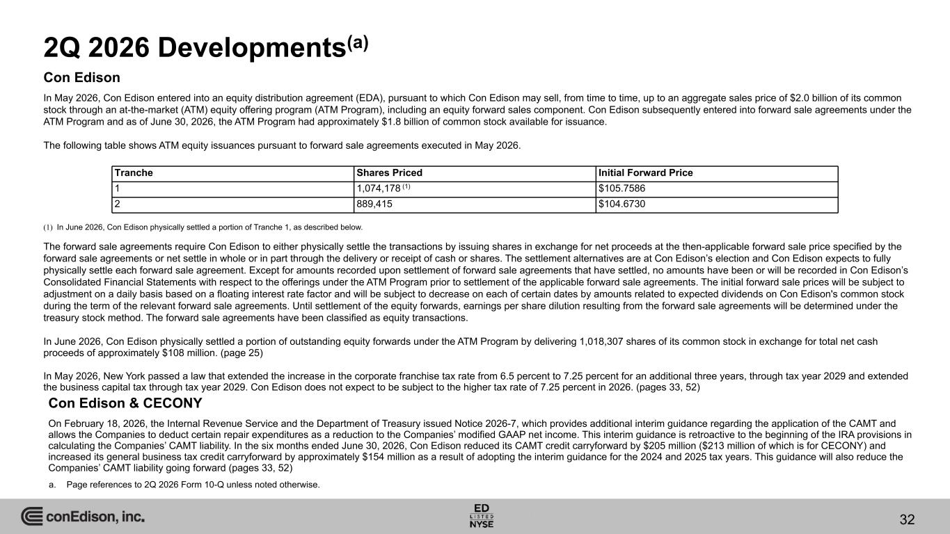
2Q 2026 Developments(a) Con Edison & CECONY On February 18, 2026, the Internal Revenue Service and the Department of Treasury issued Notice 2026-7, which provides additional interim guidance regarding the application of the CAMT and allows the Companies to deduct certain repair expenditures as a reduction to the Companies’ modified GAAP net income. This interim guidance is retroactive to the beginning of the IRA provisions in calculating the Companies’ CAMT liability. In the six months ended June 30, 2026, Con Edison reduced its CAMT credit carryforward by $205 million ($213 million of which is for CECONY) and increased its general business tax credit carryforward by approximately $154 million as a result of adopting the interim guidance for the 2024 and 2025 tax years. This guidance will also reduce the Companies’ CAMT liability going forward (pages 33, 52) a. Page references to 2Q 2026 Form 10-Q unless noted otherwise. 32 Con Edison In May 2026, Con Edison entered into an equity distribution agreement (EDA), pursuant to which Con Edison may sell, from time to time, up to an aggregate sales price of $2.0 billion of its common stock through an at-the-market (ATM) equity offering program (ATM Program), including an equity forward sales component. Con Edison subsequently entered into forward sale agreements under the ATM Program and as of June 30, 2026, the ATM Program had approximately $1.8 billion of common stock available for issuance. The following table shows ATM equity issuances pursuant to forward sale agreements executed in May 2026. (1) In June 2026, Con Edison physically settled a portion of Tranche 1, as described below. The forward sale agreements require Con Edison to either physically settle the transactions by issuing shares in exchange for net proceeds at the then-applicable forward sale price specified by the forward sale agreements or net settle in whole or in part through the delivery or receipt of cash or shares. The settlement alternatives are at Con Edison’s election and Con Edison expects to fully physically settle each forward sale agreement. Except for amounts recorded upon settlement of forward sale agreements that have settled, no amounts have been or will be recorded in Con Edison’s Consolidated Financial Statements with respect to the offerings under the ATM Program prior to settlement of the applicable forward sale agreements. The initial forward sale prices will be subject to adjustment on a daily basis based on a floating interest rate factor and will be subject to decrease on each of certain dates by amounts related to expected dividends on Con Edison's common stock during the term of the relevant forward sale agreements. Until settlement of the equity forwards, earnings per share dilution resulting from the forward sale agreements will be determined under the treasury stock method. The forward sale agreements have been classified as equity transactions. In June 2026, Con Edison physically settled a portion of outstanding equity forwards under the ATM Program by delivering 1,018,307 shares of its common stock in exchange for total net cash proceeds of approximately $108 million. (page 25) In May 2026, New York passed a law that extended the increase in the corporate franchise tax rate from 6.5 percent to 7.25 percent for an additional three years, through tax year 2029 and extended the business capital tax through tax year 2029. Con Edison does not expect to be subject to the higher tax rate of 7.25 percent in 2026. (pages 33, 52) Tranche Shares Priced Initial Forward Price 1 1,074,178 (1) $105.7586 2 889,415 $104.6730

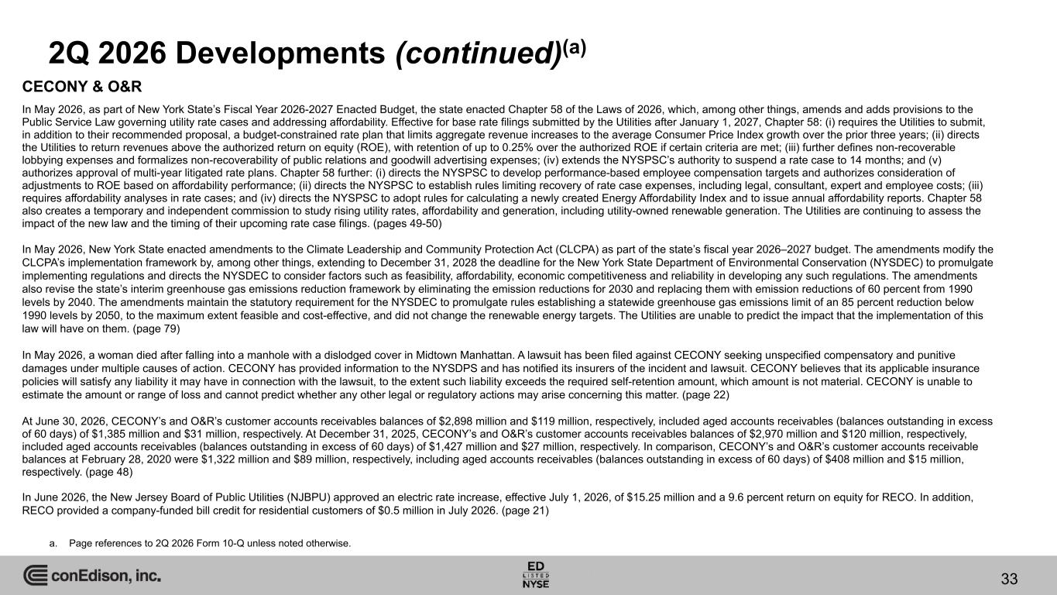
33 2Q 2026 Developments (continued)(a) a. Page references to 2Q 2026 Form 10-Q unless noted otherwise. CECONY & O&R In May 2026, as part of New York State’s Fiscal Year 2026-2027 Enacted Budget, the state enacted Chapter 58 of the Laws of 2026, which, among other things, amends and adds provisions to the Public Service Law governing utility rate cases and addressing affordability. Effective for base rate filings submitted by the Utilities after January 1, 2027, Chapter 58: (i) requires the Utilities to submit, in addition to their recommended proposal, a budget-constrained rate plan that limits aggregate revenue increases to the average Consumer Price Index growth over the prior three years; (ii) directs the Utilities to return revenues above the authorized return on equity (ROE), with retention of up to 0.25% over the authorized ROE if certain criteria are met; (iii) further defines non-recoverable lobbying expenses and formalizes non-recoverability of public relations and goodwill advertising expenses; (iv) extends the NYSPSC’s authority to suspend a rate case to 14 months; and (v) authorizes approval of multi-year litigated rate plans. Chapter 58 further: (i) directs the NYSPSC to develop performance-based employee compensation targets and authorizes consideration of adjustments to ROE based on affordability performance; (ii) directs the NYSPSC to establish rules limiting recovery of rate case expenses, including legal, consultant, expert and employee costs; (iii) requires affordability analyses in rate cases; and (iv) directs the NYSPSC to adopt rules for calculating a newly created Energy Affordability Index and to issue annual affordability reports. Chapter 58 also creates a temporary and independent commission to study rising utility rates, affordability and generation, including utility-owned renewable generation. The Utilities are continuing to assess the impact of the new law and the timing of their upcoming rate case filings. (pages 49-50) In May 2026, New York State enacted amendments to the Climate Leadership and Community Protection Act (CLCPA) as part of the state’s fiscal year 2026–2027 budget. The amendments modify the CLCPA’s implementation framework by, among other things, extending to December 31, 2028 the deadline for the New York State Department of Environmental Conservation (NYSDEC) to promulgate implementing regulations and directs the NYSDEC to consider factors such as feasibility, affordability, economic competitiveness and reliability in developing any such regulations. The amendments also revise the state’s interim greenhouse gas emissions reduction framework by eliminating the emission reductions for 2030 and replacing them with emission reductions of 60 percent from 1990 levels by 2040. The amendments maintain the statutory requirement for the NYSDEC to promulgate rules establishing a statewide greenhouse gas emissions limit of an 85 percent reduction below 1990 levels by 2050, to the maximum extent feasible and cost-effective, and did not change the renewable energy targets. The Utilities are unable to predict the impact that the implementation of this law will have on them. (page 79) In May 2026, a woman died after falling into a manhole with a dislodged cover in Midtown Manhattan. A lawsuit has been filed against CECONY seeking unspecified compensatory and punitive damages under multiple causes of action. CECONY has provided information to the NYSDPS and has notified its insurers of the incident and lawsuit. CECONY believes that its applicable insurance policies will satisfy any liability it may have in connection with the lawsuit, to the extent such liability exceeds the required self-retention amount, which amount is not material. CECONY is unable to estimate the amount or range of loss and cannot predict whether any other legal or regulatory actions may arise concerning this matter. (page 22) At June 30, 2026, CECONY’s and O&R’s customer accounts receivables balances of $2,898 million and $119 million, respectively, included aged accounts receivables (balances outstanding in excess of 60 days) of $1,385 million and $31 million, respectively. At December 31, 2025, CECONY’s and O&R’s customer accounts receivables balances of $2,970 million and $120 million, respectively, included aged accounts receivables (balances outstanding in excess of 60 days) of $1,427 million and $27 million, respectively. In comparison, CECONY’s and O&R’s customer accounts receivable balances at February 28, 2020 were $1,322 million and $89 million, respectively, including aged accounts receivables (balances outstanding in excess of 60 days) of $408 million and $15 million, respectively. (page 48) In June 2026, the New Jersey Board of Public Utilities (NJBPU) approved an electric rate increase, effective July 1, 2026, of $15.25 million and a 9.6 percent return on equity for RECO. In addition, RECO provided a company-funded bill credit for residential customers of $0.5 million in July 2026. (page 21)

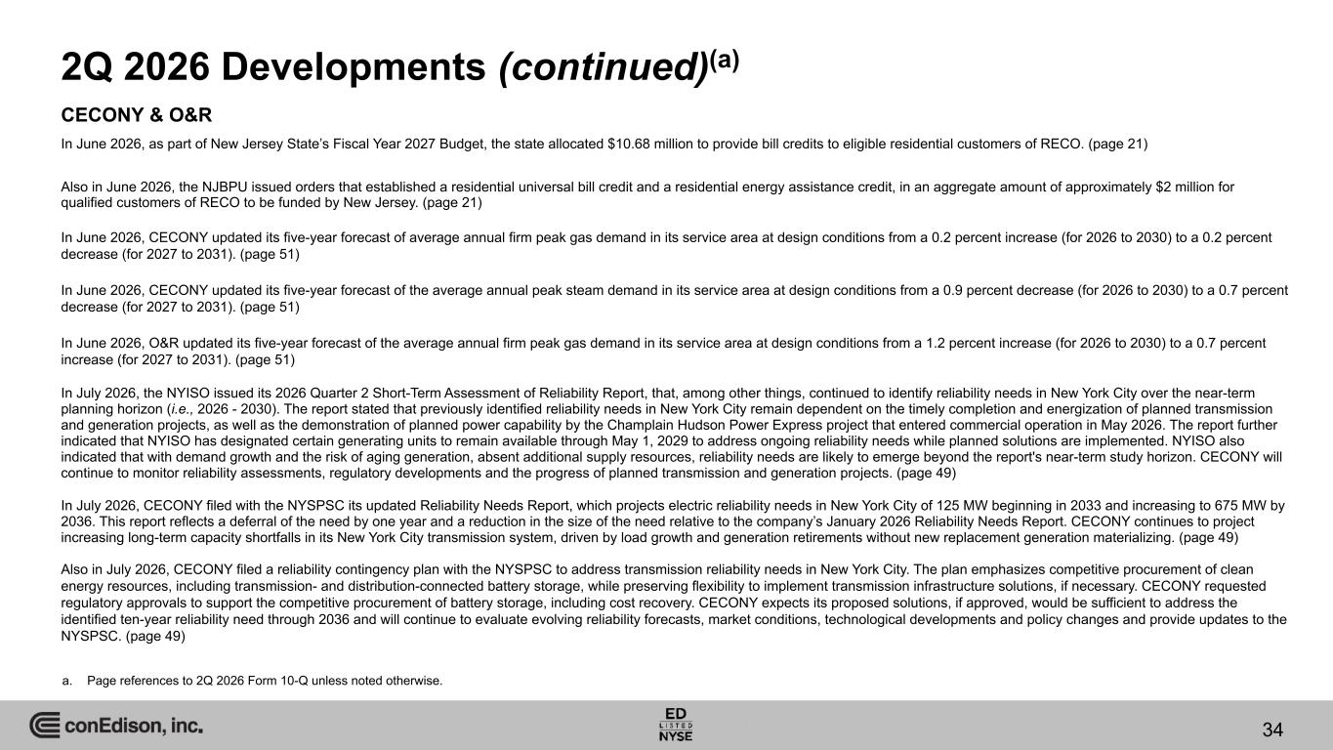
34 2Q 2026 Developments (continued)(a) a. Page references to 2Q 2026 Form 10-Q unless noted otherwise. CECONY & O&R In June 2026, as part of New Jersey State’s Fiscal Year 2027 Budget, the state allocated $10.68 million to provide bill credits to eligible residential customers of RECO. (page 21) Also in June 2026, the NJBPU issued orders that established a residential universal bill credit and a residential energy assistance credit, in an aggregate amount of approximately $2 million for qualified customers of RECO to be funded by New Jersey. (page 21) In June 2026, CECONY updated its five-year forecast of average annual firm peak gas demand in its service area at design conditions from a 0.2 percent increase (for 2026 to 2030) to a 0.2 percent decrease (for 2027 to 2031). (page 51) In June 2026, CECONY updated its five-year forecast of the average annual peak steam demand in its service area at design conditions from a 0.9 percent decrease (for 2026 to 2030) to a 0.7 percent decrease (for 2027 to 2031). (page 51) In June 2026, O&R updated its five-year forecast of the average annual firm peak gas demand in its service area at design conditions from a 1.2 percent increase (for 2026 to 2030) to a 0.7 percent increase (for 2027 to 2031). (page 51) In July 2026, the NYISO issued its 2026 Quarter 2 Short-Term Assessment of Reliability Report, that, among other things, continued to identify reliability needs in New York City over the near-term planning horizon (i.e., 2026 - 2030). The report stated that previously identified reliability needs in New York City remain dependent on the timely completion and energization of planned transmission and generation projects, as well as the demonstration of planned power capability by the Champlain Hudson Power Express project that entered commercial operation in May 2026. The report further indicated that NYISO has designated certain generating units to remain available through May 1, 2029 to address ongoing reliability needs while planned solutions are implemented. NYISO also indicated that with demand growth and the risk of aging generation, absent additional supply resources, reliability needs are likely to emerge beyond the report's near-term study horizon. CECONY will continue to monitor reliability assessments, regulatory developments and the progress of planned transmission and generation projects. (page 49) In July 2026, CECONY filed with the NYSPSC its updated Reliability Needs Report, which projects electric reliability needs in New York City of 125 MW beginning in 2033 and increasing to 675 MW by 2036. This report reflects a deferral of the need by one year and a reduction in the size of the need relative to the company’s January 2026 Reliability Needs Report. CECONY continues to project increasing long-term capacity shortfalls in its New York City transmission system, driven by load growth and generation retirements without new replacement generation materializing. (page 49) Also in July 2026, CECONY filed a reliability contingency plan with the NYSPSC to address transmission reliability needs in New York City. The plan emphasizes competitive procurement of clean energy resources, including transmission- and distribution-connected battery storage, while preserving flexibility to implement transmission infrastructure solutions, if necessary. CECONY requested regulatory approvals to support the competitive procurement of battery storage, including cost recovery. CECONY expects its proposed solutions, if approved, would be sufficient to address the identified ten-year reliability need through 2036 and will continue to evaluate evolving reliability forecasts, market conditions, technological developments and policy changes and provide updates to the NYSPSC. (page 49)

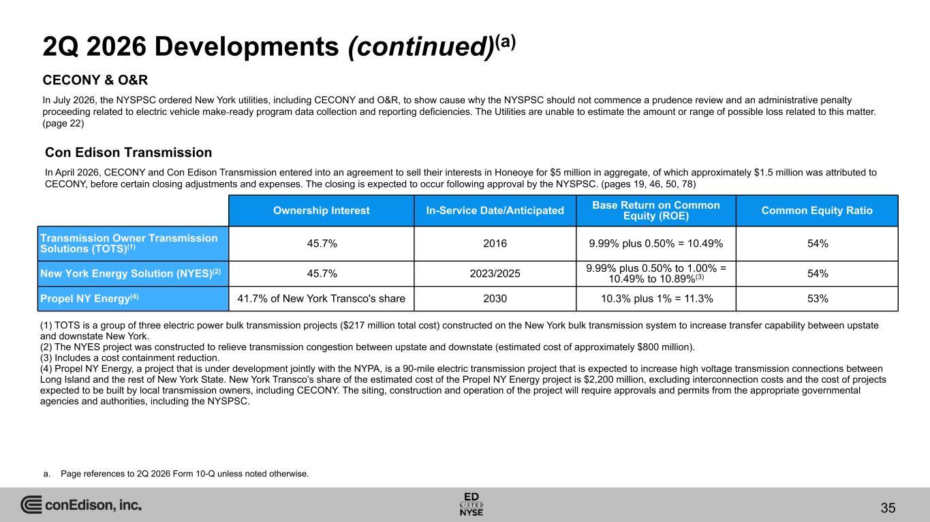
Con Edison Transmission In April 2026, CECONY and Con Edison Transmission entered into an agreement to sell their interests in Honeoye for $5 million in aggregate, of which approximately $1.5 million was attributed to CECONY, before certain closing adjustments and expenses. The closing is expected to occur following approval by the NYSPSC. (pages 19, 46, 50, 78) 35 (1) TOTS is a group of three electric power bulk transmission projects ($217 million total cost) constructed on the New York bulk transmission system to increase transfer capability between upstate and downstate New York. (2) The NYES project was constructed to relieve transmission congestion between upstate and downstate (estimated cost of approximately $800 million). (3) Includes a cost containment reduction. (4) Propel NY Energy, a project that is under development jointly with the NYPA, is a 90-mile electric transmission project that is expected to increase high voltage transmission connections between Long Island and the rest of New York State. New York Transco’s share of the estimated cost of the Propel NY Energy project is $2,200 million, excluding interconnection costs and the cost of projects expected to be built by local transmission owners, including CECONY. The siting, construction and operation of the project will require approvals and permits from the appropriate governmental agencies and authorities, including the NYSPSC. Ownership Interest In-Service Date/Anticipated Base Return on Common Equity (ROE) Common Equity Ratio Transmission Owner Transmission Solutions (TOTS)(1) 45.7% 2016 9.99% plus 0.50% = 10.49% 54% New York Energy Solution (NYES)(2) 45.7% 2023/2025 9.99% plus 0.50% to 1.00% = 10.49% to 10.89%(3) 54% Propel NY Energy(4) 41.7% of New York Transco's share 2030 10.3% plus 1% = 11.3% 53% 2Q 2026 Developments (continued)(a) a. Page references to 2Q 2026 Form 10-Q unless noted otherwise. CECONY & O&R In July 2026, the NYSPSC ordered New York utilities, including CECONY and O&R, to show cause why the NYSPSC should not commence a prudence review and an administrative penalty proceeding related to electric vehicle make-ready program data collection and reporting deficiencies. The Utilities are unable to estimate the amount or range of possible loss related to this matter. (page 22)

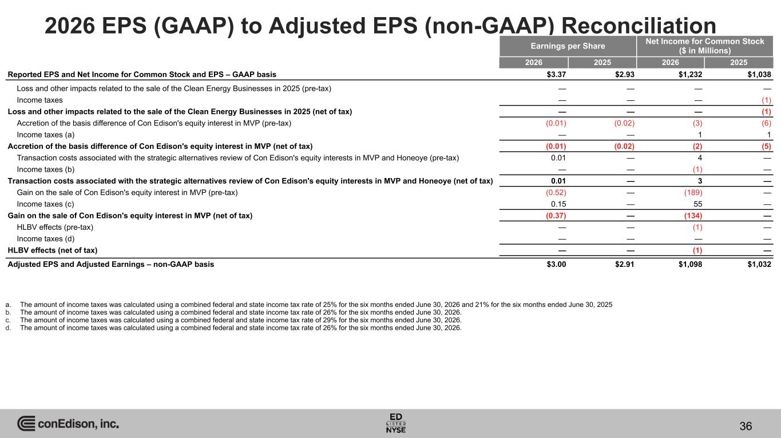
2026 EPS (GAAP) to Adjusted EPS (non-GAAP) Reconciliation Earnings per Share Net Income for Common Stock ($ in Millions) 2026 2025 2026 2025 Reported EPS and Net Income for Common Stock and EPS – GAAP basis $3.37 $2.93 $1,232 $1,038 Loss and other impacts related to the sale of the Clean Energy Businesses in 2025 (pre-tax) — — — — Income taxes — — — (1) Loss and other impacts related to the sale of the Clean Energy Businesses in 2025 (net of tax) — — — (1) Accretion of the basis difference of Con Edison's equity interest in MVP (pre-tax) (0.01) (0.02) (3) (6) Income taxes (a) — — 1 1 Accretion of the basis difference of Con Edison's equity interest in MVP (net of tax) (0.01) (0.02) (2) (5) Transaction costs associated with the strategic alternatives review of Con Edison's equity interests in MVP and Honeoye (pre-tax) 0.01 — 4 — Income taxes (b) — — (1) — Transaction costs associated with the strategic alternatives review of Con Edison's equity interests in MVP and Honeoye (net of tax) 0.01 — 3 — Gain on the sale of Con Edison's equity interest in MVP (pre-tax) (0.52) — (189) — Income taxes (c) 0.15 — 55 — Gain on the sale of Con Edison's equity interest in MVP (net of tax) (0.37) — (134) — HLBV effects (pre-tax) — — (1) — Income taxes (d) — — — — HLBV effects (net of tax) — — (1) — Adjusted EPS and Adjusted Earnings – non-GAAP basis $3.00 $2.91 $1,098 $1,032 a. The amount of income taxes was calculated using a combined federal and state income tax rate of 25% for the six months ended June 30, 2026 and 21% for the six months ended June 30, 2025 b. The amount of income taxes was calculated using a combined federal and state income tax rate of 26% for the six months ended June 30, 2026. c. The amount of income taxes was calculated using a combined federal and state income tax rate of 29% for the six months ended June 30, 2026. d. The amount of income taxes was calculated using a combined federal and state income tax rate of 26% for the six months ended June 30, 2026. 36

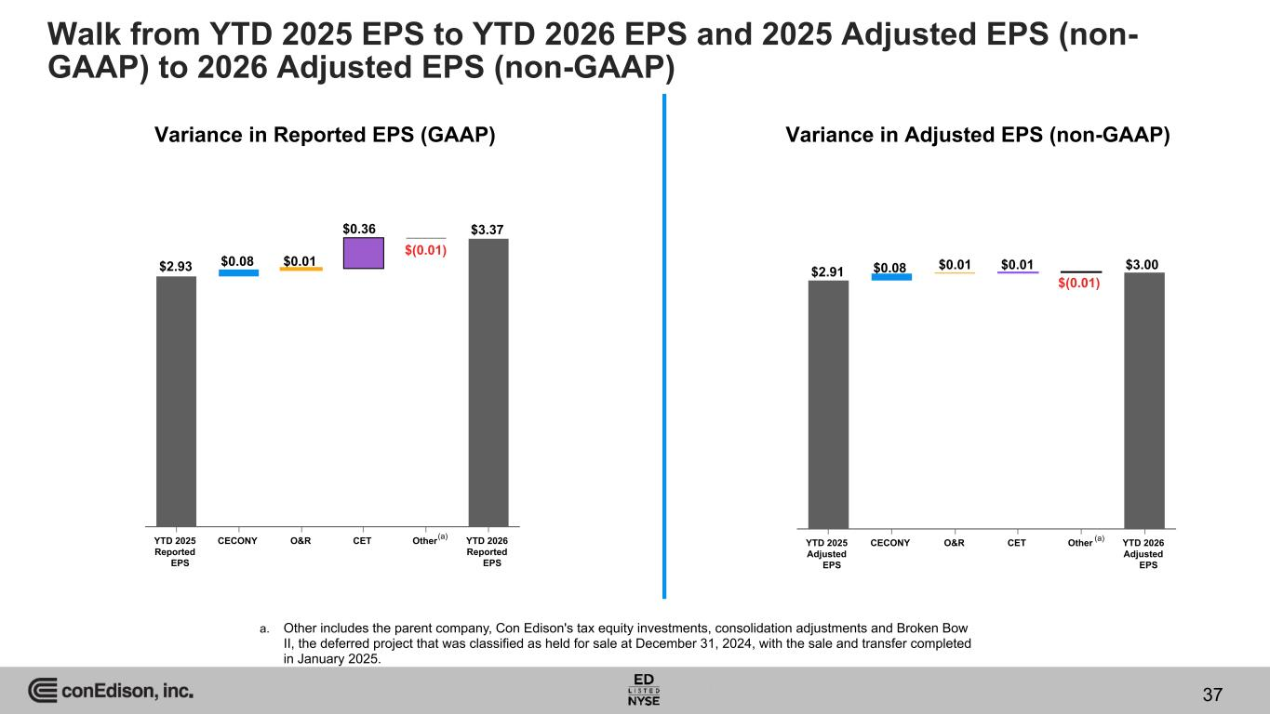
YTD 2025 Adjusted EPS CECONY O&R CET Other YTD 2026 Adjusted EPS Variance in Reported EPS (GAAP) Variance in Adjusted EPS (non-GAAP) YTD 2025 Reported EPS CECONY O&R CET Other YTD 2026 Reported EPS $2.93 $0.08 $0.01 $0.36 $(0.01) $3.37 $2.91 $0.08 $0.01 $0.01 $(0.01) $3.00 (a) (a) a. Other includes the parent company, Con Edison's tax equity investments, consolidation adjustments and Broken Bow II, the deferred project that was classified as held for sale at December 31, 2024, with the sale and transfer completed in January 2025. Walk from YTD 2025 EPS to YTD 2026 EPS and 2025 Adjusted EPS (non- GAAP) to 2026 Adjusted EPS (non-GAAP) 37

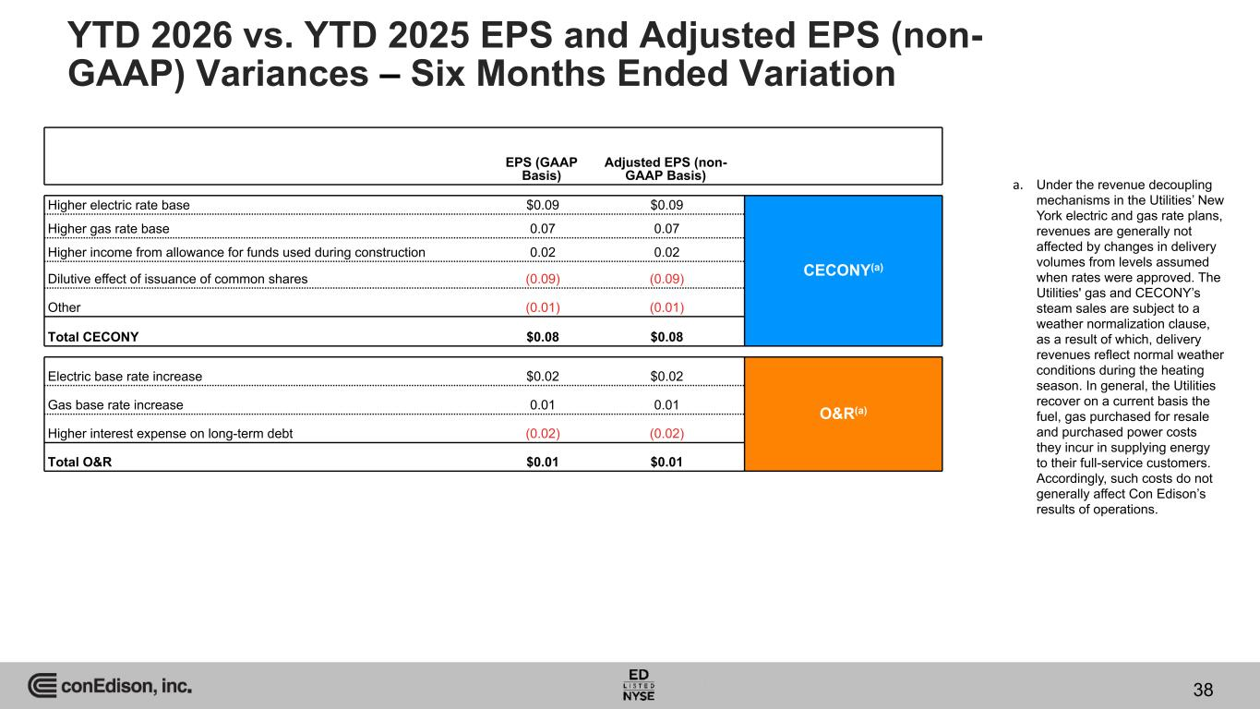
EPS (GAAP Basis) Adjusted EPS (non- GAAP Basis) Higher electric rate base $0.09 $0.09 CECONY(a) Higher gas rate base 0.07 0.07 Higher income from allowance for funds used during construction 0.02 0.02 Dilutive effect of issuance of common shares (0.09) (0.09) Other (0.01) (0.01) Total CECONY $0.08 $0.08 Electric base rate increase $0.02 $0.02 O&R(a)Gas base rate increase 0.01 0.01 Higher interest expense on long-term debt (0.02) (0.02) Total O&R $0.01 $0.01 YTD 2026 vs. YTD 2025 EPS and Adjusted EPS (non- GAAP) Variances – Six Months Ended Variation 38 a. Under the revenue decoupling mechanisms in the Utilities’ New York electric and gas rate plans, revenues are generally not affected by changes in delivery volumes from levels assumed when rates were approved. The Utilities' gas and CECONY’s steam sales are subject to a weather normalization clause, as a result of which, delivery revenues reflect normal weather conditions during the heating season. In general, the Utilities recover on a current basis the fuel, gas purchased for resale and purchased power costs they incur in supplying energy to their full-service customers. Accordingly, such costs do not generally affect Con Edison’s results of operations.

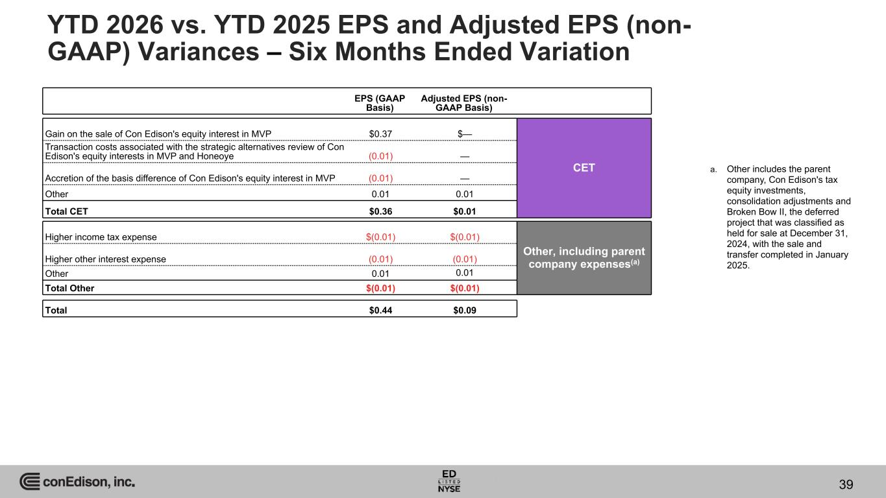
EPS (GAAP Basis) Adjusted EPS (non- GAAP Basis) Gain on the sale of Con Edison's equity interest in MVP $0.37 $— CET Transaction costs associated with the strategic alternatives review of Con Edison's equity interests in MVP and Honeoye (0.01) — Accretion of the basis difference of Con Edison's equity interest in MVP (0.01) — Other 0.01 0.01 Total CET $0.36 $0.01 Higher income tax expense $(0.01) $(0.01) Other, including parent company expenses(a)Higher other interest expense (0.01) (0.01) Other 0.01 0.01 Total Other $(0.01) $(0.01) Total $0.44 $0.09 YTD 2026 vs. YTD 2025 EPS and Adjusted EPS (non- GAAP) Variances – Six Months Ended Variation 39 a. Other includes the parent company, Con Edison's tax equity investments, consolidation adjustments and Broken Bow II, the deferred project that was classified as held for sale at December 31, 2024, with the sale and transfer completed in January 2025.

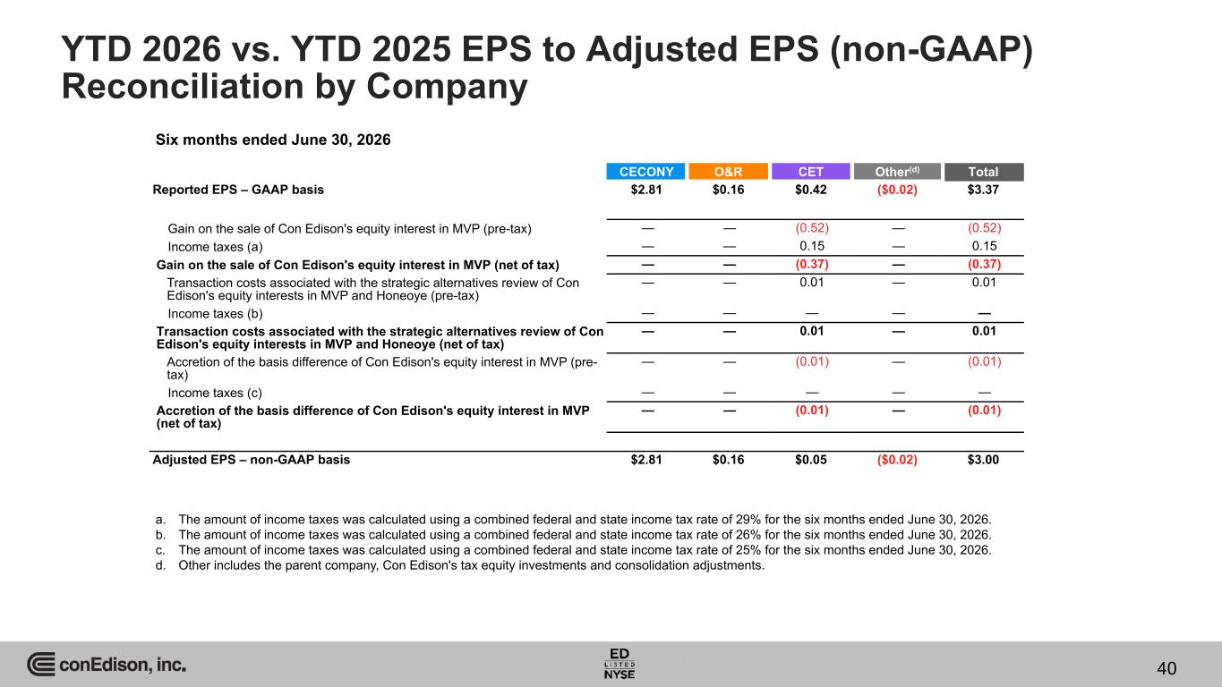
YTD 2026 vs. YTD 2025 EPS to Adjusted EPS (non-GAAP) Reconciliation by Company CECONY O&R CET Other(d) Total Reported EPS – GAAP basis $2.81 $0.16 $0.42 ($0.02) $3.37 Gain on the sale of Con Edison's equity interest in MVP (pre-tax) — — (0.52) — (0.52) Income taxes (a) — — 0.15 — 0.15 Gain on the sale of Con Edison's equity interest in MVP (net of tax) — — (0.37) — (0.37) Transaction costs associated with the strategic alternatives review of Con Edison's equity interests in MVP and Honeoye (pre-tax) — — 0.01 — 0.01 Income taxes (b) — — — — — Transaction costs associated with the strategic alternatives review of Con Edison's equity interests in MVP and Honeoye (net of tax) — — 0.01 — 0.01 Accretion of the basis difference of Con Edison's equity interest in MVP (pre- tax) — — (0.01) — (0.01) Income taxes (c) — — — — — Accretion of the basis difference of Con Edison's equity interest in MVP (net of tax) — — (0.01) — (0.01) Adjusted EPS – non-GAAP basis $2.81 $0.16 $0.05 ($0.02) $3.00 Six months ended June 30, 2026 a. The amount of income taxes was calculated using a combined federal and state income tax rate of 29% for the six months ended June 30, 2026. b. The amount of income taxes was calculated using a combined federal and state income tax rate of 26% for the six months ended June 30, 2026. c. The amount of income taxes was calculated using a combined federal and state income tax rate of 25% for the six months ended June 30, 2026. d. Other includes the parent company, Con Edison's tax equity investments and consolidation adjustments. 40

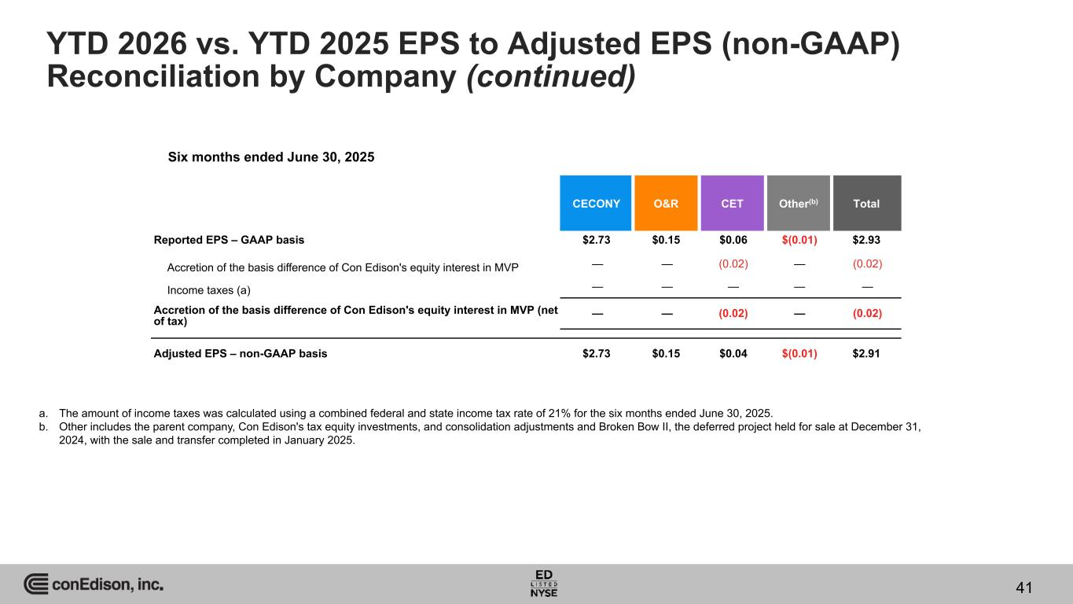
YTD 2026 vs. YTD 2025 EPS to Adjusted EPS (non-GAAP) Reconciliation by Company (continued) CECONY O&R CET Other(b) Total Reported EPS – GAAP basis $2.73 $0.15 $0.06 $(0.01) $2.93 Accretion of the basis difference of Con Edison's equity interest in MVP — — (0.02) — (0.02) Income taxes (a) — — — — — Accretion of the basis difference of Con Edison's equity interest in MVP (net of tax) — — (0.02) — (0.02) Adjusted EPS – non-GAAP basis $2.73 $0.15 $0.04 $(0.01) $2.91 Six months ended June 30, 2025 a. The amount of income taxes was calculated using a combined federal and state income tax rate of 21% for the six months ended June 30, 2025. b. Other includes the parent company, Con Edison's tax equity investments, and consolidation adjustments and Broken Bow II, the deferred project held for sale at December 31, 2024, with the sale and transfer completed in January 2025. 41

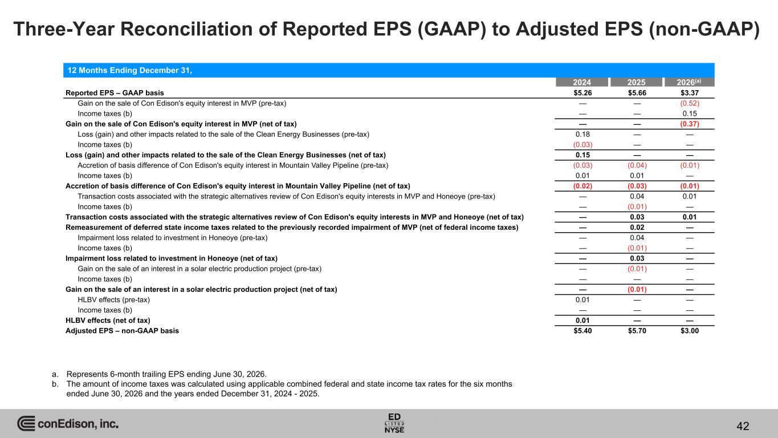
Three-Year Reconciliation of Reported EPS (GAAP) to Adjusted EPS (non-GAAP) 2024 2025 2026(a) Reported EPS – GAAP basis $5.26 $5.66 $3.37 Gain on the sale of Con Edison's equity interest in MVP (pre-tax) — — (0.52) Income taxes (b) — — 0.15 Gain on the sale of Con Edison's equity interest in MVP (net of tax) — — (0.37) Loss (gain) and other impacts related to the sale of the Clean Energy Businesses (pre-tax) 0.18 — — Income taxes (b) (0.03) — — Loss (gain) and other impacts related to the sale of the Clean Energy Businesses (net of tax) 0.15 — — Accretion of basis difference of Con Edison's equity interest in Mountain Valley Pipeline (pre-tax) (0.03) (0.04) (0.01) Income taxes (b) 0.01 0.01 — Accretion of basis difference of Con Edison's equity interest in Mountain Valley Pipeline (net of tax) (0.02) (0.03) (0.01) Transaction costs associated with the strategic alternatives review of Con Edison's equity interests in MVP and Honeoye (pre-tax) — 0.04 0.01 Income taxes (b) — (0.01) — Transaction costs associated with the strategic alternatives review of Con Edison's equity interests in MVP and Honeoye (net of tax) — 0.03 0.01 Remeasurement of deferred state income taxes related to the previously recorded impairment of MVP (net of federal income taxes) — 0.02 — Impairment loss related to investment in Honeoye (pre-tax) — 0.04 — Income taxes (b) — (0.01) — Impairment loss related to investment in Honeoye (net of tax) — 0.03 — Gain on the sale of an interest in a solar electric production project (pre-tax) — (0.01) — Income taxes (b) — — — Gain on the sale of an interest in a solar electric production project (net of tax) — (0.01) — HLBV effects (pre-tax) 0.01 — — Income taxes (b) — — — HLBV effects (net of tax) 0.01 — — Adjusted EPS – non-GAAP basis $5.40 $5.70 $3.00 12 Months Ending December 31, 42 a. Represents 6-month trailing EPS ending June 30, 2026. b. The amount of income taxes was calculated using applicable combined federal and state income tax rates for the six months ended June 30, 2026 and the years ended December 31, 2024 - 2025.

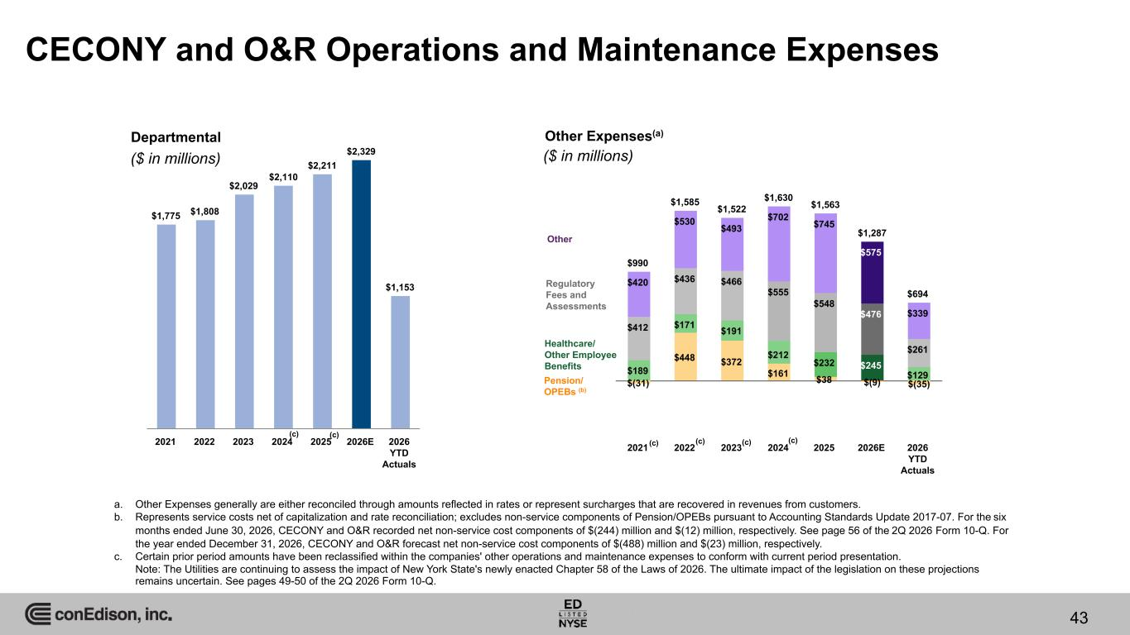
$990 $1,585 $1,522 $1,630 $1,563 $1,287 $694 $(31) $448 $372 $161 $38 $(9) $(35) $189 $171 $191 $212 $232 $245 $129 $412 $436 $466 $555 $548 $476 $261 $420 $530 $493 $702 $745 $575 $339 2021 2022 2023 2024 2025 2026E 2026 YTD Actuals CECONY and O&R Operations and Maintenance Expenses a. Other Expenses generally are either reconciled through amounts reflected in rates or represent surcharges that are recovered in revenues from customers. b. Represents service costs net of capitalization and rate reconciliation; excludes non-service components of Pension/OPEBs pursuant to Accounting Standards Update 2017-07. For the six months ended June 30, 2026, CECONY and O&R recorded net non-service cost components of $(244) million and $(12) million, respectively. See page 56 of the 2Q 2026 Form 10-Q. For the year ended December 31, 2026, CECONY and O&R forecast net non-service cost components of $(488) million and $(23) million, respectively. c. Certain prior period amounts have been reclassified within the companies' other operations and maintenance expenses to conform with current period presentation. Note: The Utilities are continuing to assess the impact of New York State's newly enacted Chapter 58 of the Laws of 2026. The ultimate impact of the legislation on these projections remains uncertain. See pages 49-50 of the 2Q 2026 Form 10-Q. Other Expenses(a) $1,775 $1,808 $2,029 $2,110 $2,211 $2,329 $1,153 2021 2022 2023 2024 2025 2026E 2026 YTD Actuals Departmental Pension/ OPEBs (b) Regulatory Fees and Assessments Healthcare/ Other Employee Benefits Other ($ in millions) ($ in millions) 43 (c) (c) (c)(c)(c) (c)

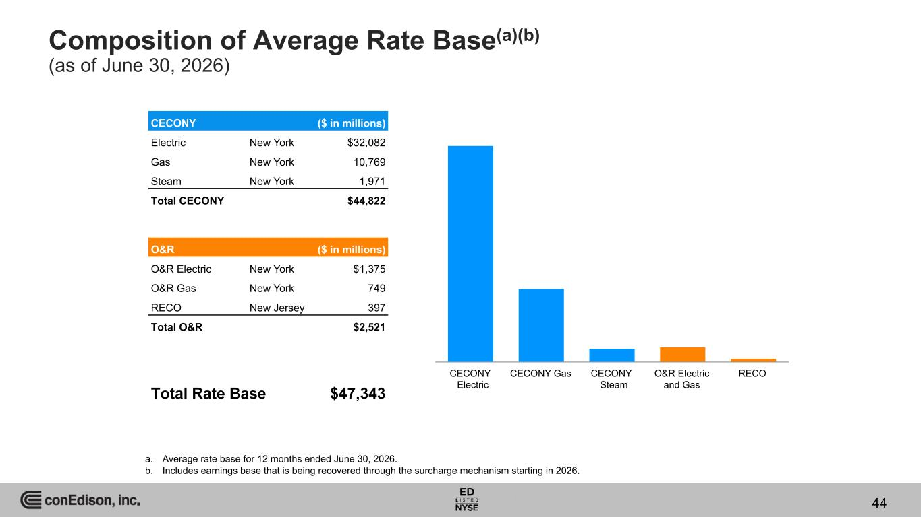
Composition of Average Rate Base(a)(b) (as of June 30, 2026) a. Average rate base for 12 months ended June 30, 2026. b. Includes earnings base that is being recovered through the surcharge mechanism starting in 2026. CECONY ($ in millions) Electric New York $32,082 Gas New York 10,769 Steam New York 1,971 Total CECONY $44,822 O&R ($ in millions) O&R Electric New York $1,375 O&R Gas New York 749 RECO New Jersey 397 Total O&R $2,521 Total Rate Base $47,343 CECONY Electric CECONY Gas CECONY Steam O&R Electric and Gas RECO 44

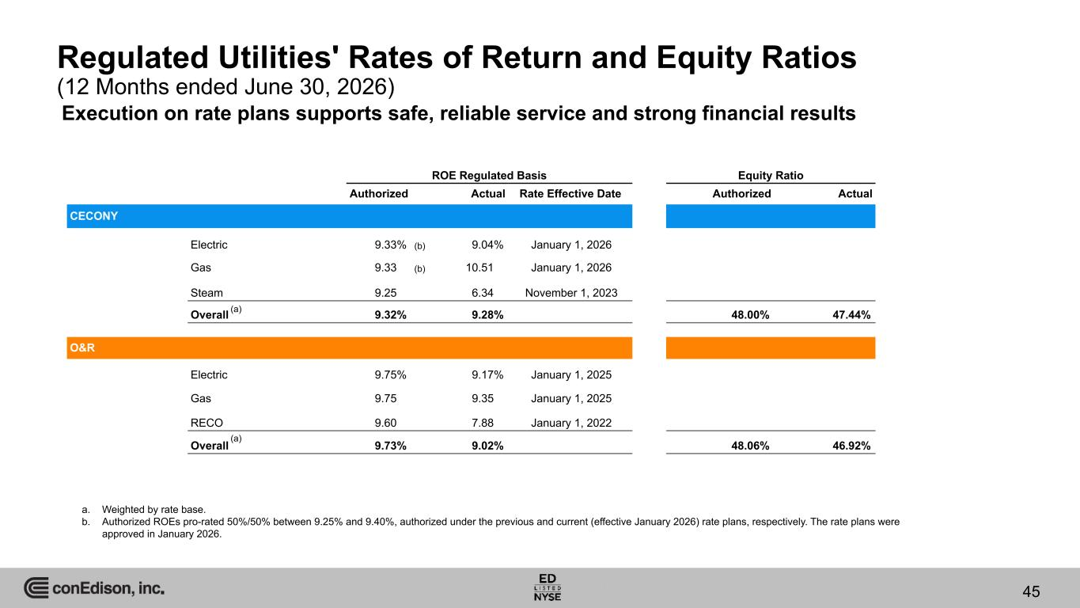
Regulated Utilities' Rates of Return and Equity Ratios (12 Months ended June 30, 2026) ROE Regulated Basis Equity Ratio Authorized Actual Rate Effective Date Authorized Actual CECONY Electric 9.33% (b) 9.04% January 1, 2026 Gas 9.33 (b) 10.51 January 1, 2026 Steam 9.25 6.34 November 1, 2023 Overall 9.32% 9.28% 48.00% 47.44% O&R Electric 9.75% 9.17% January 1, 2025 Gas 9.75 9.35 January 1, 2025 RECO 9.60 7.88 January 1, 2022 Overall 9.73% 9.02% 48.06% 46.92% a. Weighted by rate base. b. Authorized ROEs pro-rated 50%/50% between 9.25% and 9.40%, authorized under the previous and current (effective January 2026) rate plans, respectively. The rate plans were approved in January 2026. (a) (a) 45 Execution on rate plans supports safe, reliable service and strong financial results

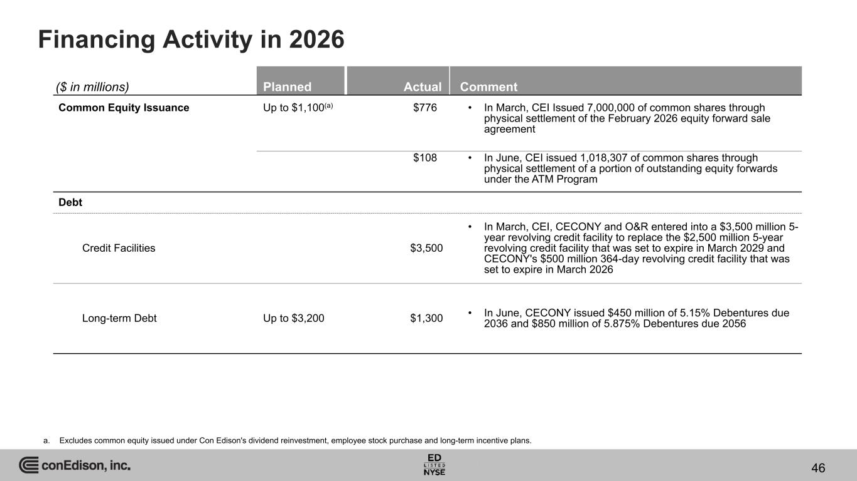
Financing Activity in 2026 a. Excludes common equity issued under Con Edison's dividend reinvestment, employee stock purchase and long-term incentive plans. ($ in millions) Planned Actual Comment Common Equity Issuance Up to $1,100(a) _________$776 • In March, CEI Issued 7,000,000 of common shares through physical settlement of the February 2026 equity forward sale agreement _________$108 • In June, CEI issued 1,018,307 of common shares through physical settlement of a portion of outstanding equity forwards under the ATM Program Debt Credit Facilities ___ ____$3,500 • In March, CEI, CECONY and O&R entered into a $3,500 million 5- year revolving credit facility to replace the $2,500 million 5-year revolving credit facility that was set to expire in March 2029 and CECONY's $500 million 364-day revolving credit facility that was set to expire in March 2026 Long-term Debt Up to $3,200 ___ ____$1,300 • In June, CECONY issued $450 million of 5.15% Debentures due 2036 and $850 million of 5.875% Debentures due 2056 46

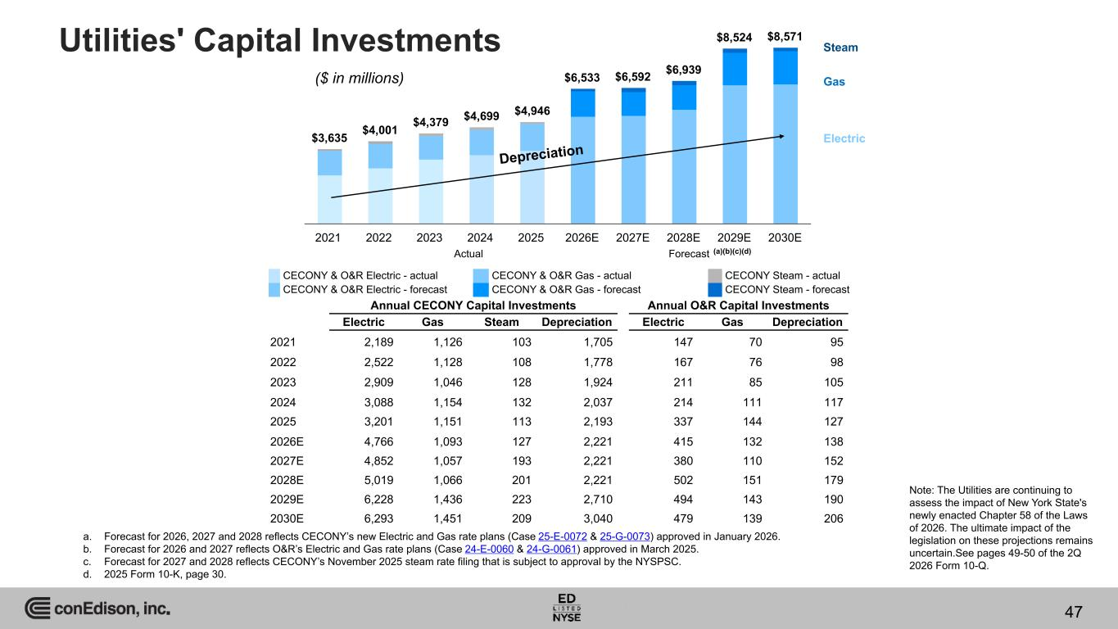
$3,635 $4,001 $4,379 $4,699 $4,946 $6,533 $6,592 $6,939 $8,524 $8,571 2021 2022 2023 2024 2025 2026E 2027E 2028E 2029E 2030E Utilities' Capital Investments Gas Electric Annual CECONY Capital Investments Annual O&R Capital Investments Electric Gas Steam Depreciation Electric Gas Depreciation 2021 2,189 1,126 103 1,705 147 70 95 2022 2,522 1,128 108 1,778 167 76 98 2023 2,909 1,046 128 1,924 211 85 105 2024 3,088 1,154 132 2,037 214 111 117 2025 3,201 1,151 113 2,193 337 144 127 2026E 4,766 1,093 127 2,221 415 132 138 2027E 4,852 1,057 193 2,221 380 110 152 2028E 5,019 1,066 201 2,221 502 151 179 2029E 6,228 1,436 223 2,710 494 143 190 2030E 6,293 1,451 209 3,040 479 139 206 Steam Depreciation Actual Forecast a. Forecast for 2026, 2027 and 2028 reflects CECONY’s new Electric and Gas rate plans (Case 25-E-0072 & 25-G-0073) approved in January 2026. b. Forecast for 2026 and 2027 reflects O&R’s Electric and Gas rate plans (Case 24-E-0060 & 24-G-0061) approved in March 2025. c. Forecast for 2027 and 2028 reflects CECONY’s November 2025 steam rate filing that is subject to approval by the NYSPSC. d. 2025 Form 10-K, page 30. (a)(b)(c)(d) ($ in millions) 47 CECONY & O&R Electric - actual CECONY & O&R Gas - actual CECONY Steam - actual CECONY & O&R Electric - forecast CECONY & O&R Gas - forecast CECONY Steam - forecast Note: The Utilities are continuing to assess the impact of New York State's newly enacted Chapter 58 of the Laws of 2026. The ultimate impact of the legislation on these projections remains uncertain.See pages 49-50 of the 2Q 2026 Form 10-Q.

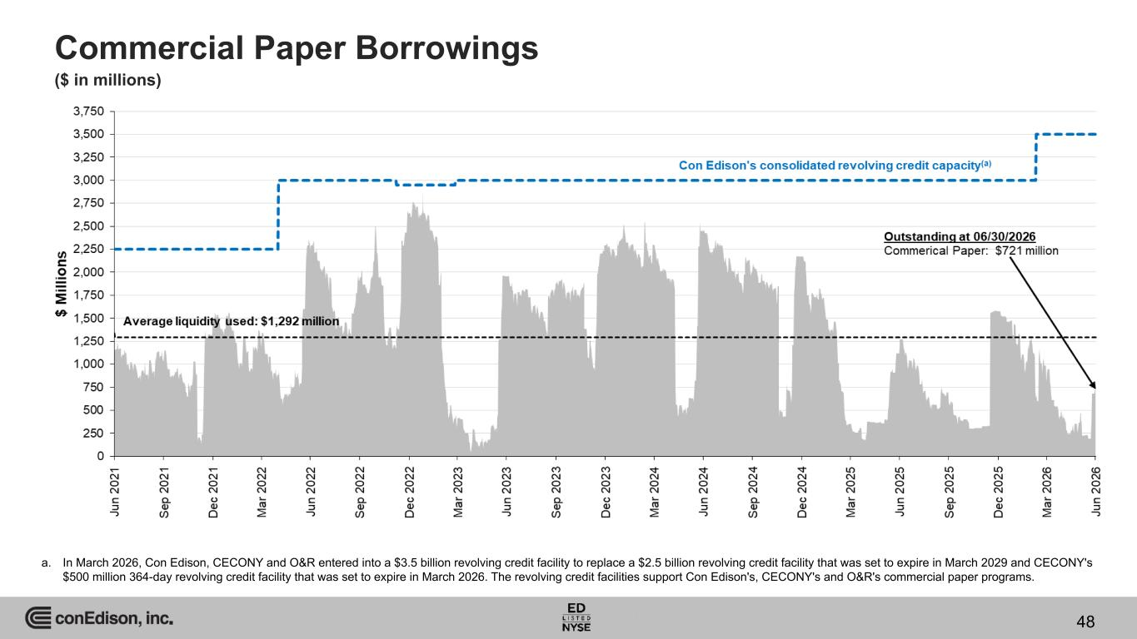
Commercial Paper Borrowings ($ in millions) a. In March 2026, Con Edison, CECONY and O&R entered into a $3.5 billion revolving credit facility to replace a $2.5 billion revolving credit facility that was set to expire in March 2029 and CECONY's $500 million 364-day revolving credit facility that was set to expire in March 2026. The revolving credit facilities support Con Edison's, CECONY's and O&R's commercial paper programs. 48

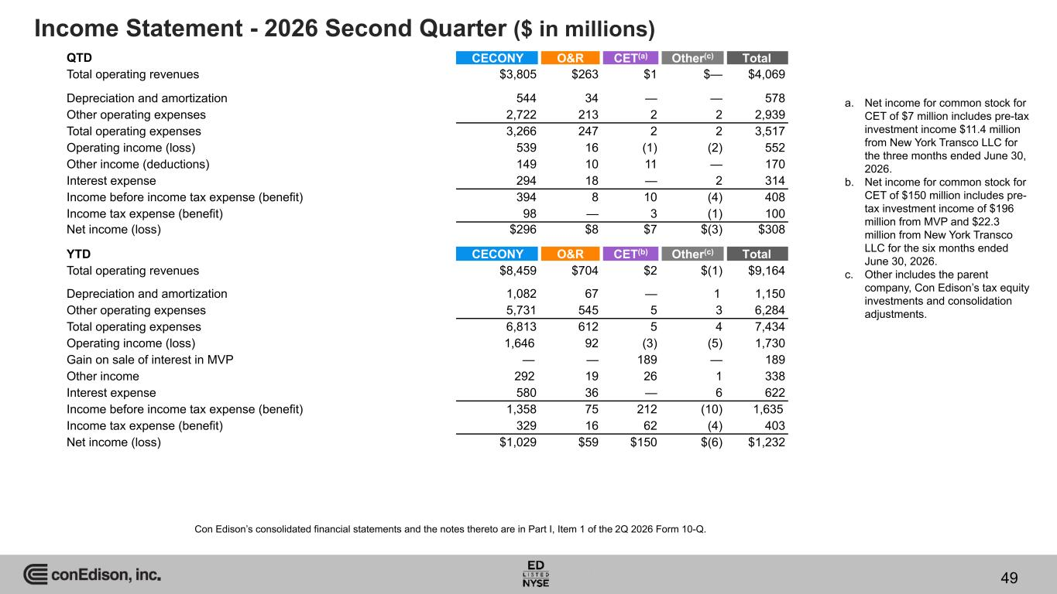
Income Statement - 2026 Second Quarter ($ in millions) QTD CECONY O&R CET(a) Other(c) Total Total operating revenues $3,805 $263 $1 $— $4,069 Depreciation and amortization 544 34 — — 578 Other operating expenses 2,722 213 2 2 2,939 Total operating expenses 3,266 247 2 2 3,517 Operating income (loss) 539 16 (1) (2) 552 Other income (deductions) 149 10 11 — 170 Interest expense 294 18 — 2 314 Income before income tax expense (benefit) 394 8 10 (4) 408 Income tax expense (benefit) 98 — 3 (1) 100 Net income (loss) $296 $8 $7 $(3) $308 YTD CECONY O&R CET(b) Other(c) Total Total operating revenues $8,459 $704 $2 $(1) $9,164 Depreciation and amortization 1,082 67 — 1 1,150 Other operating expenses 5,731 545 5 3 6,284 Total operating expenses 6,813 612 5 4 7,434 Operating income (loss) 1,646 92 (3) (5) 1,730 Gain on sale of interest in MVP — — 189 — 189 Other income 292 19 26 1 338 Interest expense 580 36 — 6 622 Income before income tax expense (benefit) 1,358 75 212 (10) 1,635 Income tax expense (benefit) 329 16 62 (4) 403 Net income (loss) $1,029 $59 $150 $(6) $1,232 a. Net income for common stock for CET of $7 million includes pre-tax investment income $11.4 million from New York Transco LLC for the three months ended June 30, 2026. b. Net income for common stock for CET of $150 million includes pre- tax investment income of $196 million from MVP and $22.3 million from New York Transco LLC for the six months ended June 30, 2026. c. Other includes the parent company, Con Edison’s tax equity investments and consolidation adjustments. Con Edison’s consolidated financial statements and the notes thereto are in Part I, Item 1 of the 2Q 2026 Form 10-Q. 49

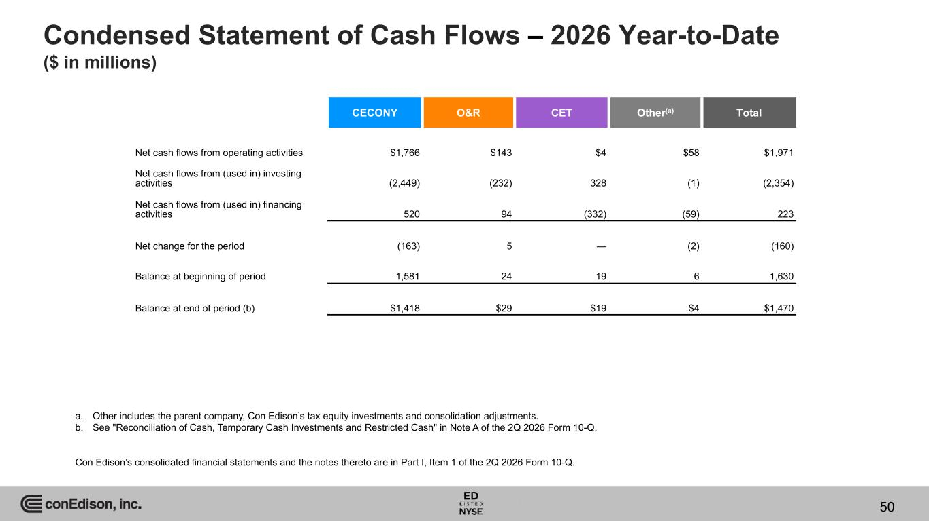
Condensed Statement of Cash Flows – 2026 Year-to-Date ($ in millions) CECONY O&R CET Other(a) Total Net cash flows from operating activities $1,766 $143 $4 $58 $1,971 Net cash flows from (used in) investing activities (2,449) (232) 328 (1) (2,354) Net cash flows from (used in) financing activities 520 94 (332) (59) 223 Net change for the period (163) 5 — (2) (160) Balance at beginning of period 1,581 24 19 6 1,630 Balance at end of period (b) $1,418 $29 $19 $4 $1,470 a. Other includes the parent company, Con Edison’s tax equity investments and consolidation adjustments. b. See "Reconciliation of Cash, Temporary Cash Investments and Restricted Cash" in Note A of the 2Q 2026 Form 10-Q. Con Edison’s consolidated financial statements and the notes thereto are in Part I, Item 1 of the 2Q 2026 Form 10-Q. 50

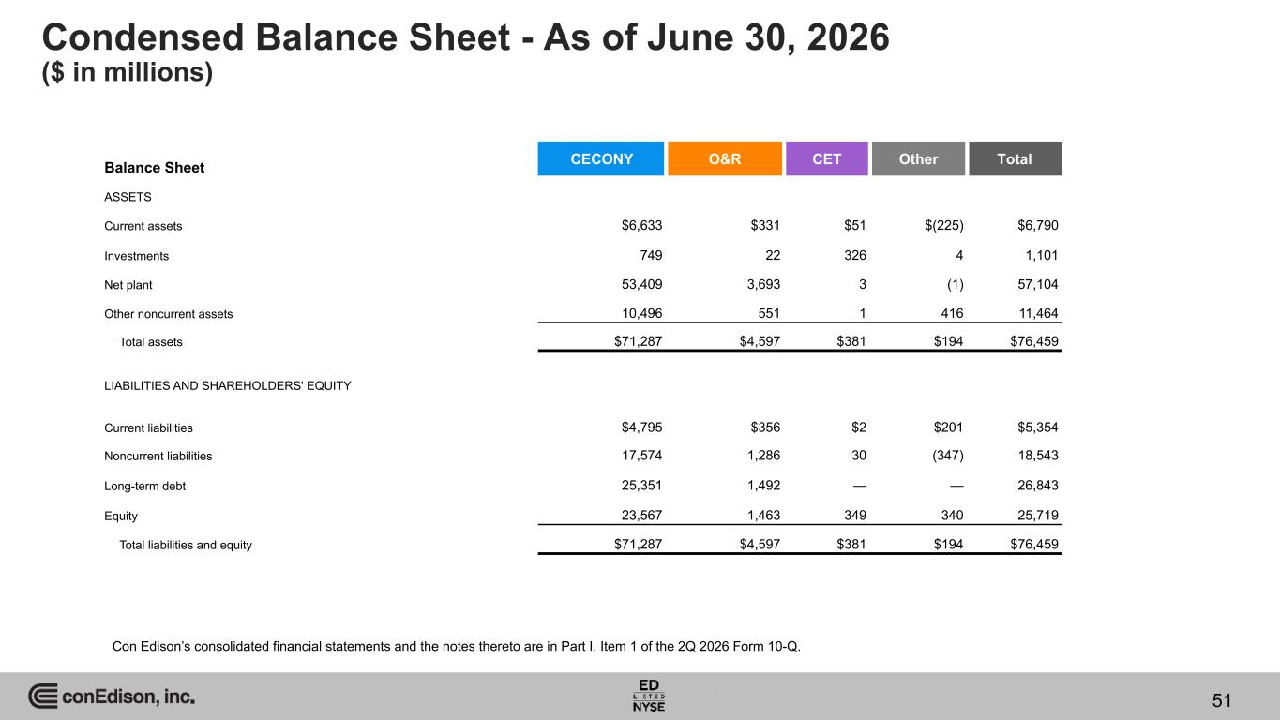
Condensed Balance Sheet - As of June 30, 2026 ($ in millions) Balance Sheet CECONY O&R CET Other Total ASSETS Current assets $6,633 $331 $51 $(225) $6,790 Investments 749 22 326 4 1,101 Net plant 53,409 3,693 3 (1) 57,104 Other noncurrent assets 10,496 551 1 416 11,464 Total assets $71,287 $4,597 $381 $194 $76,459 LIABILITIES AND SHAREHOLDERS' EQUITY Current liabilities $4,795 $356 $2 $201 $5,354 Noncurrent liabilities 17,574 1,286 30 (347) 18,543 Long-term debt 25,351 1,492 — — 26,843 Equity 23,567 1,463 349 340 25,719 Total liabilities and equity $71,287 $4,597 $381 $194 $76,459 Con Edison’s consolidated financial statements and the notes thereto are in Part I, Item 1 of the 2Q 2026 Form 10-Q. 51

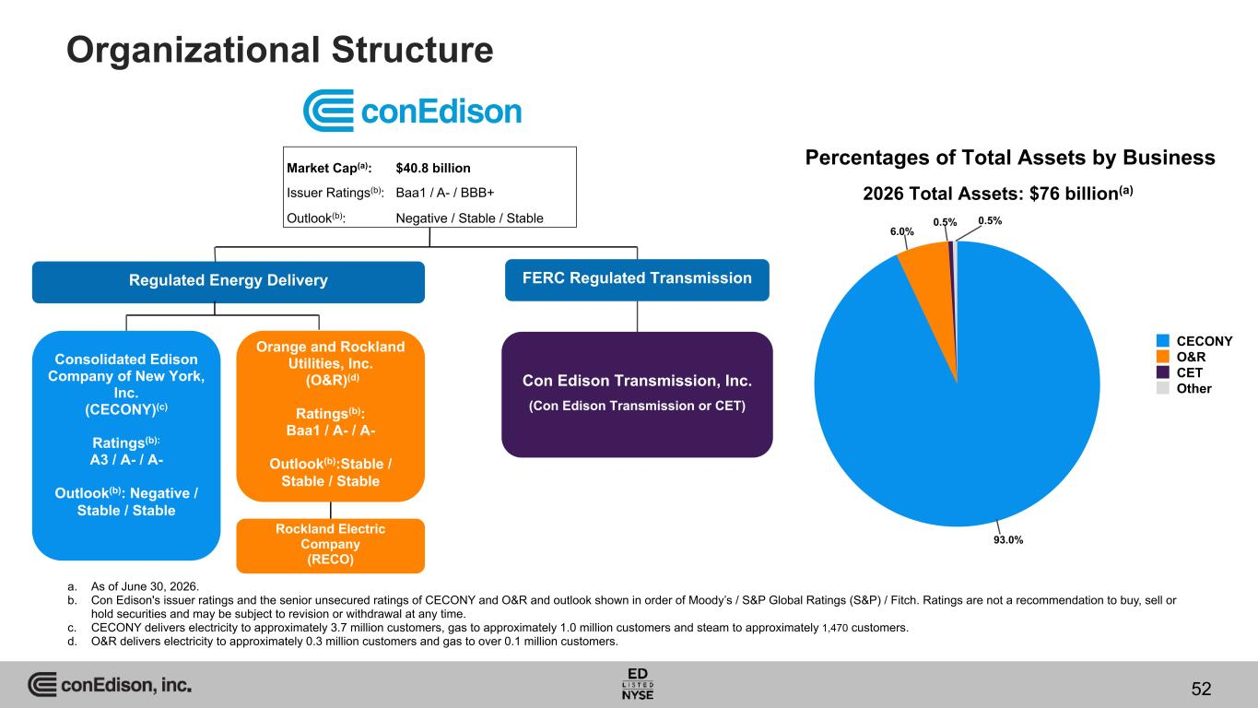
52 Organizational Structure a. As of June 30, 2026. b. Con Edison's issuer ratings and the senior unsecured ratings of CECONY and O&R and outlook shown in order of Moody’s / S&P Global Ratings (S&P) / Fitch. Ratings are not a recommendation to buy, sell or hold securities and may be subject to revision or withdrawal at any time. c. CECONY delivers electricity to approximately 3.7 million customers, gas to approximately 1.0 million customers and steam to approximately 1,470 customers. d. O&R delivers electricity to approximately 0.3 million customers and gas to over 0.1 million customers. Regulated Energy Delivery Orange and Rockland Utilities, Inc. (O&R)(d) Ratings(b): Baa1 / A- / A- Outlook(b):Stable / Stable / Stable Consolidated Edison Company of New York, Inc. (CECONY)(c) Ratings(b): A3 / A- / A- Outlook(b): Negative / Stable / Stable FERC Regulated Transmission Market Cap(a): $40.8 billion Issuer Ratings(b): Baa1 / A- / BBB+ Outlook(b): Negative / Stable / Stable Con Edison Transmission, Inc. (Con Edison Transmission or CET) Rockland Electric Company (RECO) Percentages of Total Assets by Business 93.0% 6.0% 0.5% 0.5% CECONY O&R CET Other 2026 Total Assets: $76 billion(a) 52

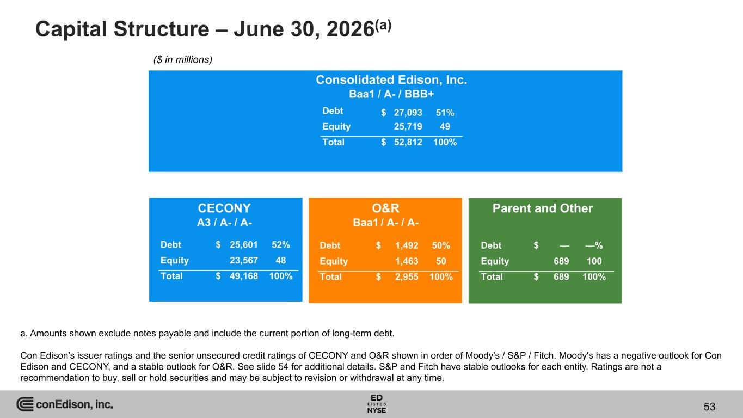
Capital Structure – June 30, 2026(a) Consolidated Edison, Inc. Baa1 / A- / BBB+ CECONY A3 / A- / A- O&R Baa1 / A- / A- Parent and Other Debt $ 27,093 51% Equity 25,719 49 Total $ 52,812 100% Debt $ 25,601 52% Equity 23,567 48 Total $ 49,168 100% Debt $ 1,492 50% Equity 1,463 50 Total $ 2,955 100% Debt $ — —% Equity 689 100 Total $ 689 100% a. Amounts shown exclude notes payable and include the current portion of long-term debt. Con Edison's issuer ratings and the senior unsecured credit ratings of CECONY and O&R shown in order of Moody's / S&P / Fitch. Moody's has a negative outlook for Con Edison and CECONY, and a stable outlook for O&R. See slide 54 for additional details. S&P and Fitch have stable outlooks for each entity. Ratings are not a recommendation to buy, sell or hold securities and may be subject to revision or withdrawal at any time. ($ in millions) 53

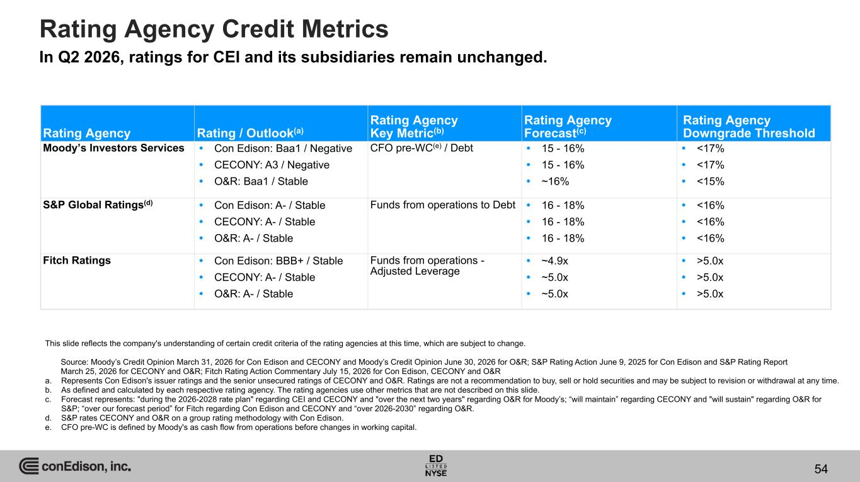
Rating Agency Credit Metrics This slide reflects the company's understanding of certain credit criteria of the rating agencies at this time, which are subject to change. Source: Moody’s Credit Opinion March 31, 2026 for Con Edison and CECONY and Moody’s Credit Opinion June 30, 2026 for O&R; S&P Rating Action June 9, 2025 for Con Edison and S&P Rating Report March 25, 2026 for CECONY and O&R; Fitch Rating Action Commentary July 15, 2026 for Con Edison, CECONY and O&R a. Represents Con Edison's issuer ratings and the senior unsecured ratings of CECONY and O&R. Ratings are not a recommendation to buy, sell or hold securities and may be subject to revision or withdrawal at any time. b. As defined and calculated by each respective rating agency. The rating agencies use other metrics that are not described on this slide. c. Forecast represents: "during the 2026-2028 rate plan" regarding CEI and CECONY and "over the next two years" regarding O&R for Moody’s; “will maintain” regarding CECONY and "will sustain" regarding O&R for S&P; “over our forecast period” for Fitch regarding Con Edison and CECONY and “over 2026-2030” regarding O&R. d. S&P rates CECONY and O&R on a group rating methodology with Con Edison. e. CFO pre-WC is defined by Moody's as cash flow from operations before changes in working capital. Rating Agency Rating / Outlook(a) Rating Agency Key Metric(b) Rating Agency Forecast(c) Rating Agency Downgrade Threshold Moody’s Investors Services  Con Edison: Baa1 / Negative  CECONY: A3 / Negative  O&R: Baa1 / Stable CFO pre-WC(e) / Debt  15 - 16%  15 - 16%  ~16%  <17%  <17%  <15% S&P Global Ratings(d)  Con Edison: A- / Stable  CECONY: A- / Stable  O&R: A- / Stable Funds from operations to Debt  16 - 18%  16 - 18%  16 - 18%  <16%  <16%  <16% Fitch Ratings  Con Edison: BBB+ / Stable  CECONY: A- / Stable  O&R: A- / Stable Funds from operations - Adjusted Leverage  ~4.9x  ~5.0x  ~5.0x  >5.0x  >5.0x  >5.0x In Q2 2026, ratings for CEI and its subsidiaries remain unchanged. 54

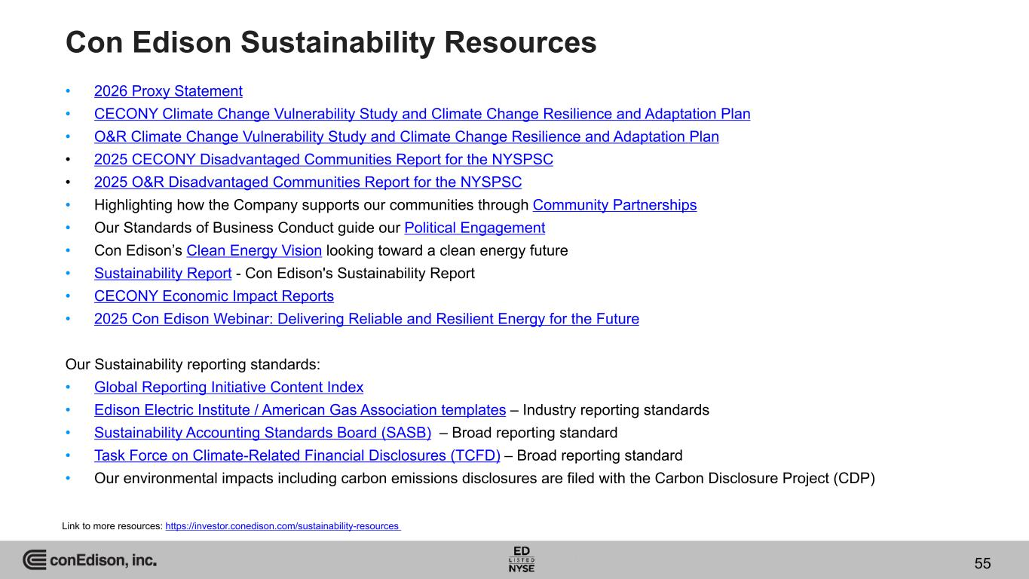
Con Edison Sustainability Resources • 2026 Proxy Statement • CECONY Climate Change Vulnerability Study and Climate Change Resilience and Adaptation Plan • O&R Climate Change Vulnerability Study and Climate Change Resilience and Adaptation Plan • 2025 CECONY Disadvantaged Communities Report for the NYSPSC • 2025 O&R Disadvantaged Communities Report for the NYSPSC • Highlighting how the Company supports our communities through Community Partnerships • Our Standards of Business Conduct guide our Political Engagement • Con Edison’s Clean Energy Vision looking toward a clean energy future • Sustainability Report - Con Edison's Sustainability Report • CECONY Economic Impact Reports • 2025 Con Edison Webinar: Delivering Reliable and Resilient Energy for the Future Our Sustainability reporting standards: • Global Reporting Initiative Content Index • Edison Electric Institute / American Gas Association templates – Industry reporting standards • Sustainability Accounting Standards Board (SASB) – Broad reporting standard • Task Force on Climate-Related Financial Disclosures (TCFD) – Broad reporting standard • Our environmental impacts including carbon emissions disclosures are filed with the Carbon Disclosure Project (CDP) Link to more resources: https://investor.conedison.com/sustainability-resources 55

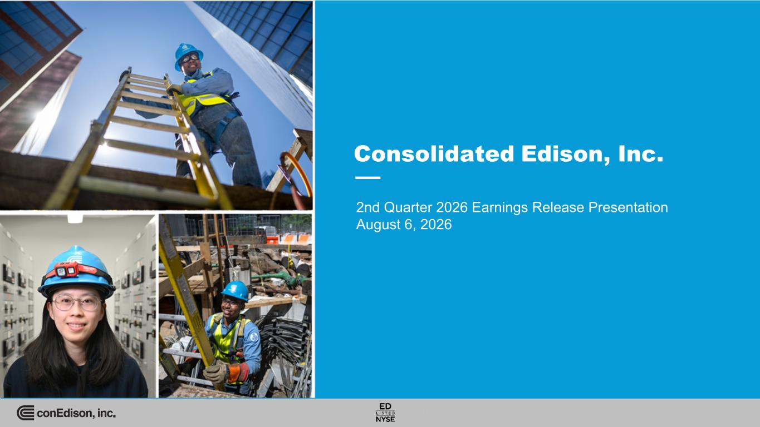
INTERNAL 2025 Earnings Release Presentation February 19, 2026 nd Qu rter 2026 E rnings Release Presentation August 6, 2026

