Table of Contents

UNITED STATES

SECURITIES AND EXCHANGE COMMISSION

Washington, D.C. 20549

SCHEDULE 14A

SCHEDULE 14A INFORMATION

Proxy Statement Pursuant to Section 14(a) of the

Securities Exchange Act of 1934
(Amendment No. )

Filed by the Registrant ☒

Filed by a party other than the Registrant ☐

Check the appropriate box:

- Preliminary Proxy Statement

- Confidential, for Use of the Commission Only (as permitted by Rule 14a-6(e)(2))

- Definitive Proxy Statement

- Definitive Additional Materials

- Soliciting Material Under §240.14a-12

CONSOLIDATED EDISON, INC.

(Name of Registrant as Specified In Its Charter)

NOT APPLICABLE

(Name of Person(s) Filing Proxy Statement, if other than the Registrant)

Payment of Filing Fee (Check the appropriate box):

- No fee required.

- Fee paid previously with preliminary materials.

- Fee computed on table in exhibit required by Item 25(b) per Exchange Act Rules 14a-6(i)(1) and 0-11

Table of Contents
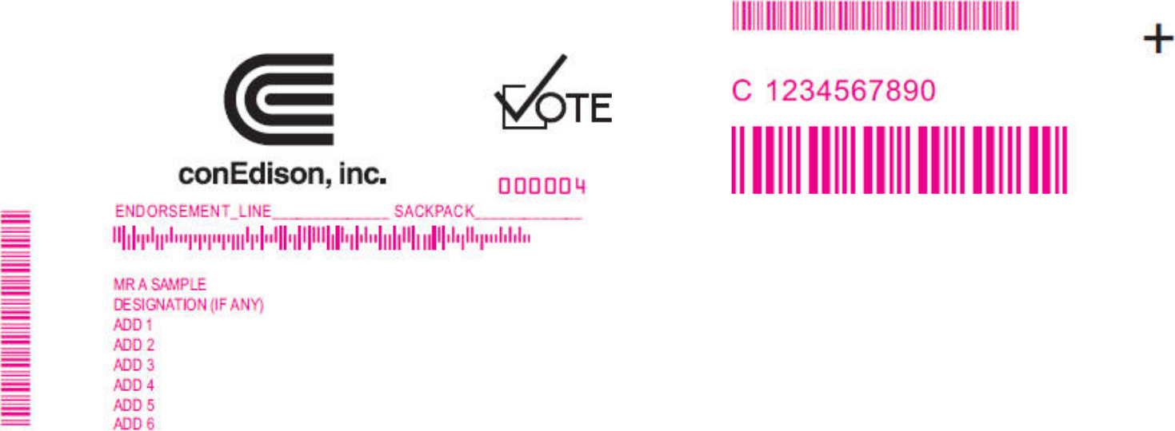

Online

Go to www.investorvote.com/ED



or scan the QR code – login details are located in the shaded bar below.

Consolidated Edison, Inc. Annual Meeting of Stockholders Notice

Important Notice Regarding the Availability of Proxy Materials for the Consolidated Edison, Inc. Virtual Annual Meeting of Stockholders to be Held on Monday, May 15, 2023, 10:00 a.m. EDT

Under Securities and Exchange Commission rules, you are receiving this Notice that the proxy materials for the Consolidated Edison, Inc. Annual Meeting of Stockholders are available on the Internet. Follow the instructions below to view the materials and vote online or request a copy. The items to be voted on and information about the Annual Meeting of Stockholders are on the reverse side. Your vote is important!

This communication presents only an overview of the more complete proxy materials that are available to you on the Internet. We encourage you to access and review all of the important information contained in the proxy materials before voting. The Consolidated Edison, Inc. proxy materials are available at:

Easy Online Access – View your proxy materials and vote.


Step 1: Go to www.investorvote.com/ED.

Step 2: Click on the icon on the right to view meeting materials.

Step 3: Return to the investorvote.com window and follow the instructions on the screen to log in.

Step 4: Make your selections as instructed on each screen for your delivery preferences.

Step 5: Vote your shares.

When you go online, you can also help the environment by consenting to receive electronic delivery of future materials.

Obtaining a Copy of the Proxy Materials – If you want to receive a copy of these documents, you must request one. There is no charge to you for requesting a copy. Please make your request for a copy as instructed on the reverse side on or before Monday, May 1, 2023 to facilitate timely delivery.


2 N O T C O Y

03QWYG

Table of Contents

Consolidated Edison, Inc. Annual Meeting of Stockholders Notice

Consolidated Edison, Inc. Annual Meeting of Stockholders will be held virtually on Monday, May 15, 2023 at 10:00 a.m. EDT.

Available via live webcast at www.virtualshareholdermeeting.com/ED2023

To access the virtual Annual Meeting via the webcast, you must obtain a virtual meeting access (“VMA”) control number as described in the proxy statement no later than 5:00 p.m., EDT, on Monday, May 8, 2023. The VMA control number is a 16-digit number that will provide you access to the Annual Meeting. It does NOT replace the 15-digit Computershare control number that allows you to vote your shares.

We plan to hold the Annual Meeting by means of remote communications only. Please check the meeting materials for any special requirements for the Annual Meeting attendance.

YOUR VOTE IS IMPORTANT!

We strongly recommend that you vote in advance of the Annual Meeting.

Proposals to be voted on at the meeting are listed below along with the Board of Directors’ recommendations.

The Board of Directors recommends a vote FOR all director nominees listed below, and FOR proposals 2, 3 and 5 and one year on proposal 4:

- Election of Directors:

01 - Timothy P. Cawley

02 - Ellen V. Futter

03 - John F. Killian

04 - Karol V. Mason

05 - Dwight A. McBride

06 - William J. Mulrow

07 - Armando J. Olivera

08 - Michael W. Ranger

09 - Linda S. Sanford

10 - Deirdre Stanley

11 - L. Frederick Sutherland

- Ratification of appointment of independent accountants.

- Advisory vote to approve named executive officer compensation.

- Advisory vote on frequency of future advisory votes on named executive officer compensation.

- Approval of the company’s 2023 long term incentive plan.

PLEASE NOTE – YOU CANNOT VOTE BY RETURNING THIS NOTICE.

To vote your shares you must vote online or request a paper copy of the proxy materials to receive a proxy card.

Information about the Consolidated Edison, Inc. Annual Meeting of Stockholders

is available in the proxy statement which can be viewed at www.investorvote.com/ED.

Here’s how to order a copy of the proxy materials and select delivery preferences:


Current and future delivery requests can be submitted using the options below.

If you request an email copy, you will receive an email with a link to the current meeting materials.

PLEASE NOTE: You must use the number in the shaded bar on the reverse side when requesting a copy of the proxy materials.

– Internet – Go to www.investorvote.com/ED.

– Phone – Call us free of charge at 1-866-641-4276.

– Email – Send an email to investorvote@computershare.com with“Proxy Materials Consolidated Edison, Inc.” in the subject line. Include your full name and address, plus the number located in the shaded bar on the reverse side, and state that you want a paper copy of the meeting materials.

To facilitate timely delivery, requests for a paper copy of proxy materials must be received by Monday, May 1, 2023.

